NIKO RUBIO SHARES NEW SONG “LEFT YOU”

RELEASED ALONGSIDE AN OFFICIAL MUSIC VIDEO
DIRECTED BY VOGUE GIAMBRI

DOWNLOAD/STREAM | WATCH HERE

FORTHCOMING EP UN MILLIÓN DE BESOS DUE OUT THIS JUNE

RISING SINGER/SONGWRITER NAMED “LATIN ACTS TO MAKE IT BIG IN 2023” BY ROLLING STONE AND “EMERGING ARTISTS TO WATCH” BY PEOPLE
“Left you is my breakup and fuck you song. It’s me in Miami having fun with Cris Chill, one of the best writers in the game and writing a diss track. It was so fun to make & is more fun to sing because I don't really come out of my shell and make songs like this... I'm so excited to perform & dance on stage to this song, it's going to be next level.”

DOWNLOAD HI-RES ARTWORK

New York, NY – May 25, 2023 – Rising singer-songwriter Niko Rubio releases new song, “Left You,” available today via Sandlot Records/Atlantic Records. The head-nodding beat underscores Spanish verses before Rubio declares in English, “Your love, it was all fake, and that’s the reason why I left you.”

“Left You” is accompanied by an official music video directed by Vogue Giambri and is the fourth track to come off Niko’s forthcoming sophomore EP, un millión de besos due out this June, following “See Me Now,” “Sunshine,” and “Olividar De Ti.”
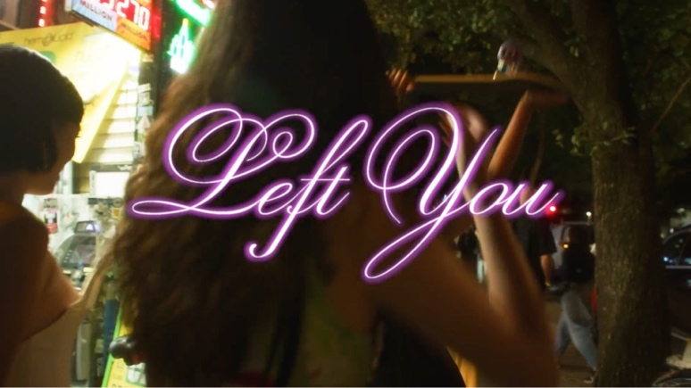

“Latin Acts to Make it Big in 2023” -ROLLING STONE

“Captivating showcase for the newcomer…“the kicky pop-rock track allows Rubio’s tone to sink down low and soar skyward.” – BILLBOARD

“Talented emerging artist to have on your playlist…” – PEOPLE

“Niko Rubio’s music feels like driving down PCH” – PAPER

“Her self-described “pop-indie-rock” music is at once ethereal and buoyant, yet grounded by a thrumming bassline. In other words, the perfect soundtrack for riding in a seafoam-green convertible, top down, along the familiar Pacific Coast Highway.” – LATINA

ABOUT NIKO RUBIO:
Southern California-born singer and songwriter Niko Rubio has quietly asserted herself as a musical empath, exploring the highs and lows of life and love with no filter in both English and Spanish. She gleefully channels formative inspirations as diverse as pop, alternative R&B, Bossa Nova, and rock. Growing up of Mexican and Salvadorian descent in the South Bay of Los Angeles, her childhood soundtrack included the likes of Madonna, Erykah Badu, and Shakira. After buzzing independently, she conjured the endless promise of the Pacific Coast Highway on her breakthrough 2021 debut Wish You Were Here EP. Anchored by highlights such as “Saving Me,” “Bed,” and “You Could Be The One,” the project tallied millions of streams and garnered critical acclaim. People appropriately christened her “California girl meets Latina queen,” while Rolling Stone pegged her as one of the “10 Latin Acts Set to Make It Big in 2023.” Along the way, she graced the stages of festivals a la Lollapalooza and BottleRock in addition to supporting Omar Apollo on tour. Inspired to embrace who she is, Niko hones a genre-breaking, yet culture-integrating vision on her 2023 EP, un millón de besos [Sandlot Records/Atlantic Records].

Press Contacts:
Jason Davis | jason.davis@atlanticrecords.com
Taylor Apel | taylor.apel@atlanticrecords.com

