NIKO RUBIO EMBRACES HER LATIN ROOTS THROUGH SOPHOMORE EP UN MILLÓN DE BESOS

DOWNLOAD/STREAM UN MILLÓN DE BESOS

RISING SINGER-SONGWRITER NAMED “LATIN ACTS TO MAKE IT BIG IN 2023” BY ROLLING STONE AND “EMERGING ARTISTS TO WATCH” BY PEOPLE
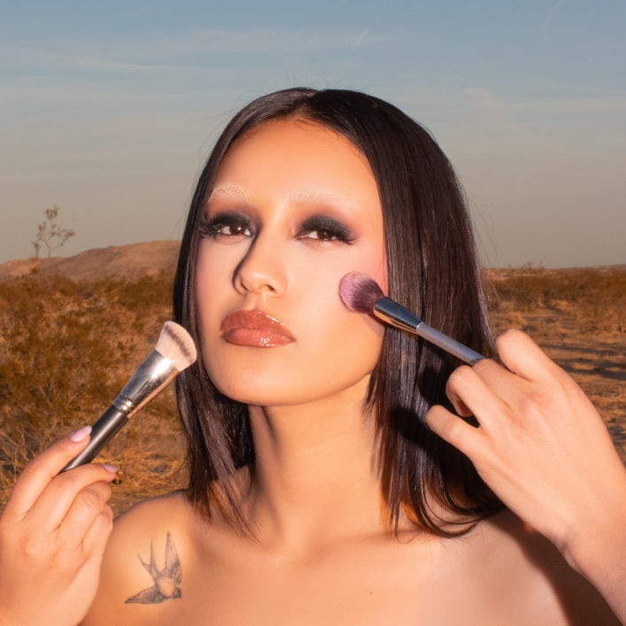
DOWNLOAD HI-RES ARTWORK

New York, NY – June 23, 2023 – Rising Latin singer-songwriter Niko Rubio unleashes sophomore EP, un millón de besos – available today via Sandlot Records/Atlantic Records. The new EP is led by the lovestruck title track, “un millón de besos,” that balances atop a Bossa Nova bounce punctuated by faint acoustic guitar and an emotive vocal performance.

“It literally translates to ‘A Million Kisses.’ It’s the romantic part of the EP. Any Latin woman my age or older listened to Shakira with her mother or grandmother in the car. I definitely did, and I’m paying homage to that.”
-NIKO RUBIO

DOWNLOAD/STREAM UN MILLÓN DE BESOS

After recording the project between Miami and Los Angeles, Rubio initially teased this chapter with “Olvidar De Ti” followed by the singles “Left You,” “See Me Now,” and “Sunshine.” On the latter, her breezy guitar and breathy vocals uplift a sunny harmony as she promises, “I won’t leave you.”

“It’s a very personal song about having to take your inner child, pack her away in a suitcase, and carry her with you through the treacheries of adulthood—which is like fear personified. There’s a lot of influence from my relationship with my mother. If you come from a difficult background or struggle internally at home, you have to constantly give yourself stability.”

With the release of the EP, Rubio shares the dreamy “No Te Vayas,” where her voice careens over stark and simple production as she coos, “You’re my favorite melody.”

“I’m a very lovey-dovey person. At the time, I’d just met my boyfriend. I was so optimistic and in love that I didn’t even want to leave the house, which is what the ‘No Te Vayas’ is about.”

UN MILLÓN DE BESOS TRACKLIST

un millón de besos
Left You
Sunshine
No Te Vayas
Olvidar De Ti
See Me Now

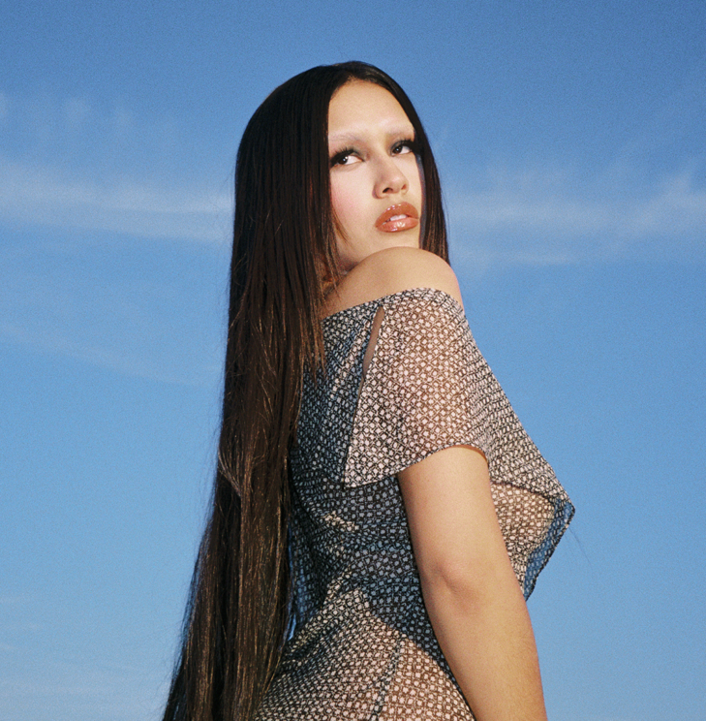
DOWNLOAD HI-RES PHOTOS

ABOUT NIKO RUBIO:
Southern California-born singer and songwriter Niko Rubio has quietly asserted herself as a musical empath, exploring the highs and lows of life and love with no filter in both English and Spanish. She gleefully channels formative inspirations as diverse as pop, alternative R&B, Bossa Nova, and rock. Growing up of Mexican and Salvadorian descent in the South Bay of Los Angeles, her childhood soundtrack included the likes of Madonna, Erykah Badu, and Shakira. After buzzing independently, she conjured the endless promise of the Pacific Coast Highway on her breakthrough 2021 debut Wish You Were Here EP. Anchored by highlights such as “Saving Me,” “Bed,” and “You Could Be The One,” the project tallied millions of streams and garnered critical acclaim. People appropriately christened her “California girl meets Latina queen,” while Rolling Stone pegged her as one of the “10 Latin Acts Set to Make It Big in 2023.” Along the way, she graced the stages of festivals a la Lollapalooza and BottleRock in addition to supporting Omar Apollo on tour. Inspired to embrace who she is, Niko hones a genre-breaking, yet culture-integrating vision on her 2023 EP, un millón de besos [Sandlot Records/Atlantic Records].

Press Contacts:
Jason Davis | jason.davis@atlanticrecords.com
Taylor Apel | taylor.apel@atlanticrecords.com

