OLIVER TREE RELEASES “BOUNCE”

NEW SINGLE HERALDS THIRD SOLO ALBUM,
ALONE IN A CROWD OUT SEPTEMBER 29 – PRE-SAVE/ADD HERE

BIGGEST HEADLINE SHOW TO DATE TAKES PLACE
AT THE LEGENDARY RED ROCKS AMPHITHEATRE TONIGHT

OFFICIAL MUSIC VIDEO FOR “BOUNCE” DIRECTED BY OLIVER TREE – OUT TODAY

DOWNLOAD PRESS PHOTO HERE
CREDIT: BRANKO STARČEVIĆ

WATCH | LISTEN
“BOUNCE”

PRE-ORDER/SAVE
'ALONE IN A CROWD’

Internationally acclaimed, multi-Platinum, chart-topping artist Oliver Tree has shared his highly anticipated new single, “Bounce,” available now via Atlantic Records. Notoriously at the helm of all things Oliver Tree, the multi-faceted, multi-medium artist not only wrote and produced “Bounce” but directed the accompanying official music video too.

Listen to “Bounce” HERE.

Watch the official music video HERE.

“Bounce” – which was teased in recent days by a viral series of social media posts – heralds the long-awaited release of Oliver Tree’s upcoming third solo album, ALONE IN A CROWD, arriving September 29. The album will also feature his most recent RIAA certified hit “Miss You.”

Undeniably a one-of-a-kind artist who continues to top the charts and sell out amphitheaters worldwide, Tree satisfies his dedicated and growing audience with Kaufman-esque Dadaist, “meta-humor” while continuing to explore and dissect the absurdity of modern culture, obsession with fame and social media. ALONE IN A CROWD serves to reflect both the light and the darkness of human nature within popular culture, while holding a mirror up to us all and embracing the absurdity of it all. Exploring themes of loneliness, disconnect, and the human experience, ALONE IN A CROWD also introduces a new character named Cornelius Cummings, a fashion designer who sets the runway for his latest body of work.

ALONE IN A CROWD is out September 29 – PRE-ORDER/SAVE HERE.

Oliver – who lit up last week’s Governors Ball in New York City with a top-billed, typically show-stealing performance – will celebrate the impending arrival of ALONE IN A CROWD with his biggest headline show to date, “Oliver Tree – The World’s Tiniest Tap Dancer – Live At Red Rocks,” a once-in-a-lifetime concert event set for tonight, June 20, at Morrison, CO’s world famous Red Rocks Amphitheatre. Special guests include Tai Verdes, UPSAHL, and Little Ricky ZR3. Additional live dates will be unveiled soon. For complete details, please see www.olivertreemusic.com.

Now boasting more than 4B global streams, over 1B YouTube views, over 14.7M TikTok followers, and an cumulative social reach of over 30M, Oliver Tree has already had a very productive 2023 with such electric releases as his first-ever collaboration with fellow superstar David Guetta, “Here We Go Again,” streaming now HERE. An official lyric video, written and directed by Oliver, has earned over 13M views via YouTube HERE. “Here We Go Again” in turn followed KSI’s “Voices (Feat. Oliver Tree),” joined by an official music video now boasting close to 7M views HERE.

Currently Spotify’s 77th Most Listened To Artist with more 35M monthly listeners, Oliver wrapped up his very busy 2022 with the long awaited release of Cowboy Tears Drown the World in a Swimming Pool of Sorrow, an expanded deluxe edition of his acclaimed sophomore LP, Cowboy Tears, available now HERE. Highlights include such favorites as “I Hate You,” “Placeholder,” and “Suitcase Full Of Cash,” the latter accompanied by an official visual featuring guest appearances from viral stars Alissa Violet, Tana Mongeau, Viking Barbie, and Melissa Ong, streaming now at Oliver’s YouTube channel HERE.

Last year also saw Oliver join forces with GRAMMY® Award-nominated producer Robin Schulz for the high-energy viral hit, “Miss You,” which swiftly amassed over 300M global streams following top 10 debuts on both Billboard’s “Hot Dance/Electronic Songs” chart and the UK’s Official Singles Chart. Recently certified 2x Platinum in Australia as well as Platinum in both the UK and Canada, the track is accompanied by a typically quirky official music video, directed by Oliver and currently boasting more than 190M views via YouTube HERE.

The new album, ‘ALONE IN A CROWD’ is out September 29 – PRE-ORDER/SAVE HERE.

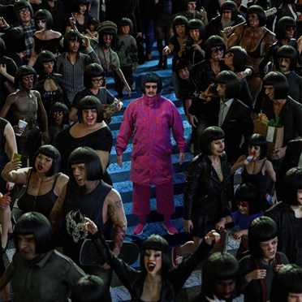

Listen to “Bounce” HERE. Watch the official music video HERE.

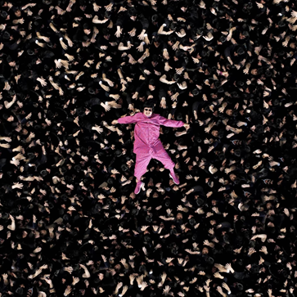

# # #

WEBSITE | FACEBOOK | INSTAGRAM | SPOTIFY | TIK TOK | TWITTER | YOUTUBE
For all media inquiries, please contact:
HIGH RISE PR
Alexandra Baker | Alexandra@highrisepr.com
Jamie Sward | Jamie@highrisepr.com
ATLANTIC RECORDS
JESSICA NALL // JESSICA.NALL@ATLANTICRECORDS.COM

