FOR IMMEDIATE RELEASE
JUNE 21, 2023

HAYLEY KIYOKO UNVEILS DEEPLY PERSONAL NEW SONG
“somewhere between the sand and the stardust”

TRAILBLAZING POP ICON SHARES EMOTIONAL TRIBUTE TO THOSE
STRUGGLING WITH MENTAL HEALTH ISSUES AND THEIR CAREGIVERS

DEBUT NOVEL GIRLS LIKE GIRLS HITS #1 ON THE NEW YORK TIMES BEST SELLERS LIST

STEVE AOKI AND GALANTIS’ “HUNGRY HEART (FT. HAYLEY KIYOKO)” CURRENTLY #1
ON DANCE RADIO CHART

LISTEN TO “somewhere between the sand and the stardust”

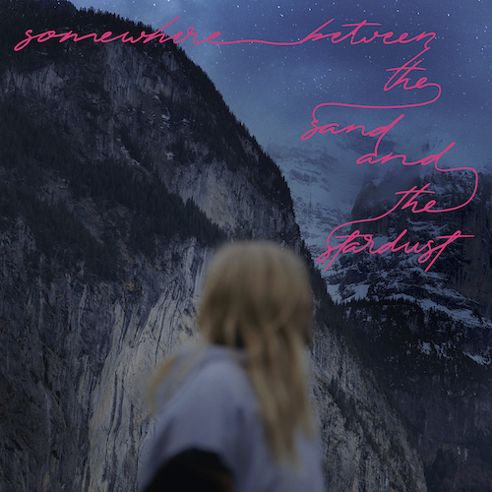
DOWNLOAD HI-RES ARTWORK

“Hayley Kiyoko is more than an actress, pop star or lesbian icon: She's a vessel of love and kindness, mirroring the fuel that has kept her going in even the darkest and loneliest of times.” – PAPER

“If Hayley Kiyoko is lesbian Jesus, ‘Girls Like Girls’ is the Bible.” – INTERVIEW MAGAZINE

Trailblazing pop star Hayley Kiyoko has shared her deeply personal new song, “somewhere between the sand and the stardust.” The heartfelt and emotional track is produced by LIONCHLD (Britney Spears, Calvin Harris, Bebe Rexha) and co-written by Kiyoko, LIONCHLD, and Violet Skies (Tiësto, Diana Ross).

“A dear friend of mine recently passed away after a long struggle with mental health,” says Kiyoko. “It’s been difficult to balance my grief while also knowing that he is finally at peace. I wrote ‘somewhere between the sand and the stardust’ to remind those dealing with a loved one taking their own life that they are not alone – that all the complicated emotions they’re feeling are valid. For me, it was a lot of anger, confusion, and what ifs in that process. We must continue to care for those struggling with mental health issues as well as the people they rely on for support. This song is a tribute to loving the people who choose to stay and embracing and finding peace with the memory of those who don’t.”

Kiyoko – whose debut novel, Girls Like Girls (Wednesday Books), recently debuted at #1 on the New York Times “Young Adult Hardcover” Best Sellers List – has just returned from her hugely successful global headline run, The PANORAMA Tour, which culminated earlier this month with sold-out shows across North America including a two-night stand at New York City’s famed Irving Plaza. In addition, Kiyoko performed at Proctor & Gamble and iHeartMedia’s “Can’t Cancel Pride 2023 – The Future Starts Now” in LA and Capital Pride in DC, plus a headline show at SF Pride.

“somewhere between the sand and the stardust” follows this spring’s arrival of another new single, “Greenlight.” Co-written with Jesse St. John (Britney Spears, Kim Petras, Charli XCX) and produced by Oliver “German” Peterhof (Justin Bieber, Camilla Cabello, Zara Larsson), the track proved a fan favorite throughout The PANORAMA Tour and earned praise from such outlets as Rolling Stone. In addition, Steve Aoki and Galantis’ “Hungry Heart (ft. Hayley Kiyoko)” is currently #1 on the Dance Radio chart, which released alongside an official music video directed by Kiyoko – Watch HERE.

A coming-of-age romance based on her breakthrough hit song and viral video, Girls Like Girls is available now HERE. The novel was quickly met with praise from Publishers Weekly, which declared it to be “a pitch-perfect tale” and a “powerfully romantic read.” “Girls Like Girls is ultimately yet another way that Kiyoko is creating the art she wishes she had as a kid — an impulse most of her career has stemmed from,” wrote NYLON while Cosmopolitan declared, “with her debut, Hayley is just adding ‘author’ to her long list of huge accomplishments that we definitely can't get enough of.” During a conversation with Taylor Jenkins Reid (Daisy Jones & The Six) for Interview Magazine, the esteemed author described Girls Like Girls as “a book that feels like a glass of water when you are parched” and thanked Kiyoko for writing it.

Last year saw the acclaimed release of Kiyoko’s sophomore album, PANORAMA, available now via Atlantic Records HERE. Co-written by Kiyoko and co-produced with Danja (Beyoncé, Britney Spears) and Pat Morrisey & Kill Dave, the album – which includes singles, “For The Girls,” “Chance,” and “Found My Friends” – received rave reviews from such leading publications as The New York Times, FADER, Billboard, SPIN, PAPER, V Magazine, Variety, Entertainment Weekly, and more. The groundbreaking musician also graced the cover of Teen Vogue’s Music issue and was declared “Artist Of The Year” by Out Magazine as she covered their annual “Out100” issue.

Adoringly known as “Lesbian Jesus” to her legion of fans, Kiyoko has become one of pop’s most celebrated artists since releasing 2018’s landmark debut album EXPECTATIONS, which, according to Rolling Stone, placed her “at the forefront of an unapologetically queer pop movement.” In #20GAYTEEN, she was nominated for two MTV Video Music Awards, winning “Push Artist Of The Year.” Since her 2015 debut, Hayley has amassed over 1.1B global streams and more than 2.3M YouTube subscribers, accrued over 840M lifetime YouTube views, and sold-out numerous venues across the country and abroad on her previous headline tours. Lauded as one of “The 21st Century's Most Influential Women Musicians” by NPR, among other milestones, Hayley continues to impact and inspire her community through nuanced storytelling and lyricism, encouraging hope as her resounding message.

CONNECT WITH HAYLEY KIYOKO:
WEBSITE | FACEBOOK | TWITTER | INSTAGRAM | TIKTOK | YOUTUBE | PRESS ASSETS

PRESS CONTACT:
Andrew George / Atlantic Records
andrew.george@atlanticrecords.com

