FOR IMMEDIATE RELEASE
JUNE 1, 2023

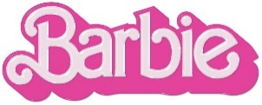

BARBIE THE ALBUM RETURNS ONE WEEK AFTER EPIC LAUNCH WITH FIERCE NEW SINGLE “WATATI” FROM KAROL G FT. ALDO RANKS – LISTEN HERE

“WATATI” FOLLOWS LEAD SINGLE “DANCE THE NIGHT” BY DUA LIPA
NOW WITH OVER 50M COMBINED AUDIO AND VIDEO STREAMS

ALL-NEW COMPANION ALBUM TO WARNER BROS. PICTURES’ HIGHLY ANTICIPATED FILM INSPIRED BY MATTEL’S BARBIE FEATURES MASSIVE NEW TRACKS FROM AN UNPRECEDENTED LINEUP OF GLOBAL SUPERSTARS INCLUDING NICKI MINAJ, ICE SPICE, LIZZO, CHARLI XCX,
PINKPANTHERESS, TAME IMPALA, THE KID LAROI AND MORE

SOUNDTRACK EXECUTIVE PRODUCED BY OSCAR, GOLDEN GLOBE AND
7X GRAMMY® AWARD WINNING ARTIST AND PRODUCER MARK RONSON

BARBIE + BARBIE THE ALBUM ARRIVE EVERYWHERE ON JULY 21ST

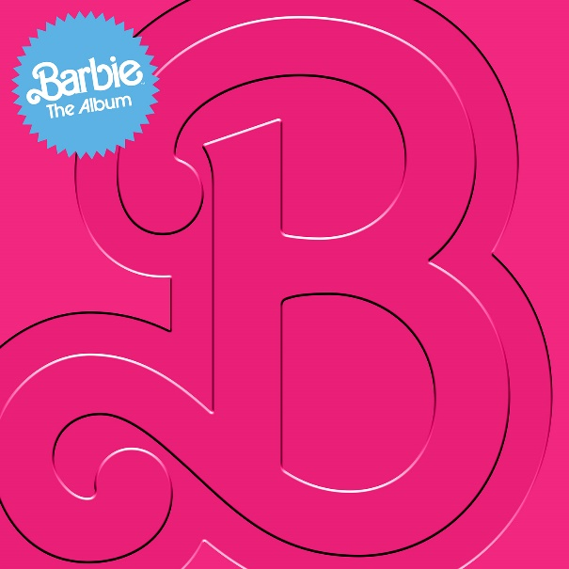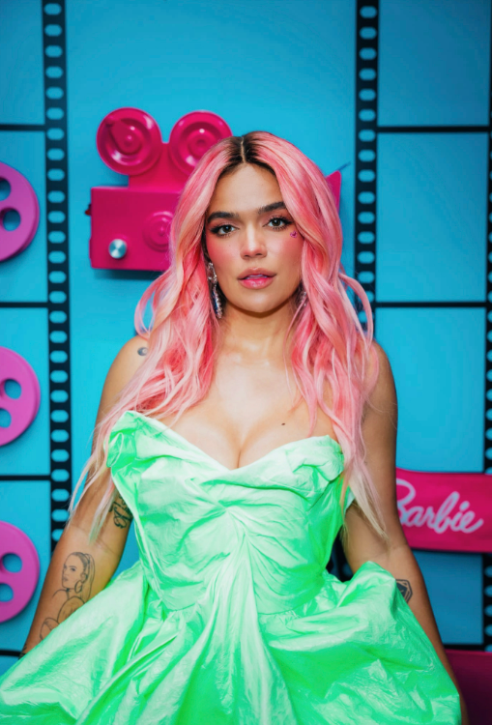
DOWNLOAD HI-RES IMAGES HERE
KAROL G PHOTO CREDIT: LEO ARGUELLO

“Attn: The ‘Barbie’ Soundtrack Features *the* Most Star-Studded Ensemble!” – COSMOPOLITAN

“Barbie definitely has some sick beats playing in those plastic headphones” – BILLBOARD

“The blockbuster-in-waiting is coming with an appropriately loaded soundtrack” – FADER

“It looks like there won't be any skippers on this album” – E! NEWS

After last week’s groundbreaking launch of BARBIE THE ALBUM, complete with an epic artist lineup reveal and electrifying first single, Atlantic Records has released the latest track from the star-studded musical companion to the highly anticipated summer event film Barbie, starring Margot Robbie and Ryan Gosling as Barbie and Ken and distributed by Warner Bros. Pictures. The soundtrack continues to build with the fierce new single “WATATI” from global recording artist, KAROL G feat. Aldo Ranks. An official companion video will be released later this month. BARBIE THE ALBUM is now available for pre-order HERE and arrives in stores and at all online retailers on Friday, July 21st in conjunction with the theatrical release of the feature film.

“WATATI” was preceded by the soundtrack’s first official single, “Dance The Night” from 3x GRAMMY® Award-winning global superstar Dua Lipa, who also makes a special appearance in the film. Produced by Mark Ronson, Andrew Wyatt and the Picard Brothers, the sexy, fit for summer track can be heard in the film’s global official trailer and arrived alongside a dazzling official video featuring a special appearance from Barbie writer/director/executive producer Greta Gerwig (“Little Women,” “Lady Bird”) – watch HERE. Upon release, the track was immediately met with widespread acclaim with ROLLING STONE proclaiming, “Lipa sings with the confidence of a siren,” NPR describing it as “undeniably glamorous,” BILLBOARD asserting it has “one of the sleekest bridges in mainstream pop this year,” and INSTYLE declaring it “our new summer anthem.” The single has already amassed over 50M combined audio and official video streams in just one week.

BARBIE THE ALBUM will feature massive new tracks from an unprecedented lineup of artists including Nicki Minaj and Ice Spice, Lizzo, Charli XCX, PinkPantheress, Ava Max, Dominic Fike, Khalid, The Kid LAROI, Tame Impala, HAIM, GAYLE and FIFTY FIFTY feat. Kali. Barbie star Ryan Gosling also joins the robust roster of soundtrack artists with his iconic original song performed as his character, Ken. See below for full tracklisting.

BARBIE THE ALBUM continues the hugely successful partnership between Atlantic Records and Warner Bros. Pictures. The two companies previously teamed up for 2020’s BIRDS OF PREY: THE ALBUM which spawned the RIAA Certified 2x Platinum smash “Boss B*tch” by Doja Cat, along with the 2016’s GRAMMY® Award-nominated SUICIDE SQUAD: THE ALBUM, which topped album charts in over 70 countries around the world, including two consecutive weeks on the Billboard 200, and featured the RIAA Certified Diamond hit “Heathens” by Twenty One Pilots.

BARBIE THE ALBUM was executive produced by internationally renowned DJ and Oscar, Golden Globe and 7x GRAMMY® award winning artist and producer, Mark Ronson and Barbie writer/director/executive producer Greta Gerwig. The soundtrack album was Produced and overseen by Atlantic Records’ West Coast President, Kevin Weaver (Soundtrack Album Producer of The Greatest Showman, Suicide Squad, Daisy Jones & The Six, Birds Of Prey, Furious 7, The Fault in Our Stars, The Fate of the Furious) and Atlantic Records’ EVP and Co-Head of Pop/Rock A&R, Brandon Davis. Named by Rolling Stone as a “soundtrack guru,” Weaver is a GRAMMY® Award winner and five-time nominee, who has produced numerous multi-platinum soundtrack projects that have amassed tens of millions of albums sold worldwide. Additional key players involved on the project include Soundtrack Album Co-Producers, Brandon Creed and Joseph Khoury, as well as the Barbie Music Supervisor and Album Executive Producer, George Drakoulias.

ABOUT BARBIE
To live in Barbie Land is to be a perfect being in a perfect place. Unless you have a full-on existential crisis. Or you’re a Ken. Warner Bros. Pictures Presents a Heyday Films Production, a LuckyChap Entertainment Production, an NB/GG Pictures Production, a Mattel Production, Barbie. The film will be distributed worldwide by Warner Bros. Pictures and released in theaters only nationwide on July 21, 2023 and internationally beginning July 19, 2023. Directed by Greta Gerwig, Barbie stars Margot Robbie, Ryan Gosling, America Ferrera, Kate McKinnon, Issa Rae, Rhea Perlman, and Will Ferrell. The film is written by Greta Gerwig & Noah Baumbach, based on “Barbie” by Mattel, and produced by David Heyman, Margot Robbie, Tom Ackerley and Robbie Brenner. The executive producers are Michael Sharp, Josey McNamara, Ynon Kreiz, Courtenay Valenti, Toby Emmerich and Cate Adams. The film’s music supervisor is George Drakoulias, with music by Mark Ronson and Andrew Wyatt.

ABOUT KAROL G
Karol G is a multi-platinum global recording artist, an international pop culture icon, and a leading Latin Music powerhouse. The two-time Latin GRAMMY® winner and recipient of 199 Diamond certifications from the RIAA in the United States is a top-selling artist with 77 billion combined career streams. Known for her ability to shatter records, Karol became the first female artist to debut at #1 on the Billboard 200 with a Spanish-language album, broke the all-time record for the biggest female Latin album by first-day streams on Apple Music, and had the biggest debut ever for a Spanish Album by a Female Latin Artist on Spotify. She is currently the most watched Artist of 2023 on YouTube excluding features with over 990 million Views this year alone. The superstar also attained the highest grossing North American tour of all time by a Latin female artist and ranked in on Pollstar’s Top 10 most successful music tours in the world with her "$trip Love Tour."

BARBIE THE ALBUM TRACKLIST

- Lizzo – Pink
- Dua Lipa – Dance The Night
- Nicki Minaj & Ice Spice – Barbie World (with Aqua)
- Charli XCX – Speed Drive
- KAROL G – WATATI (feat. Aldo Ranks)
- TBA
- Tame Impala – Journey To The Real World
- Ryan Gosling – I’m Just Ken
- Dominic Fike – Hey Blondie
- HAIM – Home
- TBA
- The Kid LAROI – Forever & Again
- Khalid – Silver Platter
- PinkPantheress – Angel
- GAYLE – butterflies
- Ava Max – Choose Your Fighter
- FIFTY FIFTY – Barbie Dreams (feat. Kali)

CONNECT:
BARBIETHEALBUM.COM | INSTAGRAM | TIKTOK | TWITTER | FACEBOOK

PRESS CONTACT:
ANDREW GEORGE
ANDREW.GEORGE@ATLANTICRECORDS.COM

