FOR IMMEDIATE RELEASE
JUNE 23, 2023

NICKI MINAJ AND ICE SPICE REUNITE TO TAKE OVER “BARBIE WORLD”

GLOBAL MEGASTARS TRANSFORM AQUA’S CLASSIC WITH
INSTANTLY ICONIC VISUAL DIRECTED BY HANNAH LUX DAVIS
WATCH HERE

“BARBIE WORLD (WITH AQUA)” WAS PRECEDED BY BARBIE THE ALBUM SINGLES “DANCE THE NIGHT” FROM DUA LIPA, “WATATI (FT. ALDO RANKS)” FROM KAROL G AND “ANGEL” FROM PINKPANTHERESS WHICH HAVE COLLECTIVELY AMASSED OVER 250 MILLION GLOBAL STREAMS

ALL-NEW COMPANION ALBUM TO WARNER BROS. PICTURES’ HIGHLY ANTICIPATED FILM
INSPIRED BY MATTEL’S BARBIE FEATURES MASSIVE NEW TRACKS FROM AN UNPRECEDENTED LINEUP OF GLOBAL SUPERSTARS INCLUDING LIZZO, CHARLI XCX, TAME IMPALA, THE KID LAROI AND MORE

SOUNDTRACK EXECUTIVE PRODUCED BY OSCAR, GOLDEN GLOBE AND
7X GRAMMY® AWARD WINNING ARTIST AND PRODUCER MARK RONSON

BARBIE + BARBIE THE ALBUM ARRIVE EVERYWHERE ON JULY 21ST

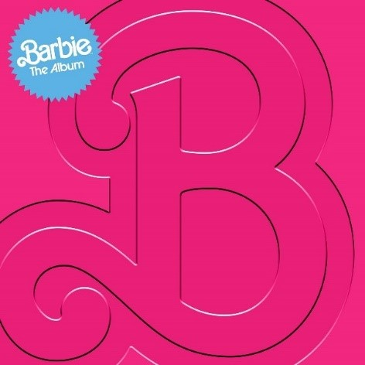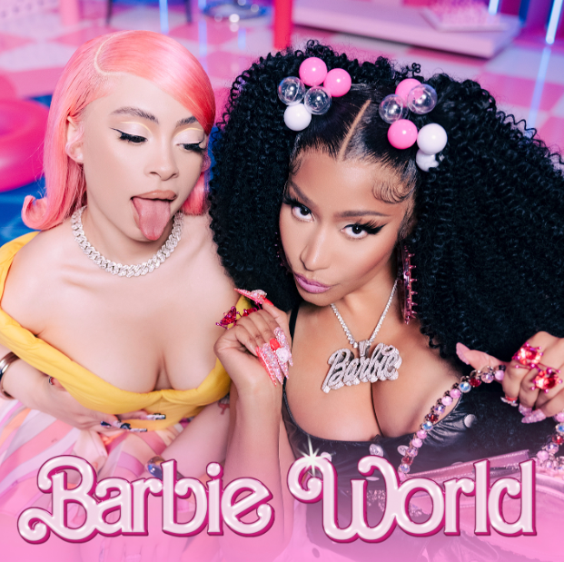
DOWNLOAD HI-RES IMAGES HERE

Following the groundbreaking and star-studded BARBIE THE ALBUM artist reveal and its first three singles, global megastars Nicki Minaj and Ice Spice have reunited to take over “Barbie World,” with their instantly iconic transformation of the legendary Aqua song “Barbie Girl,” out now. First teased last month at the end of the global Barbie trailer, which already hit over 33M views and reached #1 trending on YouTube, news of the superstar collaboration was further fueled by a viral joint Instagram post and additional teases that have quickly amassed over 1 BILLION impressions and counting. Produced by RIOTUSA, listen to “Barbie World (with Aqua)” HERE and watch the official video directed by Hannah Lux Davis HERE.

BARBIE THE ALBUM is the official musical companion to the highly anticipated summer event film Barbie, starring Margot Robbie and Ryan Gosling as Barbie and Ken and distributed by Warner Bros. Pictures. Available for pre-order HERE, the soundtrack arrives in stores and at all online retailers on Friday, July 21st in conjunction with the theatrical release of the feature film.

“Barbie World” was preceded by UK-based artist and producer PinkPantheress’ captivating track, “Angel,” global recording artist KAROL G’s high-energy anthem, “WATATI (ft. Aldo Ranks)” and the electrifying lead single “Dance The Night” from 3x GRAMMY® Award-winning global superstar Dua Lipa, who also makes a special appearance in the film. Upon release, “Angel” was praised by THE NEW YORK TIMES for its “dreamy melody” as ELLE dubbed it “an unexpected party anthem.” “WATATI” was also immediately met with critical acclaim with ROLLING STONE calling it a “reggaetón party” and HOLA! stating it’s an “exciting addition, poised to be a hit.” The high-energy anthem is complemented by its official visual directed by Mike Ho and starring KAROL herself as she enters the actual World of Barbie, shot on-site in LA – watch HERE. Produced by Mark Ronson, Andrew Wyatt and the Picard Brothers, “Dance The Night” arrived alongside a dazzling official video featuring a special appearance from Barbie writer/director/executive producer Greta Gerwig (“Little Women,” “Lady Bird”) – watch HERE. Upon release, V MAGAZINE called the track “disco-pop perfection,” NPR described it as “undeniably glamorous,” BILLBOARD asserted it has “one of the sleekest bridges in mainstream pop this year,” and INSTYLE declared it “our new summer anthem.” All singles released so far have already amassed an impressive 250M+ combined global audio streams and official video views.

BARBIE THE ALBUM will continue to feature massive new tracks from an unprecedented lineup of artists including Lizzo, Charli XCX, Ava Max, Dominic Fike, Khalid, The Kid LAROI, Tame Impala, HAIM, GAYLE and FIFTY FIFTY feat. Kali. Barbie star Ryan Gosling also joins the robust roster of soundtrack artists with his iconic original song performed as his character, Ken. See below for full tracklisting.

BARBIE THE ALBUM continues the hugely successful partnership between Atlantic Records and Warner Bros. Pictures. The two companies previously teamed up for 2020’s BIRDS OF PREY: THE ALBUM which spawned the RIAA Certified 2x Platinum smash “Boss B*tch” by Doja Cat, along with the 2016’s GRAMMY® Award-nominated SUICIDE SQUAD: THE ALBUM, which topped album charts in over 70 countries around the world, including two consecutive weeks on the Billboard 200, and featured the RIAA Certified Diamond hit “Heathens” by Twenty One Pilots.

BARBIE THE ALBUM was executive produced by internationally renowned DJ and Oscar, Golden Globe and 7x GRAMMY® award winning artist and producer, Mark Ronson and Barbie writer/director/executive producer Greta Gerwig. The soundtrack album was Produced and overseen by Atlantic Records’ West Coast President, Kevin Weaver (Soundtrack Album Producer of The Greatest Showman, Suicide Squad, Daisy Jones & The Six, Birds Of Prey, Furious 7, The Fault in Our Stars, The Fate of the Furious) and Atlantic Records’ EVP and Co-Head of Pop/Rock A&R, Brandon Davis. Named by Rolling Stone as a “soundtrack guru,” Weaver is a GRAMMY® Award winner and five-time nominee, who has produced numerous multi-platinum soundtrack projects that have amassed tens of millions of albums sold worldwide. Additional key players involved on the project include Soundtrack Album Co-Producers, Brandon Creed and Joseph Khoury, as well as the Barbie Music Supervisor and Album Executive Producer, George Drakoulias.

ABOUT BARBIE
To live in Barbie Land is to be a perfect being in a perfect place. Unless you have a full-on existential crisis. Or you’re a Ken. Warner Bros. Pictures Presents a Heyday Films Production, a LuckyChap Entertainment Production, an NB/GG Pictures Production, a Mattel Production, Barbie. The film will be distributed worldwide by Warner Bros. Pictures and released in theaters only nationwide on July 21, 2023 and internationally beginning July 19, 2023. Directed by Greta Gerwig, Barbie stars Margot Robbie, Ryan Gosling, America Ferrera, Kate McKinnon, Issa Rae, Rhea Perlman, and Will Ferrell. The film is written by Greta Gerwig & Noah Baumbach, based on “Barbie” by Mattel, and produced by David Heyman, Margot Robbie, Tom Ackerley and Robbie Brenner. The executive producers are Gerwig, Baumbach, Ynon Kreiz, Richard Dickson, Michael Sharp, Josey McNamara, Courtenay Valenti, Toby Emmerich and Cate Adams. The film’s music supervisor is George Drakoulias, with music by Mark Ronson and Andrew Wyatt.

BARBIE THE ALBUM TRACKLIST

- Lizzo – Pink
- Dua Lipa – Dance The Night
- Nicki Minaj & Ice Spice – Barbie World (with Aqua)
- Charli XCX – Speed Drive
- KAROL G – WATATI (feat. Aldo Ranks)
- TBA
- Tame Impala – Journey To The Real World
- Ryan Gosling – I’m Just Ken
- Dominic Fike – Hey Blondie
- HAIM – Home
- TBA
- The Kid LAROI – Forever & Again
- Khalid – Silver Platter
- PinkPantheress – Angel
- GAYLE – butterflies
- Ava Max – Choose Your Fighter
- FIFTY FIFTY – Barbie Dreams (feat. Kali)

CONNECT:
BARBIETHEALBUM.COM | INSTAGRAM | TIKTOK | TWITTER | FACEBOOK | PRESS SITE

BARBIE THE ALBUM PRESS CONTACT:
ANDREW GEORGE
ANDREW.GEORGE@ATLANTICRECORDS.COM

