FOR IMMEDIATE RELEASE
JUNE 2, 2023

corook shares serious person (part 1) EP

new project features viral anthem “if i were a fish” now surpassing 11M streams worldwide

performing SOLD-OUT headline shows at baby’s all right (june 3) and the echo (june 11)
plus nashville pride (june 25) and austin city limits (october 15)

stream serious person (part 1) here

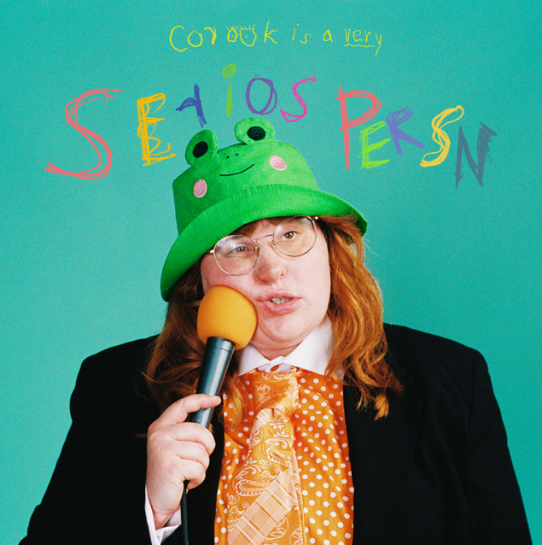
download hi-res artwork

“If specificity is the soul of narrative, then corook is one of the most naturally gifted storytellers in the game.”
– BILLBOARD

“Living outside of the box is also something corook does musically.”
– NPR

“it would be impossible not to fall in love with the quirky and talented singer”
– them

Nashville-based singer-songwriter and multi-instrumentalist corook has shared their eagerly awaited new EP, serious person (part 1).

“‘serious person part 1’ is the first of a two-part series of music,” shared corook. “This project is a collection of feelings and stories that have made me the weird, queer, funny, sensitive, serious person I am. I chose to call the album ‘serious person’ to comment on the humor I use in my songs. I have used humor to mask a lot of insecurities and hardships in my life and while humor will always be a part of my writing style and my life in general, I wanted to show all the other parts of myself too. It's sprinkled with upbeat pop tunes but at its core it is my story accompanied by whatever instrument I chose that day. Part 2 is coming soon.”

The first installment in a two-part project, serious person (part 1) includes the brand new song, “tiny little titties” as well as recently released title track, “serious person,” co-written with 2x Latin Grammy Award-winner Dan Fernandez and available now for streaming and download HERE.

serious person (part 1) also includes the viral smash, “if i were a fish (ft. olivia barton).” Co-written with their girlfriend Olivia as a response to internet hate whilst feeling emotional, insecure, and out of place, the heartwarming track came together in ten minutes and was then posted to TikTok where it received an incredible response, earning 18.1M views, 2.9M likes and 380.8K shares and counting. With over 24.8K creates, “if i were a fish” has also received support from fellow artists including Charlotte Lawrence, grandson and more. Following the outpouring of love and support on social media, corook and Olivia worked quickly to record a full version of the song plus release an official video featuring special behind-the-scenes moments from the making of the song – watch HERE. The track is their biggest streaming debut to date, currently sitting at No. 36 on Billboard’s Hot Rock & Alternative chart with over 10.8M+ global audio streams and counting. It first premiered on BBC Radio 1’s Future Pop and since then, corook has been profiled by NPR, Rolling Stone, The New York Times, Boston Globe and more.

corook – pronounced ‘co-rook’ – kicked off their latest, more vulnerable musical era with recent releases, “i’m not doing well” and “CGI,” the latter of which was included within Billboard’s “10 Cool New Pop Songs” and “Queer Jams of the Week” roundups. Earlier this year, they celebrated their 28th birthday with their first single of 2023, “the dog” and its heartbreaking music video (co-starring corook and their actual girlfriend) - Watch HERE. The poignant track was met by applause from PAPER, which raved, “Channeling Phoebe Bridgers, corook finds anguish and heartbreak in the small details of a breakup.”

Having spent much of their last year on the road, including tours with K.Flay, Jukebox the Ghost, and Maddie Zahm, as well as their debut festival performance at Bonnaroo (featured in Rolling Stone), corook will celebrate serious person (part 1) and much more with two SOLD-OUT headline shows set for Brooklyn, NY’s Baby’s All Right (June 3) and Los Angeles, CA’s The Echo (June 11), followed later that month with an eagerly awaited performance at Nashville PRIDE on Sunday, June 25. In addition, corook will perform at Weekend 2 of Austin, TX’s upcoming Austin City Limits Music Festival on October 15 and at Raleigh, NC’s Hopscotch Music Festival, set for September 7-9. For updates and additional information, please visit www.corook.com.

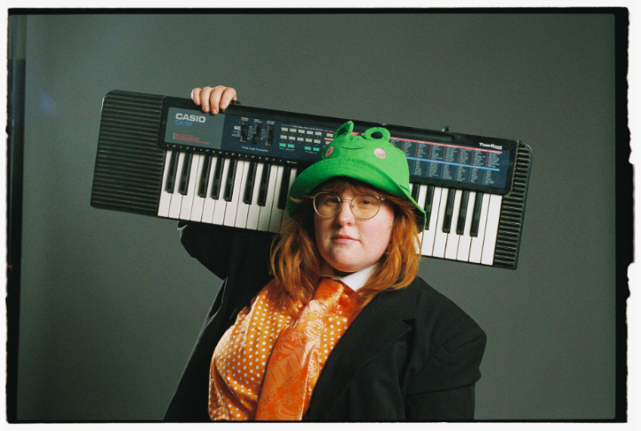
download press photos here // credit: libby danforth

about corook
Named as one of The Advocate’s “7 Queer Artists For Your Fall Playlist,” corook has become known for their ability to tackle deeply personal themes in their music and visuals through a humorous lens. Last spring, the genre-busting, Nashville-based musician blessed the world with their debut EP, achoo!, featuring such surprising and insightful tracks as “idk god,” “degree,” “bad friend,” and “sims” in addition to the fan favorite “snakes.” Further releases followed, among them the viral adult lullaby, “it’s ok!,” the unrestrained “BDSM,” the super-hot “hell yeah,” the heartfelt “your mom,” and the ode to self-worth, “smoothie.” corook also got vulnerable in front of the camera, reflecting on their mental health journey in an episode of Out Magazine’s “Love, Me” video series streaming now HERE.

corook – serious person (part 1) tracklist
1. serious person
2. tiny little titties
3. ok getting older
4. CGI
5. i’m not doing well
6. natalie
7. if i were a fish ft. Olivia Barton

connect with corook:
corook.com | instagram | tiktok | press assets

press contact:
andrew.george@atlanticrecords.com

