FOR IMMEDIATE RELEASE
JUNE 6, 2023

corook announces “serious person tour”

first-ever north american headline run includes stops at
nyc’s bowery ballroom on sept. 14 and the roxy in LA on oct. 7

dates kick off sept. 5 with tickets on sale friday, june 9 here

new serious person (part 1) EP out now

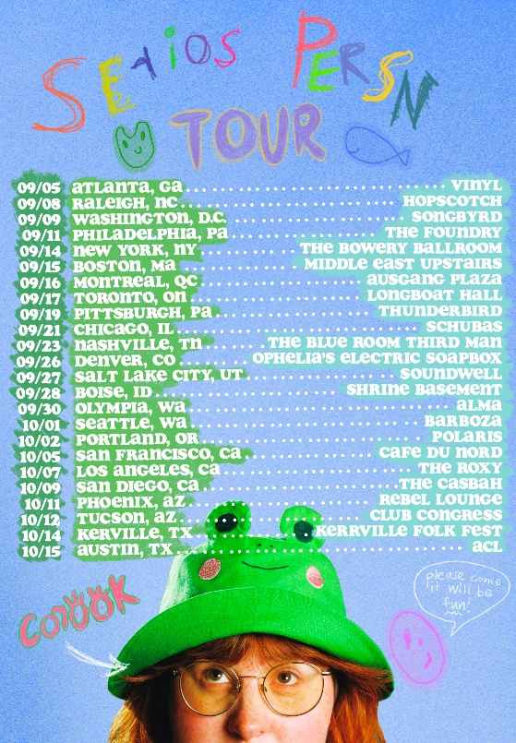
download hi-res press photos + tour art

Celebrating their recently released EP, serious person (part 1), Nashville-based singer-songwriter and multi-instrumentalist corook will embark on the serious person tour this fall. Officially marking their first-ever north american headline run, dates kick off September 5th at Vinyl in Atlanta, GA and travel through October 15th with stops at NYC’s Bowery Ballroom on September 14th and The Roxy in LA on October 7th. Full routing is copied below with tickets on sale this Friday, June 9th HERE.

The first installment in a two-part project, serious person (part 1) is highlighted by the brand new song, “tiny little titties,” acclaimed title track, “serious person,” and viral smash, “if i were a fish (ft. olivia barton).” Co-written with their girlfriend Olivia as a response to internet hate whilst feeling emotional, insecure, and out of place, “if i were a fish” came together in ten minutes before it was posted to TikTok where it received an incredible response, earning 18.2M views, 2.9M likes and 381.8K shares and counting. Following the outpouring of love and support on social media, corook and Olivia worked quickly to record a full version of the song and the official video – watch HERE. The track is their biggest streaming debut to date with over 11.8M+ global audio streams and counting. It first premiered on BBC Radio 1’s Future Pop and since then, corook has been profiled by NPR, Rolling Stone, The New York Times, Boston Globe and more.

corook – pronounced ‘co-rook’ – kicked off their latest, more vulnerable musical era with additional EP tracks, “i’m not doing well” and “CGI,” the latter of which was included within Billboard’s “10 Cool New Pop Songs” and “Queer Jams of the Week” roundups. Earlier this year, they celebrated their 28th birthday with their first single of 2023, “the dog” and its heartbreaking music video. The poignant track was met by applause from PAPER, which raved, “Channeling Phoebe Bridgers, corook finds anguish and heartbreak in the small details of a breakup.”

Having spent much of their last year on the road, including tours with K.Flay, Jukebox the Ghost, and Maddie Zahm, as well as their debut festival performance at Bonnaroo (featured in Rolling Stone), corook rang in the release of serious person (part 1) last weekend with a SOLD-OUT headline show at Baby’s All Right in Brooklyn. This Sunday, June 11, they’ll headline yet another SOLD-OUT show at The Echo in LA. Later this month, they’ll travel back home for a performance at Nashville PRIDE on Sunday, June 25 and shortly after, corook will travel overseas for their first-ever UK headline show at LONDON COLOURS on July 4. Also this fall, corook will perform at Raleigh, NC’s Hopscotch Music Festival on September 8 and Austin City Limits on October 15.For updates and additional information, please visit www.corook.com/tour.

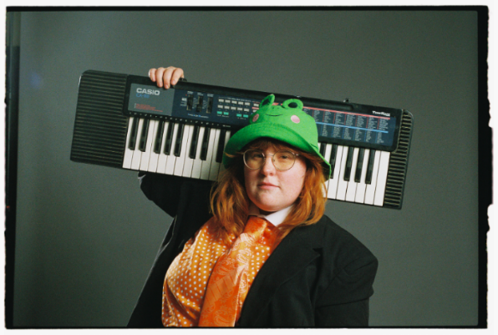
download hi-res artwork + press photos // credit: libby danforth

about corook
Named as one of The Advocate’s “7 Queer Artists For Your Fall Playlist,” corook has become known for their ability to tackle deeply personal themes in their music and visuals through a humorous lens. Last spring, the genre-busting, Nashville-based musician blessed the world with their debut EP, achoo!, featuring such surprising and insightful tracks as “idk god,” “degree,” “bad friend,” and “sims” in addition to the fan favorite “snakes.” Further releases followed, among them the viral adult lullaby, “it’s ok!,” the unrestrained “BDSM,” the super-hot “hell yeah,” the heartfelt “your mom,” and the ode to self-worth, “smoothie.” corook also got vulnerable in front of the camera, reflecting on their mental health journey in an episode of Out Magazine’s “Love, Me” video series streaming now HERE.

what critics are saying about corook:

“If specificity is the soul of narrative, then corook is one of the most naturally gifted storytellers in the game.
– BILLBOARD

“Living outside of the box is also something corook does musically.”
– NPR

“it would be impossible not to fall in love with the quirky and talented singer”
– THEM

“corook is just getting started”
– ALTPRESS

corook on tour

june
11 – Los Angeles, CA – The Echo
25 – Nashville, TN – Nashville PRIDE

july
4 – London, UK – LONDON COLOURS

september
5 – Atlanta, GA – Vinyl
8 – Raleigh, NC – Hopscotch
9 – Washington DC – Songbyrd
11 – Philadelphia, PA – The Foundry
14 – New York, NY – The Bowery Ballroom
15 – Boston, MA – Middle East Upstairs
16 – Montreal, QC – Ausgang Plaza
17 – Toronto, ON – Longboat Hall
19 – Pittsburgh PA – Thunderbird
21 – Chicago, IL – Schubas
23 – Nashville, TN – The Blue Room Third Man
26 – Denver, CO – Ophelia's Electric Soapbox
27 – Salt Lake City, UT – Soundwell
28 – Boise ID – Shrine Basement
30 – Olympia, WA – ALMA

october
1 – Seattle, WA – Barboza
2 – Portland, OR – Polaris
5 – San Francisco, CA – Cafe du Norde
7 – Los Angeles, CA – The Roxy
9 – San Diego, CA – The Casbah
11 – Phoenix, AZ – Rebel Lounge
12 – Tucson, AZ – Club Congress
14 – Kerville, TX – Kerrville Folk Fest
15 – Austin, TX – ACL

connect with corook:
corook.com | instagram | tiktok | press assets

press contact:
andrew.george@atlanticrecords.com

