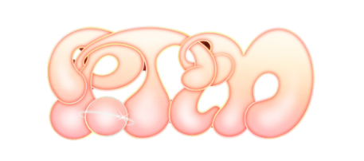

PORTUGAL. THE MAN RELEASE NEW ALBUM
CHRIS BLACK CHANGED MY LIFE

DOWNLOAD/STREAM HERE

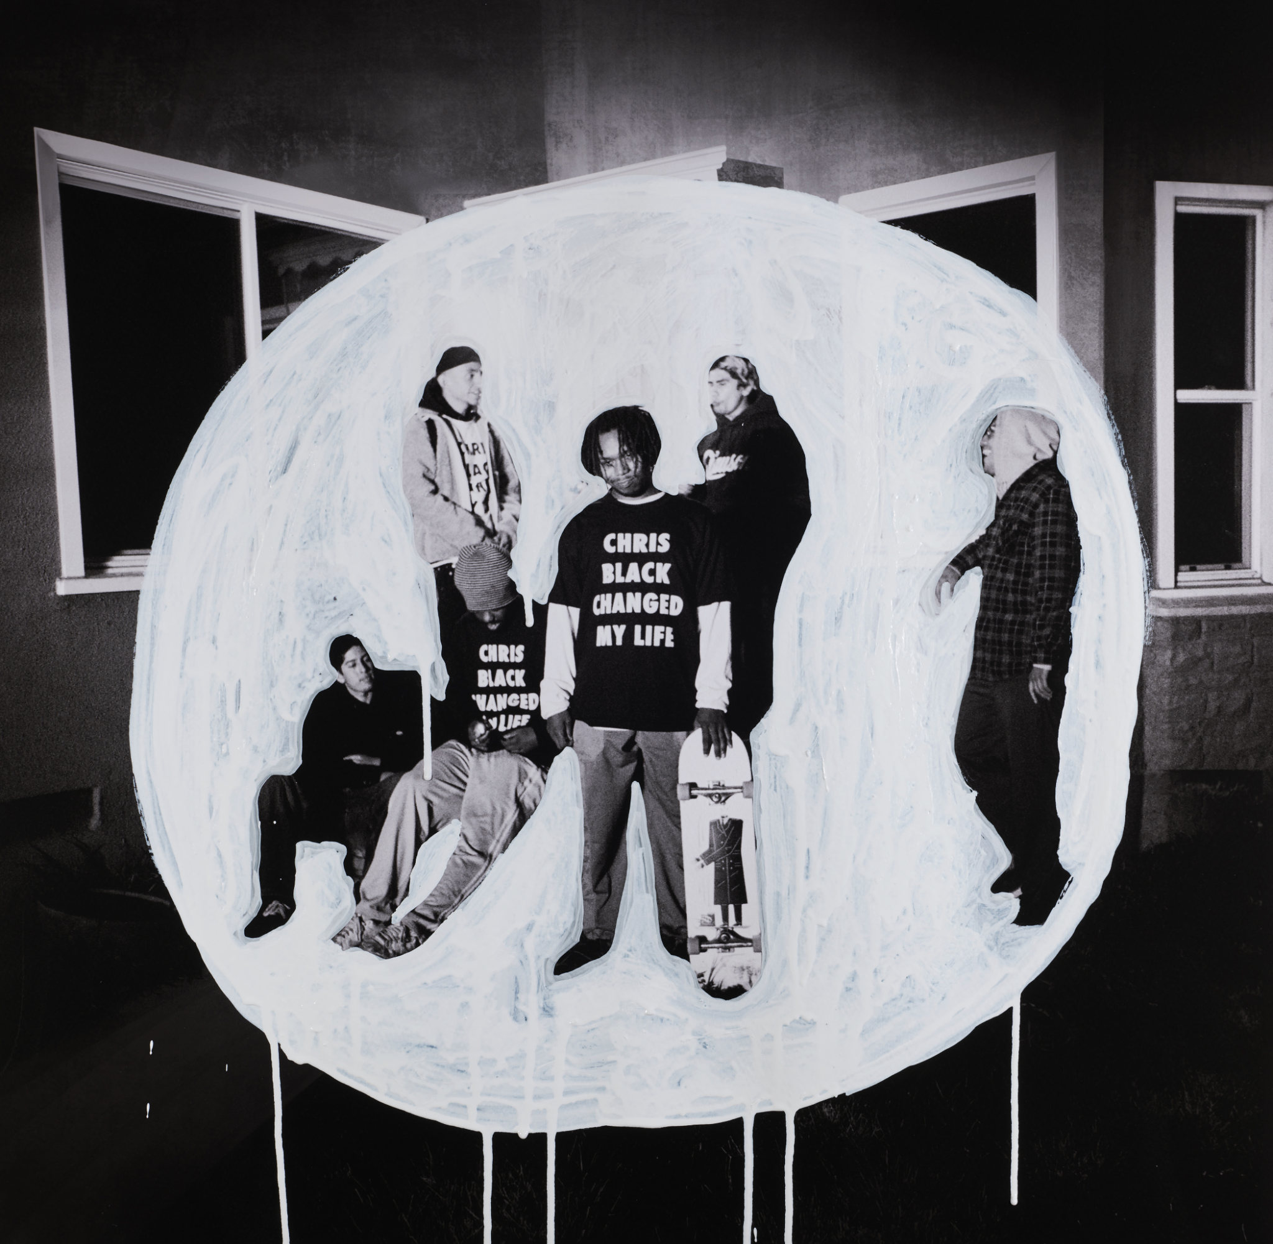
DOWNLOAD ALL PRESS ASSETS
“Chris Black was so big, and so full of life, his energy was a constant reminder of how lucky we are and how grateful we should be for the people we get to share this life with. I feel it's really important to honor these people, and that’s the point of this album – to honor these people that change our lives. And say it while they’re here. We love these people. Acknowledge them.”
– John Gourley, Portugal. The Man

INFECTIOUS LEAD SINGLE “DUMMY” BECOMES BAND’S FOURTH
TOP 5 SINGLE AT ALT RADIO

LISTEN TO “DUMMY” | WATCH OFFICIAL MUSIC VIDEO

READ BILLBOARD COVER STORY HERE

LEARN MORE ABOUT THE FRANCES CHANGED MY LIFE + CHRIS BLACK CHANGED MY LIFE CAMPAIGNS HERE

BAND’S NYC ALBUM PREVIEW CONCERT VIEWED BY 384K FANS ON TWITCH – THE PLATFORM’S BIGGEST MUSIC LIVESTREAM OF THE YEAR

‘PORTLAND. THE MAN’ TAKEOVER SCHEDULED FOR THIS SATURDAY 6/24

New York, NY – (June 23, 2023) Multi-platinum, GRAMMY ® Award-winning rock band Portugal. The Man release their long-awaited new album, CHRIS BLACK CHANGED MY LIFE, out everywhere today – download/stream HERE.

The album is produced by the legendary Jeff Bhasker (Beyonce, Harry Styles, SZA, Mark Ronson).

In addition to today’s album release, Portugal. The Man is encouraging fans to learn about the Frances Changed My Life and Chris Black Changed My Life campaigns – read more HERE. Both initiatives empower others to celebrate those who have impacted their lives, while also taking a moment to reflect and pay it forward.

Portugal. The Man made their triumphant return in early March with the infectious lead single, “Dummy,” which has become the band’s fourth Top 5 single at Alternative Radio, after spending 15 weeks on the format thus far, and was immediately praised by Billboard as an “an apocalyptic jingle” upon release. “Dummy” arrived with an official music video directed by Noel Paul and starred the band’s new, honorary member, Tank Dog. Created by Wes Hubbard (Wooden Cyclops) and John Gourley, Tank Dog is PTM’s newest sidekick – Watch HERE.

Yesterday, Billboard revealed their cover story on the band – ‘Everyone Knows ‘Feel It Still’ – But No One Could’ve Predicted What Would Happen Next To Portugal. The Man’ – featuring exclusive photos of John Gourley, taken by Indigenous photographer Brian Adams (read the full story HERE).

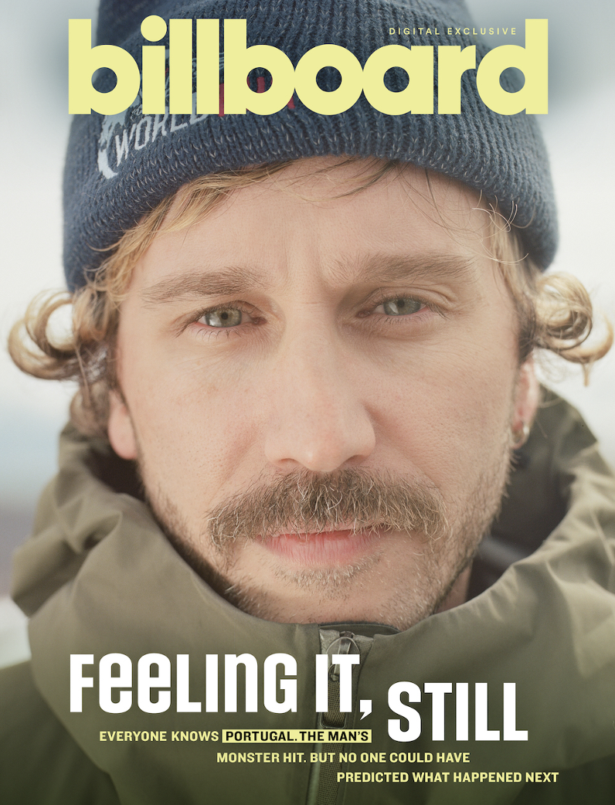
DOWNLOAD HI-RES IMAGES HERE

This Saturday, June 24, the band will take over their adopted hometown of Portland, Oregon with a music video special event at Movie Madness, in-store signing at Music Millennium, and merch pop-up at Portland Mercado. The weekend will culminate with Portland Pickles x PTM Day on Sunday, June 25.

Following the release of “Dummy,” the band shared “Plastic Island,” “Summer of Luv” featuring Unknown Mortal Orchestra, “Thunderdome [W.T.A]” featuring Black Thought and Natalia Lafourcade, and “Champ,” which incorporated a re-imagining of GRAMMY ® Award-winning musician Edgar Winter’s 1971 hit, “Dying to Live.”

CHRIS BLACK CHANGED MY LIFE is the band’s first full-length since the release of their Platinum-certified, 2017 record, WOODSTOCK. Opening song, “Heavy Games II (feat. Jeff Bhasker),” teased the forthcoming album with a companion visual featuring and produced by Jeff Bhasker – Watch HERE. The album’s title is dedicated to the band’s late friend and honorary band member, Chris Black.

The band teamed up with collaborators Paul Williams (John Lennon, David Bowie, Mac Miller), Jeff Bhasker (Beyonce, Harry Styles, SZA, Mark Ronson), Asa Taccone, Black Thought, Unknown Mortal Orchestra, Nick Reinhart, Homer Steinweiss and Natalia Lafourcade on the highly anticipated album.

The Portland-based rockers will follow the release of CHRIS BLACK CHANGED MY LIFE with a limited run of headline shows for 2023. Featuring a career spanning set, each show will take place at an iconic venue this summer, including Portland’s Edgefield, Colorado’s Red Rocks Amphitheatre, New York City’s Radio City Music Hall, Los Angeles’ Hollywood Bowl, and a newly-announced run of Canadian dates, traversing the country from Vancouver to Toronto, and stopping at many cities in between.

CHRIS BLACK CHANGED MY LIFE TRACKLIST:
Heavy Games II (feat. Jeff Bhasker)
Grim Generation
Thunderdome [W.T.A] (feat. Black Thought & Natalia Lafourcade)
Dummy
Summer of Luv (feat. Unknown Mortal Orchestra)
Ghost Town
Time’s a Fantasy (feat. Jeff Bhasker)
Doubt
Plastic Island
Champ (feat. Edgar Winter)
Anxiety:Clarity (feat. Paul Williams)

UPCOMING LIVE SHOWS
7/1 – Cowichan, BC @ Laketown Shakedown
7/7 – Sherbrooke, Quebec @ Sherblues & Folk
7/21 - Portland, OR @ Edgefield
7/23 - Morrison, CO @ Red Rocks Amphitheatre
7/27 - New York, NY @ Radio City Music Hall
7/28 – Washington, DC @ The Atlantis
7/29 – Philadelphia, PA @ The Fillmore
8/3 – Chicago, IL @ Lollapalooza
8/4 – Chicago, IL – Official Lollapalooza Aftershow @ Metro
8/6 - Los Angeles, CA @ Hollywood Bowl
8/27 – Columbus, OH @ Wonderbus
10/6 – Austin, TX @ Austin City Limits
10/13 – Austin, TX @ Austin City Limits
11/6 – Vancouver, BC – Orpheum
11/8 – Calgary, AB – Grey Eagle
11/9 – Edmonton, AB – Edmonton Convention Centre
11/11 – Winnipeg, MB – Burton Cummings Theatre
11/14 – London, ON – London Music Hall
11/15 – Toronto, ON – HISTORY
11/16 – Toronto, ON – HISTORY
11/18 – Ottawa, ON – Ey Centre
11/19 – Montreal, QC – MTELUS

DOWNLOAD ALL PRESS ASSETS

PRESS CONTACTS:
Jason Davis | Jason.Davis@atlanticrecords.com
Libby Kober | Libby.Kober@atlanticrecords.com

ABOUT PORTUGAL. THE MAN:
Over the past decade, Portugal. The Man has established themselves as one of rock’s most prized possessions and a live phenomenon, with over 1,600 shows under their belts and a storied reputation as festival favorites.

Originally heralding from Alaska, the Portland-based band soared to new heights in 2017 with the release of their now RIAA certified-Platinum album, Woodstock. The album was marked by the astounding success of their infectious single, “Feel It Still,” which earned the group a plethora of new accolades – including a GRAMMY for “Best Pop Duo/Group Performance,” a 7x RIAA Platinum certification, a record setting 20-week residency at #1 on alternative radio, and an inescapable presence on the Top 40 airwaves.

Alongside the shine of their myriad of musical accomplishments lies the group’s long-standing passion for social justice. In fact, this is precisely the intersection in which Portugal. The Man thrives; throughout their career, the band has consistently exemplified how to deeply commit to both artistry and activism. This ultimately inspired them to officially launch PTM Foundation in 2020, focused on universal issues related to human rights, community health, and the environment, with an emphasis on causes directly impacting Indigenous Peoples, including Alaska Native Health (providing the highest quality of health services for Alaska Native people) and Seeding Sovereignty (radicalizing and disrupting colonized spaces through land, body, food sovereignty work and more).

Portugal. The Man have also partnered with an array of organizations such as National Coalition Against Censorship, The Skatepark Project (helping communities build public skate parks for youth in underserved communities), March for Our Lives (Gun Reform), Keep Oregon Well (Mental Health), and Protect Our Winters (Climate Change), to name just a few. In 2022, the band furthered their passion for activism when they launched PTM’s NIGHT OUT initiative – supporting disabled fans requiring ADA access.

ABOUT CHRIS BLACK CHANGED MY LIFE:
We lost a very dear friend of ours on May 19, 2019. It shook us to our core. Chris was one of those people who was like glue; he brought everyone together. His passing really messed with us. The band was in shambles and this record is the first time I feel I made a complete record; a complete thought about our world crumbling around us and the journey back. While it is a very personal journey, I feel like everyone has a Chris Black in their life; at least I hope that everyone has a Chris Black in their life. That one friend who has a way of making everything right and making everything fun. The one who keeps you in check when you go off course and is always there to celebrate the good times and to support you in the bad times. Chris Black Changed My Life.

# # #

