

**PORTUGAL. THE MAN ENLIST BLACK THOUGHT & NATALIA LAFOURCADE FOR NEW SONG “THUNDERDOME [W.T.A]”**

[**DOWNLOAD/STREAM “THUNDERDOME [W.T.A]”**](https://ptm.lnk.to/Thunderdome)

**FROM UPCOMING NEW ALBUM *CHRIS BLACK CHANGED MY LIFE* OUT EVERYWHERE JUNE 23**

[DOWNLOAD ALL PRESS ASSETS](https://warnermusicgroup.box.com/s/qayl8oamne44ngtciy1eeygbf5s9ryhf)

**RECENTLY RELEASED SINGLE “DUMMY” SPENDS ITS 9TH CONSECUTIVE WEEK IN THE TOP 10 AT ALTERNATIVE RADIO**

[**LISTEN TO “DUMMY”**](https://nam04.safelinks.protection.outlook.com/?url=https%3A%2F%2Fptm.lnk.to%2FDummy&data=05%7C01%7CKaty.Carmichael%40atlanticrecords.com%7C63e90f49085b4ab4c2c308db1a77cd1a%7C8367939002ec4ba1ad3d69da3fdd637e%7C0%7C0%7C638132874133693621%7CUnknown%7CTWFpbGZsb3d8eyJWIjoiMC4wLjAwMDAiLCJQIjoiV2luMzIiLCJBTiI6Ik1haWwiLCJXVCI6Mn0%3D%7C3000%7C%7C%7C&sdata=OBkumGFMOaHwIjDKwN4DxfUNvfSUYC2t1iPijFRWqGI%3D&reserved=0) **|** [**WATCH OFFICIAL MUSIC VIDEO**](https://nam04.safelinks.protection.outlook.com/?url=https%3A%2F%2Fptm.lnk.to%2FDummyVideoPR&data=05%7C01%7CKaty.Carmichael%40atlanticrecords.com%7C63e90f49085b4ab4c2c308db1a77cd1a%7C8367939002ec4ba1ad3d69da3fdd637e%7C0%7C0%7C638132874133693621%7CUnknown%7CTWFpbGZsb3d8eyJWIjoiMC4wLjAwMDAiLCJQIjoiV2luMzIiLCJBTiI6Ik1haWwiLCJXVCI6Mn0%3D%7C3000%7C%7C%7C&sdata=JpQUy1dm5oDqzskSjq9DeC6j6UY4FwiYwffcrUvxtVo%3D&reserved=0)

**New York, NY – (May 12, 2023)** Multi-platinum, GRAMMY ® Award-winning rock band **Portugal. The Man**release new song, **“Thunderdome [W.T.A]”** featuring **Black Thought** & **Natalia Lafourcade.**

**“Thunderdome [W.T.A]”** is the third song released from the band’s long-awaited new album, ***CHRIS BLACK CHANGED MY LIFE,*** produced by **Jeff Bhasker** (Beyonce, Harry Styles, SZA, Mark Ronson), due out **June 23**. The album is now available for pre-order [**HERE**](https://nam04.safelinks.protection.outlook.com/?url=https%3A%2F%2Fptm.lnk.to%2FChrisBlackChangedMyLife&data=05%7C01%7CTaylor.Apel%40atlanticrecords.com%7C7b88d7fd6f004993254b08db3c977db2%7C8367939002ec4ba1ad3d69da3fdd637e%7C0%7C0%7C638170393581667602%7CUnknown%7CTWFpbGZsb3d8eyJWIjoiMC4wLjAwMDAiLCJQIjoiV2luMzIiLCJBTiI6Ik1haWwiLCJXVCI6Mn0%3D%7C3000%7C%7C%7C&sdata=58qKtJEtTsDOEZrWNAGLOKNcumeASAg5XOn5xLDdm4A%3D&reserved=0).

*“While I was waiting to see if / when my jaw was ever going to heal, it felt like there was either way too much time to reflect, while there was not nearly enough time to do the things I wanted to do with my music, so I began to really sink into other people’s stories and their favorite playlists. Something that really had a huge impact was a playlist that Josue Foto made me, and a song that absolutely shined that I kept coming back to was Hasta la Raiz by Natalia Lafourcade. A haunting melody sung by a voice with so much power and expressiveness. Of course, Natalia is huge, but to me it was brand new. I listened to it non-stop.*

*Flash forward a bit, and we’re down at sonic ranch with Jeff Bhasker, making the rounds, and hanging with Adanowsky. And he’s introducing us to everybody. So many people coming in and out of the room, as we’re working in studio A, and then he introduces me to Natalia. As the night goes on, we start pulling up tracks; who’s working on what, who’s collaborating with who, and then I hear Hasta la Raiz, and I put it together. Oh my god, you’re Natalia Lafourcade! This song changed my life!*

*We asked, we begged to get Natalia on a track, and when it all came together, it was magic. She has a once in a generation voice, and every time i hear it, it still reminds me of how important it is to listen to your friends favorite music, and to surround yourself with people who have great taste, especially if they’re sharing stuff you’ve never heard. It just might change your life.”*

The band made their triumphant return in early March with the infectious first single,**“**[**Dummy**](https://nam04.safelinks.protection.outlook.com/?url=https%3A%2F%2Fptm.lnk.to%2FDummy&data=05%7C01%7CTaylor.Apel%40atlanticrecords.com%7C7b88d7fd6f004993254b08db3c977db2%7C8367939002ec4ba1ad3d69da3fdd637e%7C0%7C0%7C638170393581667602%7CUnknown%7CTWFpbGZsb3d8eyJWIjoiMC4wLjAwMDAiLCJQIjoiV2luMzIiLCJBTiI6Ik1haWwiLCJXVCI6Mn0%3D%7C3000%7C%7C%7C&sdata=x5vG5FmDf1QArLeQr8KiasyUSPE3iLx0FEG6HuQ%2B9Qo%3D&reserved=0)**,”** which has spent 9 weeks in the top 10 at Alternative Radio and was praised by **Billboard** as an “*an apocalyptic jingle.”***“Dummy”**arrived with an official music video directed by**Noel Paul**and starred the band’s new, honorary member, [**Tank Dog**](https://nam04.safelinks.protection.outlook.com/?url=https%3A%2F%2Fwww.dropbox.com%2Fscl%2Ffo%2Ftdrnwxzik49cowi436qvd%2Fh%3Fdl%3D0%26rlkey%3Ddsdn80v1j48z7o07szff9hpyx&data=05%7C01%7CTaylor.Apel%40atlanticrecords.com%7C7b88d7fd6f004993254b08db3c977db2%7C8367939002ec4ba1ad3d69da3fdd637e%7C0%7C0%7C638170393581667602%7CUnknown%7CTWFpbGZsb3d8eyJWIjoiMC4wLjAwMDAiLCJQIjoiV2luMzIiLCJBTiI6Ik1haWwiLCJXVCI6Mn0%3D%7C3000%7C%7C%7C&sdata=r441g%2FAgXk%2BS0Wv9ufPiKkEvxooKx37uNXJPwQNHxHg%3D&reserved=0)**.**Created by **Wes Hubbard** ([Wooden Cyclops](https://nam04.safelinks.protection.outlook.com/?url=https%3A%2F%2Fwww.instagram.com%2Fwoodencyclops%2F%3Fhl%3Den%26__coig_restricted%3D1&data=05%7C01%7CTaylor.Apel%40atlanticrecords.com%7C7b88d7fd6f004993254b08db3c977db2%7C8367939002ec4ba1ad3d69da3fdd637e%7C0%7C0%7C638170393581667602%7CUnknown%7CTWFpbGZsb3d8eyJWIjoiMC4wLjAwMDAiLCJQIjoiV2luMzIiLCJBTiI6Ik1haWwiLCJXVCI6Mn0%3D%7C3000%7C%7C%7C&sdata=wZHddk0xHLstSYFDk2%2BH15GLxUuDKNKTFARAAwnvj8s%3D&reserved=0)) and **John Gourley**, Tank Dog is PTM’s newest sidekick – Watch [HERE](https://nam04.safelinks.protection.outlook.com/?url=https%3A%2F%2Fwww.youtube.com%2Fwatch%3Fv%3D8xT0vWporWs&data=05%7C01%7CTaylor.Apel%40atlanticrecords.com%7C7b88d7fd6f004993254b08db3c977db2%7C8367939002ec4ba1ad3d69da3fdd637e%7C0%7C0%7C638170393581667602%7CUnknown%7CTWFpbGZsb3d8eyJWIjoiMC4wLjAwMDAiLCJQIjoiV2luMzIiLCJBTiI6Ik1haWwiLCJXVCI6Mn0%3D%7C3000%7C%7C%7C&sdata=yncHoazz9h2fiivyaXB%2Fb5A9QfpEIB0lSTij9enqGxo%3D&reserved=0).

Following the release of **“Dummy,”** the band shared **“Champ,”** the **Jeff Bhasker** produced song which incorporated a re-imagining of legendary GRAMMY ® Award-winning musician **Edgar Winter**’s 1971 hit, **“Dying to Live,”** – Listen [HERE](https://ptm.lnk.to/Champ).

***CHRIS BLACK CHANGED MY LIFE*** is the band’s first full length album since the release of their Platinum-certified, 2017 album, ***WOODSTOCK.*** The album’s opening song, **“Heavy Games II (feat. Jeff Bhasker),”** teased the forthcoming album with a companion visual featuring and produced by Jeff Bhasker – Watch [HERE.](https://nam04.safelinks.protection.outlook.com/?url=https%3A%2F%2Fwww.youtube.com%2Fwatch%3Fv%3D27k0KxyvRD4&data=05%7C01%7CTaylor.Apel%40atlanticrecords.com%7C7b88d7fd6f004993254b08db3c977db2%7C8367939002ec4ba1ad3d69da3fdd637e%7C0%7C0%7C638170393581667602%7CUnknown%7CTWFpbGZsb3d8eyJWIjoiMC4wLjAwMDAiLCJQIjoiV2luMzIiLCJBTiI6Ik1haWwiLCJXVCI6Mn0%3D%7C3000%7C%7C%7C&sdata=1w6sjsm94yF90W%2B1zhuFbj%2FhpObJJmOBuphpKFA1Dzw%3D&reserved=0) The album is dedicated to the band’s late friend and honorary band member, Chris Black.

The band teamed up with collaborators **Paul Williams**(John Lennon, David Bowie, Mac Miller), **Sean Leon**, **Asa Taccone,** **Black Thought**, **Unknown Mortal Orchestra, Jeff Bhasker**(Beyonce, Harry Styles, SZA, Mark Ronson)and**Natalia Lafourcade** on the highly anticipated album.

The Portland-based rockers will follow the release of ***CHRIS BLACK CHANGED MY LIFE*** with very few headline shows for 2023. Featuring a career spanning set, each show will take place at an iconic venue this summer, including Portland’s **Edgefield,**Colorado’s **Red Rocks Amphitheatre,**New York City’s**Radio City Music Hall**andLos Angeles’**Hollywood Bowl.**

***CHRIS BLACK CHANGED MY LIFE* TRACKLIST:**

Heavy Games II (feat. Jeff Bhasker)

Grim Generation

Thunderdome [W.T.A] (feat. Black Thought & Natalia Lafourcade)

Dummy

Summer of Luv (feat. Unknown Mortal Orchestra)

Ghost Town

Time’s a Fantasy (feat. Sean Leon)

Doubt

Plastic Island

Champ (feat. Edgar Winter)

Anxiety:Clarity (feat. Paul Williams)

**UPCOMING LIVE SHOWS**

6/16 – Manchester, TN @ Bonnaroo

6/17 – Montauk, NY @ Whalebone Magazine’s The Surf Thing

7/1 – Cowichan, BC @ Laketown Shakedown

7/7 – Sherbrooke, Quebec @ Sherblues & Folk

7/21 - Portland, OR @ Edgefield

7/23 - Morrison, CO @ Red Rocks Amphitheatre

7/27 - New York, NY @ Radio City Music Hall

7/28 – Washington, DC @ The Atlantis

8/3 – Chicago, IL @ Lollapalooza

8/6 - Los Angeles, CA @ Hollywood Bowl

 8/25 – Columbus, OH @ Wonderbus

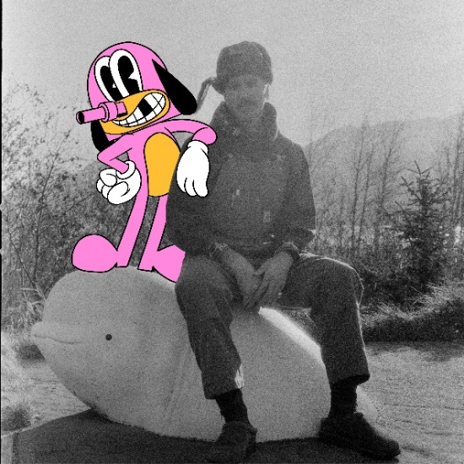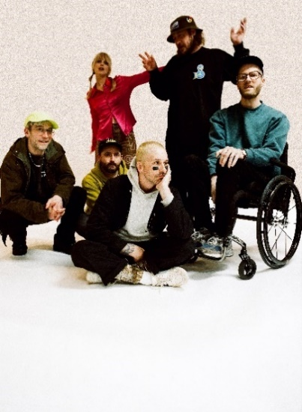

[DOWNLOAD ALL PRESS ASSETS](https://warnermusicgroup.box.com/s/qayl8oamne44ngtciy1eeygbf5s9ryhf)

**PRESS CONTACTS:**

Jason Davis | [Jason.Davis@atlanticrecords.com](mailto:Jason.Davis@atlanticrecords.com)

Libby Kober | [Libby.Kober@atlanticrecords.com](mailto:Libby.Kober@atlanticrecords.com)

**ABOUT PORTUGAL. THE MAN:**

Over the past decade, Portugal. The Man has established themselves as one of rock’s most prized possessions and a live phenomenon, with over 1,600 shows under their belts and a storied reputation as festival favorites.

Originally heralding from Alaska, the Portland-based band soared to new heights in 2017 with the release of their now RIAA certified-Platinum album, Woodstock. The album was marked by the astounding success of their infectious single, “Feel It Still,” which earned the group a plethora of new accolades – including a GRAMMY for “Best Pop Duo/Group Performance,” a 7x RIAA Platinum certification, a record setting 20-week residency at #1 on alternative radio, and an inescapable presence on the Top 40 airwaves.

Alongside the shine of their myriad of musical accomplishments lies the group’s long-standing passion for social justice. In fact, this is precisely the intersection in which Portugal. The Man thrives; throughout their career, the band has consistently exemplified how to deeply commit to both artistry and activism. This ultimately inspired them to officially launch PTM Foundation in 2020, focused on universal issues related to human rights, community health, and the environment, with an emphasis on causes directly impacting Indigenous Peoples, including Alaska Native Health (providing the highest quality of health services for Alaska Native people) and Seeding Sovereignty (radicalizing and disrupting colonized spaces through land, body, food sovereignty work and more).

Portugal. The Man have also partnered with an array of organizations such as National Coalition Against Censorship, The Skatepark Project (helping communities build public skate parks for youth in underserved communities), March for Our Lives (Gun Reform), Keep Oregon Well (Mental Health), and Protect Our Winters (Climate Change), to name just a few. In 2022, the band furthered their passion for activism when they launched PTM’s NIGHT OUT initiative – supporting disabled fans requiring ADA access.

**ABOUT *CHRIS BLACK CHANGED MY LIFE*:**

We lost a very dear friend of ours on May 19, 2019.  It shook us to our core.  Chris was one of those people who was like glue; he brought everyone together. His passing really messed with us. The band was in shambles and this record is the first time I feel I made a complete record; a complete thought about our world crumbling around us and the journey back. While it is a very personal journey, I feel like everyone has a Chris Black in their life; at least I hope that everyone has a Chris Black in their life. That one friend who has a way of making everything right and making everything fun. The one who keeps you in check when you go off course and is always there to celebrate the good times and to support you in the bad times. Chris Black Changed My Life.

# # #