FOR IMMEDIATE RELEASE

JUNE 9, 2023

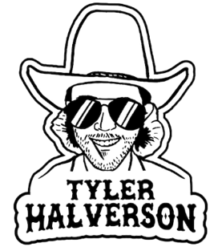

**TYLER HALVERSON NEEDS TO “CUT YOU LOOSE”**

**ACCLAIMED SOUTH DAKOTA TROUBADOUR SHARES LOVELORN NEW SINGLE**

**UPCOMING LIVE SCHEDULE INCLUDES HEADLINE DATES, FESTIVAL APPEARANCES,**

**AND ARENA SHOWS SUPPORTING COUNTRY STAR PARKER MCCOLLUM**

[**LISTEN TO “CUT YOU LOOSE” HERE**](https://tylerhalverson.lnk.to/CutYouLoose) **|** [**WATCH OFFICIAL VIDEO HERE**](https://tylerhalverson.lnk.to/CutYouLooseVideoPR)

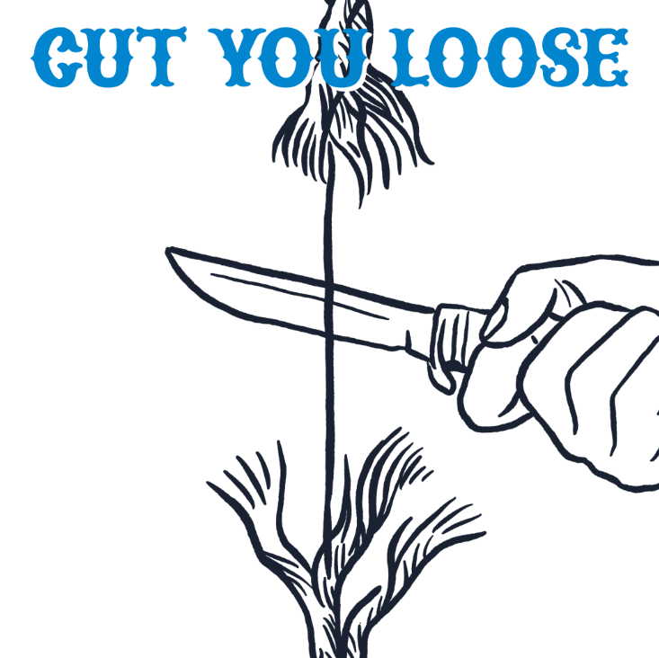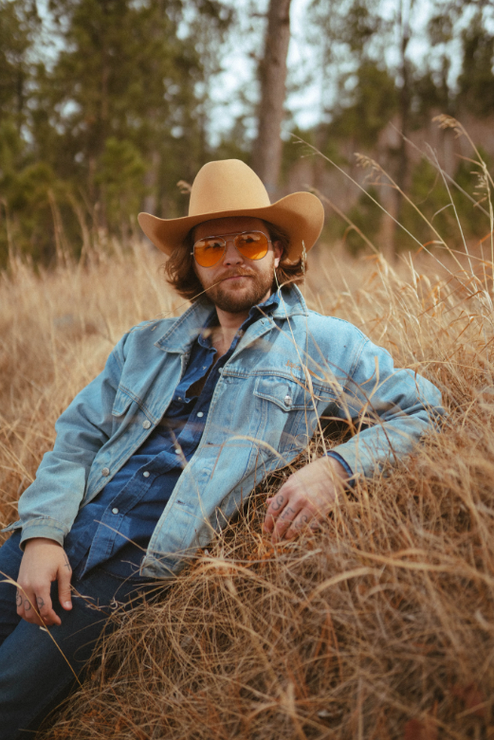

[DOWNLOAD ARTWORK + PRESS PHOTO HERE](https://warnermusicgroup.box.com/s/ors8rzbotm8dk721fy4vwixnowphybho)

South Dakota troubadour **Tyler Halverson** has shared his emotionally charged new single, “[**Cut You Loose**](https://tylerhalverson.lnk.to/CutYouLoose),” available now via Atlantic Records at all DSPs and streaming services. Fueled by swooning fiddle and Halverson’s lovelorn vocals, the heartwrenching track is joined by a companion music video premiering today at YouTube [HERE](https://tylerhalverson.lnk.to/CutYouLooseVideoPR).

*“‘Cut You Loose’ is about holding on to something a little too long,”* says Tyler Halverson. *“And wanting someone that can’t make up their mind about wanting you. You’re stuck in the gloaming, but you can’t cut it loose.”*

“Cut You Loose” follows Tyler Halverson’s recently released Atlantic Records debut single, “[Her](https://tylerhalverson.lnk.to/her),” which released alongside an official music video – Watch [HERE](https://www.youtube.com/watch?v=iINId4UC6RY). More new music will arrive this summer.

Halverson will celebrate “Cut You Loose” and much more with a busy live schedule that includes headline dates, festival appearances, and arena shows supporting Parker McCollum. Halverson is represented by legendary Nashville manager Erv Woolsey (George Strait, LeeAnn Womack) and Allen Mitchell of The Erv Woolsey Mgmt Company. For complete details and updates, please visit [tylerhalverson.com](https://tylerhalverson.com/shows).

Born and raised in the tiny town of Canton, SD (pop. 3054), Tyler Halverson isn’t just any cowboy. He’s got the hat and the boots, but he also plays a mean guitar and writes an even meaner tune. He has no problem bouncing around the country chasing adventure *(or a girl)*, and is telling his different kind of cowboy tale with his self-described “Amerijuana Music,” bridging honest storytelling with songcraft inspired by country powerhouses Garth Brooks, George Strait, and Hayes Carll as much as Boyz II Men, Taking Back Sunday, and The Used.

Halverson fell in thrall to music at an early age, receiving his first guitar while in middle school. A local bluegrass festival convinced him to focus on music, throwing down at 4H and FFA festivals before heading to Nashville to attend the prestigious Belmont University. Upon graduation, he decided to hit the road and spent an extended run traveling around South Dakota, Montana, and Wyoming, all the while writing and playing his songs on social media. Halverson’s original approach caught fire with a string of independent releases including “Beer Garden Baby,” “Mac Miller,” and “Your Bar Now” (with Kylie Frey), amassing tens of millions of streams. Now, with his Atlantic Records debut single and more to come, Tyler Halverson is eager to take the next step on what has already proven an amazing journey.

“*I’m finding myself,*” says Halverson. “*I feel like I’m an artist and I’m finally about to do something.”*

# # #

**TYLER HALVERSON**

**ON TOUR 2023**

**JUNE**

9 – Crosby, TX – Crosby Fair & Rodeo

10 – Brenham, TX – Welcome Texas General Store

14 – Nashville, TN – The Basement

16 – Amarillo, TX – Golden Light Cantina

24 – Farwell, TX – Alpo’s Barn

**JULY**

2 – Greeley, CO – Independence Stampede

8 – Wichita, KS – Intrust Bank Arena *

15 – Johnson City, TX – Stone Valley Live

21 – Concan, TX – House Pasture Cattle Co.

27 – San Angelo, TX – Wild West Fest (5:00 pm)

28 – San Angelo, TX – Wild West Fest (8:30 pm)

**AUGUST**

12 – Laramie, WY – Tom Horn Days

**SEPTEMBER**

3 – Colville, WA – FarmJam Festival

8 – Tuscaloosa, AL – Tuscaloosa Amphitheater *

9 – Beaumont, TX – Ford Arena *

*\* w/ Parker McCollum*

# # #

**CONNECT WITH TYLER HALVERSON**

[**OFFICIAL**](https://tylerhalverson.com/) **|** [**FACEBOOK**](https://www.facebook.com/TylerHalverwho/)**|** [**INSTAGRAM**](https://www.instagram.com/tylerhalverwho/?hl=en) **|** [**TIKTOK**](https://www.tiktok.com/@tylerhalverwho?lang=en) **|** [**TWITTER**](https://twitter.com/tylerhalverwho?ref_src=twsrc%5Egoogle%7Ctwcamp%5Eserp%7Ctwgr%5Eauthor) **|** [**YOUTUBE**](https://www.youtube.com/channel/UCMLvFEQq86Dv3Tfb0EOaQKg?app=desktop)

**PRESS CONTACT**

Jessica Nall // [Jessica.Nall@atlanticrecords.com](mailto:Jessica.Nall@atlanticrecords.com)