BRISTON MARONEY SHARES 2-SIDED SINGLE “DETONATOR” / “THE IDEA”
BUY/STREAM HERE

WATCH ACOUSTIC PERFORMANCE OF “DETONATOR” HERE

NEW ALBUM ULTRAPURE – PRODUCED BY DANIEL TASHIAN
DUE OUT SEPTEMBER 22 VIA CANVASBACK MUSIC/ATLANTIC RECORDS
PRE-ORDER HERE

LEAD SINGLE “BODY” ASCENDS INTO TOP 30 AT TRIPLE A RADIO
WATCH OFFICIAL VIDEO – CO-DIRECTED BY MARONEY – HERE

“SUNBURN FADES” ALSO OUT NOW – BUY/STREAM HERE + WATCH ACOUSTIC VIDEO HERE

SECOND ANNUAL ‘PARADISE FESTIVAL’ – CURATED BY MARONEY – SET FOR OCT 12-14 AT BROOKLYN BOWL NASHVILLE WITH SAMIA, HOVVDY + MORE

“Pretty flawless. Briston Maroney has pulled it off.”
Zane Lowe re: “Body” on New Music Daily [listen here]

“Briston Maroney tells stories that feel personal without posturing. ‘Sunburn Fades,’ which arrives ahead of a new album slated for September, is an example of the minimalist, home-spun sound the artist is continuing to craft…”
CONSEQUENCE

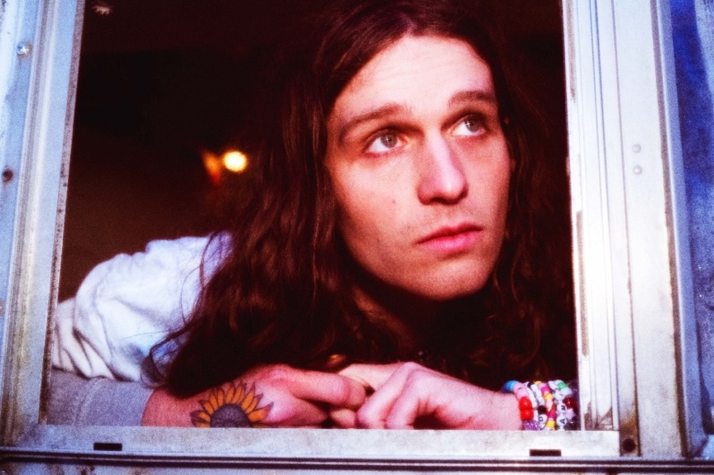
press photo credit: Muriel Margaret | download hi-res HERE
download additional images, boiler + Maroney’s album note HERE

July 21, 2023 – Acclaimed Nashville-based artist Briston Maroney has shared new track “Detonator,” accompanied by B-side “The Idea” (buy/stream here). Today’s release marks the third offering from his forthcoming album, Ultrapure, due out Friday, September 22 via Canvasback Music/Atlantic Records (pre-order here; full tracklist enclosed below), and arrives alongside a live, acoustic performance video for “Detonator” (watch here).

“Detonator” / “The Idea” follows the incredibly personal “Sunburn Fades,” immediately hailed by Consequence as “an example of the minimalist, home-spun sound the artist is continuing to craft” upon its release last month, when it landed in the publication’s ‘Top Songs of the Week’ column.

Today’s tracks also follow lead single “Body,” which debuted in May via Apple Music’s New Music Daily alongside an interview with Briston and Zane Lowe, was praised by FLOOD as “invoking stadium-indie songwriters,” and is currently Top 30 at AAA Radio (and quickly rising).

Next week, on Wednesday, July 26, Maroney will support Noah Kahan for a highly-anticipated show at Colorado’s famed Red Rocks Amphitheatre.

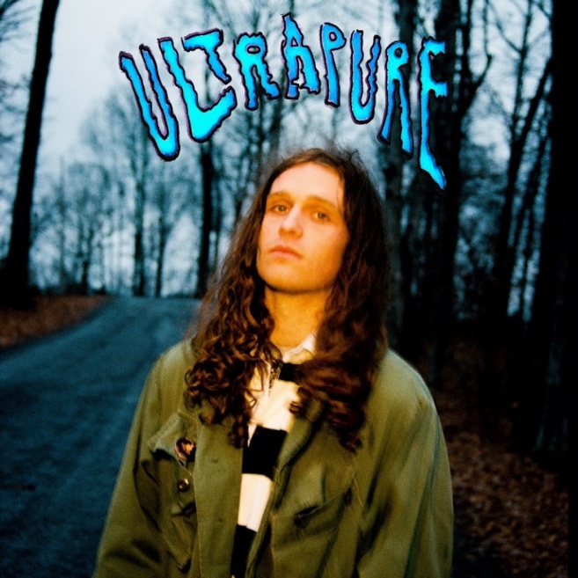
download hi-res album artwork HERE

Produced by 2x GRAMMY®-winner Daniel Tashian (Kacey Musgraves) and engineered by Konrad Snyder (Noah Kahan, Rainbow Kitten Surprise), Ultrapure was crafted in Maroney’s adopted hometown of Nashville, TN and showcases the artist playing every single instrument.

Of its genesis, Maroney shares: My favorite moments in the human experience are ones that you don’t even realize have started,but feel so deeply when you realize they’ve ended. I refer to these as ‘Ultrapure’ moments. This album was my humble, unqualified, and earnest as hell attempt at sitting in those feelings until they had no choice but to burst out of my head. These songs are about a type of pain I hate and love, but mostly have a deep appreciation for.

This fall, Maroney will host his second annual ‘Paradise Festival,’ set to return to Brooklyn Bowl Nashville from October 12-14. Last year’s sold-out inaugural edition was curated in its entirety by the artist himself, who closed out each night with high-energy and celebratory headline sets. Featuring a handpicked lineup of peers – including Samia, Hovvdy, and Skullcrusher joining this fall’s iteration – and with a portion of proceeds supporting Nashville-based nonprofits, the annual event further cements Maroney’s status as an artist who “has helped define a new generation of local music” (Nashville Scene).

Later this year, Maroney will embark on a headline UK/EU tour in support of Ultrapure. The dates kick off in Brighton, UK on October 31 and culminate in Cologne, Germany on November 16, with stops in London, Paris, Amsterdam, and many more cities in between [all upcoming tour dates enclosed below].

Maroney’s debut LP Sunflower was released in 2021, following a trio of EPs: Miracle, Indiana, and Carnival – the latter of which spurned the RIAA Platinum-certified single, “Freakin’ Out On The Interstate.” These releases amassed critical acclaim from the likes of NPR, Vulture, NME, amongst many others, and led to sold-out headline tour dates across the US, Canada, UK and Europe; performances at marquee festivals around the world (from Bonnaroo to Outside Lands to Pitchfork Paris); opening slots for Jack White and Rainbow Kitten Surprise; and a feature collaboration with Manchester Orchestra on 2022’s Sunflower: Deluxe.

ULTRAPURE TRACKLIST
- Intro
- Body
- Breathe
- Chaos Party
- Sunburn Fades
- Sunshine
- Delaware
- Detonator
- The Idea
- Spring
- Sink;Swim
- Skyline
- Ultrapure

###

BRISTON MARONEY | UPCOMING TOUR DATES
# festival performance

JULY
26 – Morrison, CO @ Red Rocks (supporting Noah Kahan)

SEPTEMBER
8 – Denver, CO @ Endless Sunshine #

OCTOBER
12 – Nashville, TN @ Brooklyn Bowl Nashville – Paradise Festival #
13 – Nashville, TN @ Brooklyn Bowl Nashville – Paradise Festival #
14 – Nashville, TN @ Brooklyn Bowl Nashville – Paradise Festival #
31 – Brighton, UK @ Chalk

NOVEMBER
1 – London, UK @ Scala
3 – Manchester, UK @ Gorilla
4 – Glasgow, UK @ Stereo
5 – Leeds, UK @ Brudnell Social Club
7 – Nottingham, UK @ Rescue Rooms
8 – Bristol, UK @ Thekla
10 – Paris, FR @ Le Trabendo
11 – Nijmegen, NL @ Doornroosje
12 – Amsterdam, NL @ Melkweg OZ
14 – Hamburg, DE @ Knust
15 – Berlin, DE @ Gretchen

###

CONNECT WITH BRISTON MARONEY:
OFFICIAL I INSTAGRAM I YOUTUBE I FACEBOOK I TWITTER I TIKTOK

FOR ALL PRESS INQUIRIES, PLEASE CONTACT:
Libby Kober (National) | Libby.Kober@AtlanticRecords.com
Gabby Reese (Tour) | Gabrielle.Reese@AtlanticRecords.com

