BRISTON MARONEY SHARES “SUNBURN FADES”
BUY/STREAM HERE

NEW ALBUM ULTRAPURE – PRODUCED BY DANIEL TASHIAN
DUE OUT SEPTEMBER 22 VIA CANVASBACK MUSIC/ATLANTIC RECORDS
PRE-ORDER HERE

DEBUT SINGLE “BODY” OUT NOW – BUY/STREAM HERE
WATCH OFFICIAL VIDEO – CO-DIRECTED BY MARONEY – HERE

SECOND ANNUAL ‘PARADISE FESTIVAL’ – CURATED BY MARONEY – SET FOR OCT 12-14 AT BROOKLYN BOWL NASHVILLE WITH SAMIA, HOVVDY + MORE

HEADLINE UK/EU TOUR SET FOR FALL 2023

“Pretty flawless. Briston Maroney has pulled it off.”
Zane Lowe re: “Body” on New Music Daily [listen here]

“invoking stadium-indie songwriters” – FLOOD

"Briston Maroney is writing powerful rock songs with grit and heart" – NPR

“Nashville-based singer-songwriter Briston Maroney … flaunts a keen understanding of the hooks that will explode in front of festival crowds.” – BILLBOARD

“A breath of fresh air in these dark times… Maroney’s musical chops and resumé belie his age.” – CONSEQUENCE

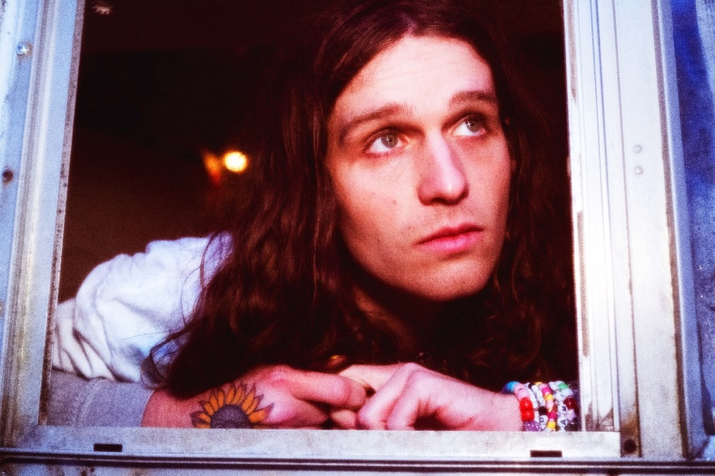
press photo credit: Muriel Margaret | download hi-res HERE
download additional images, boiler + Maroney’s album note HERE

June 23, 2023 – Acclaimed Nashville-based artist Briston Maroney has shared new track “Sunburn Fades” (buy/stream here), the second offering from his forthcoming album, Ultrapure, due out Friday, September 22 via Canvasback Music/Atlantic Records (pre-order here; full tracklist enclosed below). The song arrives with an acoustic, live performance video (watch here).

Of today’s incredibly personal release, written after a trip with friends to Tennessee’s beloved Dollywood amusement park – Maroney shares:

“Everyone was so happy; it was the perfect movie moment. I wish I could’ve stopped time because I knew that life was inevitably going to take us all in different directions – but the song isn’t supposed to be sad. It’s about how inevitable that change is. It’s me reflecting on friendships and relationships changing.

I think it might be my favorite song on the album, because I’ve been trying to describe this feeling for a long time, and I feel like I finally did.”

“Sunburn Fades” follows lead single “Body” (buy/stream here + watch the music video here), which debuted last month via Apple Music’s New Music Daily alongside an interview with Briston and Zane Lowe, was immediately praised by FLOOD as “invoking stadium-indie songwriters,” and is currently impacting AAA Radio.

Produced by 2x GRAMMY®-winner Daniel Tashian (Kacey Musgraves) and engineered by Konrad Snyder (Noah Kahan, Rainbow Kitten Surprise), Ultrapure was crafted in Maroney’s adopted hometown of Nashville, TN and showcases the artist playing every single instrument.

Of its genesis, Maroney shares: My favorite moments in the human experience are ones that you don’t even realize have started,but feel so deeply when you realize they’ve ended. I refer to these as ‘Ultrapure’ moments. This album was my humble, unqualified, and earnest as hell attempt at sitting in those feelings until they had no choice but to burst out of my head. These songs are about a type of pain I hate and love, but mostly have a deep appreciation for.

This fall, Maroney will host his second annual ‘Paradise Festival,’ set to return to Brooklyn Bowl Nashville from October 12-14. Last year’s sold-out inaugural edition was curated in its entirety by the artist himself, who closed out each night with high-energy and celebratory headline sets. Featuring a handpicked lineup of peers – including Samia, Hovvdy, and Skullcrusher joining this fall’s iteration – and with a portion of proceeds supporting Nashville-based nonprofits, the annual event further cements Maroney’s status as an artist who “has helped define a new generation of local music” (Nashville Scene).

Later this year, Maroney will embark on a headline UK/EU tour in support of Ultrapure. The dates kick off in Brighton, UK on October 31 and culminate in Cologne, Germany on November 16, with stops in London, Paris, Amsterdam, and many more cities in between [all upcoming tour dates enclosed below].

Maroney’s debut LP Sunflower was released in 2021, following a trio of EPs: Miracle, Indiana, and Carnival – the latter of which spurned the RIAA Platinum-certified single, “Freakin’ Out On The Interstate.” These releases amassed critical acclaim from the likes of NPR, Vulture, NME, amongst many others, and led to sold-out headline tour dates across the US, Canada, UK and Europe; performances at marquee festivals around the world (from Bonnaroo to Outside Lands to Pitchfork Paris); opening slots for Jack White and Rainbow Kitten Surprise; and a feature collaboration with Manchester Orchestra on 2022’s Sunflower: Deluxe.

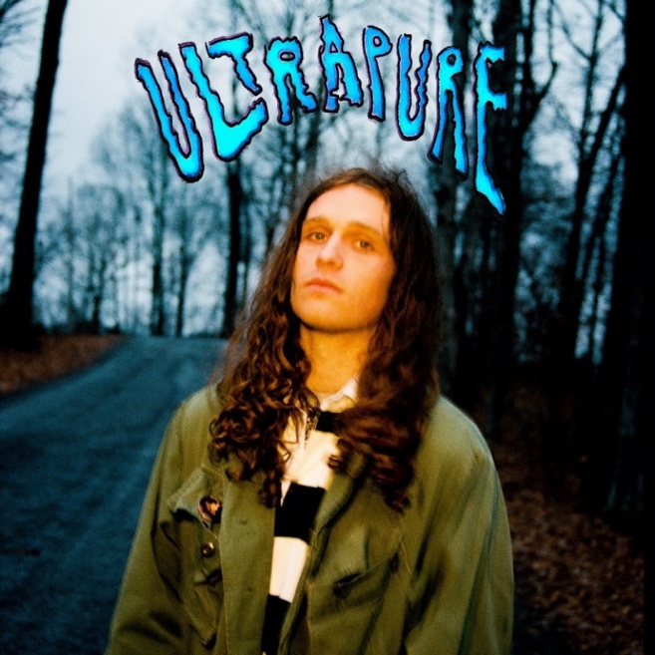
download hi-res album artwork HERE

ULTRAPURE TRACKLIST
- Intro
- Body
- Breathe
- Chaos Party
- Sunburn Fades
- Sunshine
- Delaware
- Detonator
- The Idea
- Spring
- Sink;Swim
- Skyline
- Ultrapure

###

BRISTON MARONEY | UPCOMING TOUR DATES
# festival performance

JULY
26 – Morrison, CO @ Red Rocks (supporting Noah Kahan)

SEPTEMBER
8 – Denver, CO @ Endless Sunshine #

OCTOBER
12 – Nashville, TN @ Brooklyn Bowl Nashville – Paradise Festival #
13 – Nashville, TN @ Brooklyn Bowl Nashville – Paradise Festival #
14 – Nashville, TN @ Brooklyn Bowl Nashville – Paradise Festival #
31 – Brighton, UK @ Chalk

NOVEMBER
1 – London, UK @ Scala
3 – Manchester, UK @ Gorilla
4 – Glasgow, UK @ Stereo
5 – Leeds, UK @ Brudnell Social Club
7 – Nottingham, UK @ Rescue Rooms
8 – Bristol, UK @ Thekla
10 – Paris, FR @ Le Trabendo
11 – Brussels, BE @ Doornroosje
12 – Amsterdam, NL @ Melkweg OZ
14 – Hamburg, DE @ Knust
15 – Berlin, DE @ Gretchen

###

CONNECT WITH BRISTON MARONEY:
OFFICIAL I INSTAGRAM I YOUTUBE I FACEBOOK I TWITTER I TIKTOK

FOR ALL PRESS INQUIRIES, PLEASE CONTACT:
Libby Kober (National) | Libby.Kober@AtlanticRecords.com
Gabby Reese (Tour) | Gabrielle.Reese@AtlanticRecords.com

