FOR IMMEDIATE RELEASE
JULY 27, 2023

CKAY RETURNS WITH OFFICIAL VISUAL FOR “HALLELUJAH”

COMES ON THE HEELS OF THE RELEASE OF SAD ROMANCE (DELUXE)

ONE OF FOUR ADDITIONAL TRACKS ON THE ALBUM ALSO INCLUDING “CAPTURE MY SOUL,” “NWAYI,” AND “NNEKA”

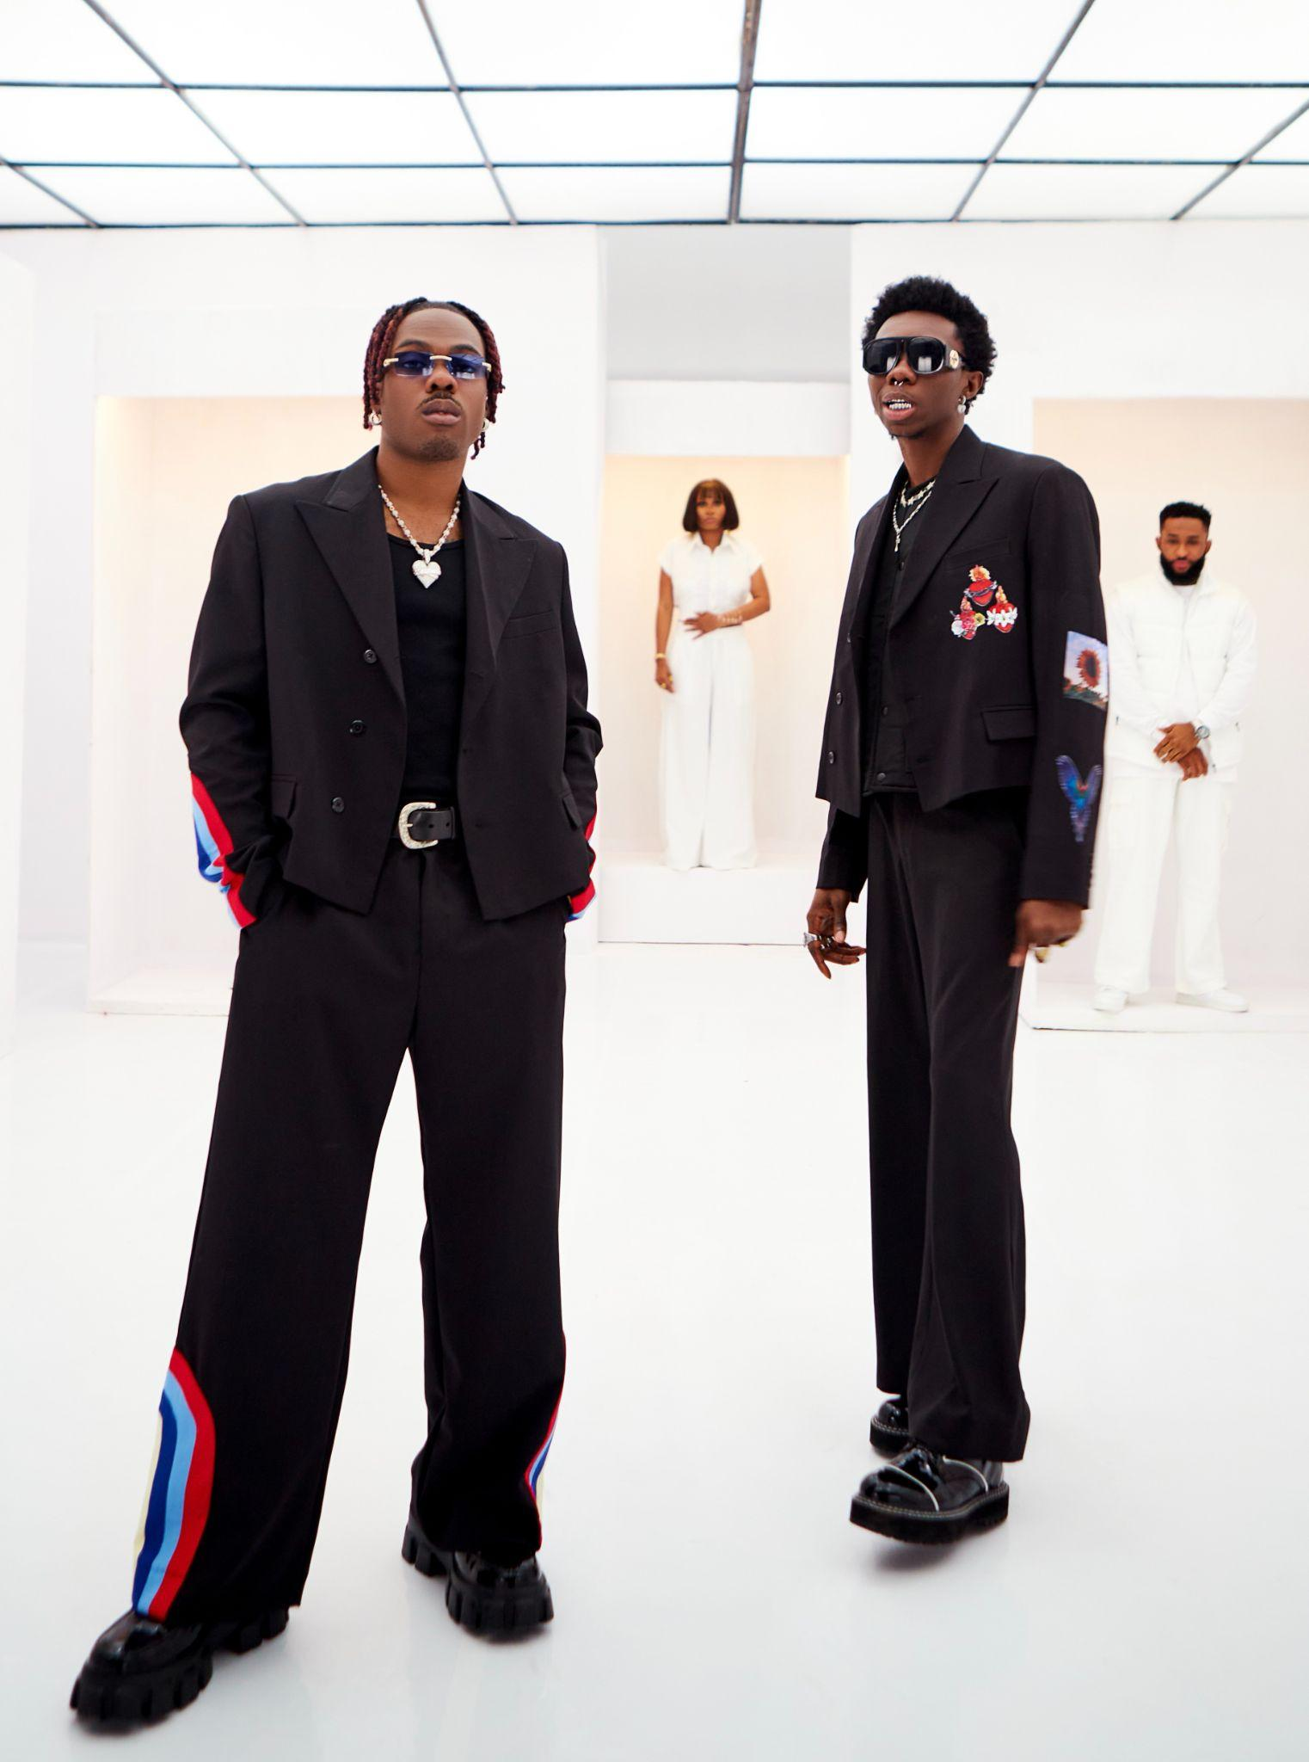
WATCH HERE

Right off the heels of the single’s success, peaking at #1 on Apple Music’s Top 50 songs in Nigeria, CKay drops the official music video to “HALLELUJAH” with Blaqbonez.

Produced by Magic Sticks (Oxlade, Davido, Asake), “HALLELUJAH” is a different vibe for CKay who has often committed to his emo-Afrobeats soundscape and perhaps picks up where ‘WATAWI’ left off. Shot in Lagos and directed by Jyde Ajala (Olamide, Victony) the visuals are also dynamic, swiftly moving across a racetrack, a vault, and interior sequences where both CKay and Blaqbonez flaunt their wins.

2023 started off a few high notes for CKay as he surpassed 3.6 billion career streams; performing at the FIFA World Cup ceremony as well as the Vh1 Supersonic 2023 festival in Pune, India, “HALLELUJAH,” now at over 20 million streams, is a moment of self-reflection and living on top of the world. This summer has been particularly busy for CKay performing at AfroNation in Miami, Dour Festival, in Belgium, and most recently Lollapalooza in Paris. Upcoming performance dates include:

July 28 – Luzern Live, Switzerland
July 29 – HipHop Open, Germany

ABOUT CKAY
Chukwuka Ekweani, known publicly as CKay, is the rising star in the ever-burgeoning Afrobeats scene. A multi-talented artist, whether behind the boards as a producer or in front of the mic performing his self-penned songs, it is CKay’s single-minded vision that shines through. The self-defined Emo-Afrobeat star has and continues to soar up charts across the globe thanks to his first globally recognized single ‘love nwantiti’.

The Nigerian singer, songwriter, and producer originally released ‘love Nwantiti (ah ah ah)’ back in 2019 as part of his debut EP, CKay The First. In 2021, CKay became the most streamed artist of the year and became the first African artist with two tracks on the Global Spotify Top 30 simultaneously. ‘love nwantiti’ has been certified platinum/multi-platinum in five countries, including the United States, India and Italy. The viral hit has also been certified gold in the UK, Australia, South Africa and New Zealand. CKay became the first African artist in 50 years to hold a top 5 position on the UK Singles Chart for 4 straight weeks with ‘love nwantiti’.
CKay has continued to create a global presence with accomplishments such as the “most Shazam-ed song in the world”. ‘Emiliana’, followed suit and racked in global chart positions and currently has just over 400 million streams worldwide. ‘Emiliana’ peaked at #1 on the UK Afrobeats Chart, #2 on Shazam Top 200 (Afrobeats), and #1 in six countries on Apple Music.
CKay’s debut album Sad Romance was released last year and has since had over 380 million streams worldwide. With over 3.5 billion streams to his name and new music slated for 2023, CKay is in a prime position to continue his upward trajectory as a globally recognized singer-songwriter and producer.

The Sad Romance Deluxe album is out now, listen/stream here: http://ckay.lnk.to/sad_romance_deluxe

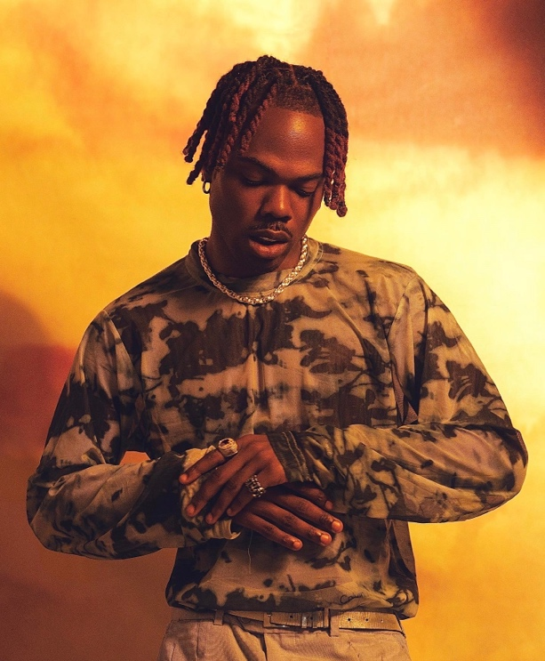

CONNECT WITH CKAY:
TWITTER | FACEBOOK | INSTAGRAM | TIKTOK | YOUTUBE

PRESS CONTACT:
ARIANA.WHITE@ATLANTICRECORDS.COM

