JANELLE MONÁE UNVEILS VIBRANT NEW VIDEO FOR “WATER SLIDE”

CRITICALLY-ACCLAIMED NEW ALBUM THE AGE OF PLEASURE OUT EVERYWHERE NOW

AWARD-WINNING SUPERSTAR KICKS OFF THE AGE OF PLEASURE TOUR AUGUST 30 IN SEATTLE

WATCH THE "WATER SLIDE" VIDEO HERE
DIRECTED BY JANELLE MONÁE AND ALAN FERGUSON
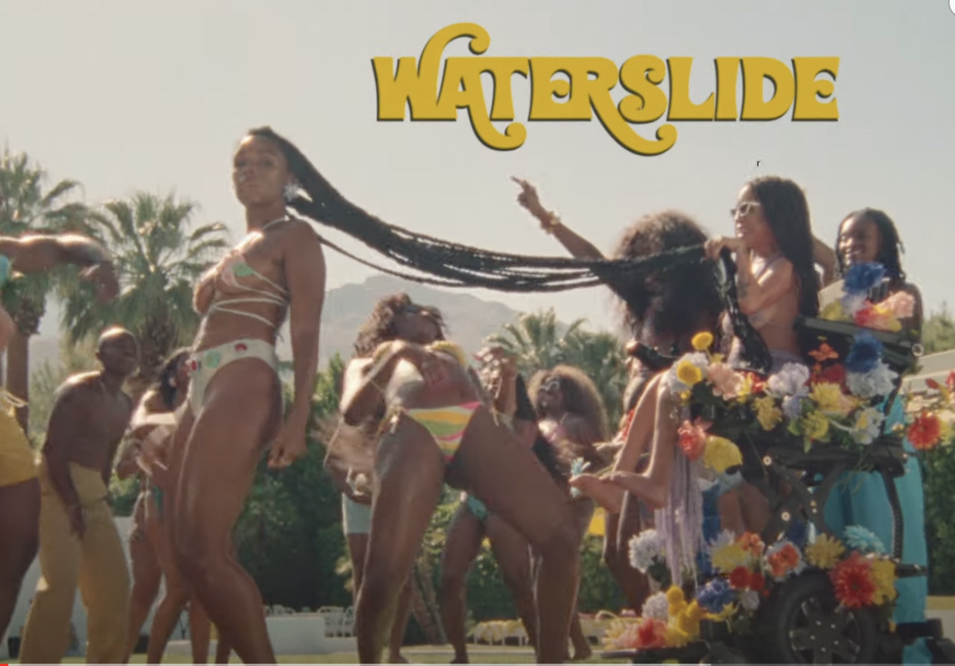
SHARE JANELLE’S INSTAGRAM POST

“Her most sumptuous album yet…” - ROLLING STONE

“An earthbound affair. True to its title, it’s filled with sensual music that’s about feeling good above all else…Monáe’s free-floating lustiness often brings to mind the music of Prince…” - WALL STREET JOURNAL

“Listening to the album is like being at the world’s most polite orgy; the lyrics are dirty and bold, but the sound is mellow, subversive, enveloping you like a safety blanket…” - ASSOCIATED PRESS

“An ode to freedom, joy, and yes, pleasure…”- CONSEQUENCE

Janelle Monáe, music’s foremost freeassmuthafucka, has unveiled the music video for "Water Slide," from her latest album, THE AGE OF PLEASURE. The vibrant, sun-soaked visual exudes a playful and carefree vibe, reminiscent of the viral video for the fan-favorite track, "Lipstick Lover". Monáe co-directed both videos alongside frequent collaborator, Alan Ferguson.

Monáe will celebrate her new era with THE AGE OF PLEASURE TOUR, getting underway August 30 at Seattle, WA’s WAMU Theater and then traveling North America through mid-October. Produced by Live Nation, the 26-city tour will make stops at such historic venues as Morrison, CO’s Red Rocks Amphitheatre (September 7), Chicago, IL’s Byline Bank Aragon Ballroom (September 14), Toronto, ON’s Massey Hall (September 21), New York City’s Radio City Music Hall (September 26), Brooklyn, NY’s Kings Theatre (September 28), Nashville, TN’s Ryman Auditorium, (October 3), and Atlanta, GA’s Fox Theatre Atlanta (October 6) before culminating at Inglewood, CA’s YouTube Theater (October 18). For complete details and remaining ticket availability, please visit www.jmonae.com.

DOWNLOAD PRESS PHOTO HERE // PHOTO CREDIT: MASON ROSE

CONNECT WITH JANELLE MONÁE
OFFICIAL | FACEBOOK | INSTAGRAM | TWITTER | YOUTUBE |PRESS ASSETS

