FOR IMMEDIATE RELEASE
JULY 21, 2023

R&B SENSATION JOSH LEVI JOINS THE RECORDING ACADEMY
FOR “LIONS, TIGERS & BEARS (REIMAGINED)”

HYPNOTIC NEW RENDITION OF JAZMINE SULLIVAN’S GRAMMY® AWARD-NOMINATED HIT SINGLE RELEASES AS PART OF THE RECORDING ACADEMY’S POPULAR “REIMAGINED” SERIES

“LIONS, TIGERS & BEARS (REIMAGINED)” SET TO ARRIVE ON ALL DSPS JULY 28TH

WATCH OFFICIAL LIVE PERFORMANCE VIDEO

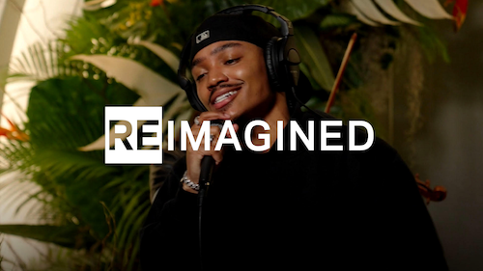
DOWNLOAD Hi-Res Artwork

R&B sensation Josh Levi has joined forces with The Recording Academy for a sublime rendition of Jazmine Sullivan’s GRAMMY® Award-nominated hit single, “Lions, Tigers & Bears (ReImagined),” which premiered earlier this week as part of The Recording Academy’s popular “ReImagined” series HERE. Driven by the sounds of hypnotic live strings played by violinist Sara Madani and Levi’s effortless, airy vocal runs, “Lions, Tigers & Bears (ReImagined)” will be available July 28th via Raedio/Atlantic Records at all DSPs and streaming services.

“Lions, Tigers & Bears (ReImagined)” follows this spring’s release of DISC TWO (SCRATCHED UP), a newly expanded version of Levi’s acclaimed 2022 EP, DISC TWO, available now HERE. The deluxe edition adds three brand new tracks to the already stacked project, including the braggadocious “EGO,” joined by an official dance video streaming now at YouTube HERE.

DISC TWO (SCRATCHED UP) further features the vulnerable hit single, “SEE LOW.” The track has fast proven another smash for Levi, featured on “Ebro Darden’s Discovered on Apple Music” and Rolling Stone’s influential “Songs You Need To Know” playlist.

Levi – who was recently featured on Spotify’s “Frequency“ Instagram, as well as on the cover of such popular playlists as Spotify’s “R&B Rising,” Amazon’s “Breakthrough R&B,” and Pandora’s “Future Soul” – marked the arrival of DISC TWO (SCRATCHED UP) with an array of high-profile media appearances, including an exclusive interview on Apple Music’s The Travis Mills Show as well as stunning one-take live performances of “EGO“ and “SEE LOW“ for The EYE Sessions.

Levi’s sophomore EP, DISC TWO includes such acclaimed tracks as “VICES“ and “ALL OVER AGAIN,” both joined by official music videos streaming now at the official Josh Levi YouTube channel HERE. Levi also blessed fans with show-stopping renditions of both tracks, filmed exclusively for Vevo at Vevo’s Brooklyn, NY studio, streaming now via YouTube HERE and HERE.

A personal favorite of Justin Bieber (who shared the song on his Instagram feed and story), “VICES” proved a phenomenon upon its arrival last year, featured on GRAMMY.com‘s “R&B Is Alive And Well“ playlist, accompanied by an exclusive feature which named Levi among the next-gen R&B “Artists Who Are Pushing The Genre Forward,” hailing him for his “soulful and electric sounds.”

DISC TWO also includes such powerhouse singles as “NASA,” “DON’T THEY REMIX (FEAT. NORMANI)“ (which exclusively premiered on Apple Music’s The Zane Lowe Show), and “SHE KEEPS COMIN,” the latter joined by an astonishing self-shot live performance video streaming via YouTube HERE.

Levi marked DISC TWO with his first ever headline tour run to date, “The VICES Tour,” kicking off with a sold-out show at Los Angeles, CA’s Peppermint Club and followed by full houses in San Francisco, Chicago, Houston, New York, Atlanta, and other major markets across the country.

DISC TWO was further celebrated with a stunning live rendition of “VICES” on The Terrell Show, as well as an exclusive interview with Rated R&B. What’s more, the rising star displayed his intimate approach to modern R&B with an exhilarating live performance video of “NASA,” streaming HERE.

Levi’s voice is featured on the GRAMMY® Award-nominated, RIAA Gold-certified worldwide smash, “Nobody Like U,” as Aaron Z, a member of the teenage heartthrob boyband 4*Town in Disney/Pixar’s blockbuster Turning Red. Written by GRAMMY® Award-winning singer-songwriters Billie Eilish and Finneas O’Connell, “Nobody Like U” proved an immediate Billboard “Hot 100” smash upon its arrival last February – Levi’s first appearance on the overall chart. The song’s global success rocketed Levi’s monthly Spotify listeners to more than 4.5M and went on to not only earn RIAA Gold certification along with honors including a prestigious GRAMMY® Award nomination for “Best Song Written For Visual Media,” but also an MTV Movie & TV Awards nod for “Best Musical Moment.”

Levi has made a wide array of electrifying performances in recent months, including a live rendition of “NOSEBLEED“ complimented by guitarist J Hawk (streaming HERE), “IF THE WORLD” for Genius’s hugely popular Open Mic series, presented by M&M’s (streaming HERE), as well as an angelic rendition of “HEAVEN” accompanied by harpist Sara Kawai (streaming HERE).

Named by PEOPLE as one of “25 Emerging Musical Artists You Should Add to Your Playlist,” Josh Levi immediately captivates with each inhale of experience and exhale of emotion. The Houston, TX-raised and Los Angeles-based singer, songwriter, and actor developed a fervent fan base through roles on such hit series as Friday Night Lights as well as a series of viral YouTube covers and consistent touring.

Levi’s 2020 debut EP, DISC ONE – highlighted by such tracks as “IF THE WORLD”– earned high profile media attention from the likes of Billboard, Wonderland, V, and Earmilk, which applauded the project as “an all-encompassing showcase of how much of an anomaly he is.” As a result, the gifted young artist caught the attention of Issa Rae’s label imprint, Raedio, featuring his 2021 single, “What’s The Use,” on the soundtrack to her critically acclaimed HBO Series, Insecure: Season 5. The track proved an instant smash for Levi, named by Billboard at #6 on their “Tunefind Top TV/Movie Syncs of 2021.”

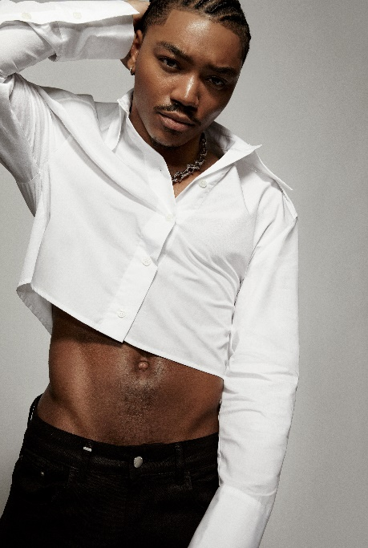
DOWNLOAD HI-RES PRESS IMAGE // PHOTO CREDIT: BLAIR CALDWELL

CONNECT WITH JOSH LEVI
OFFICIAL | FACEBOOK | INSTAGRAM | TIKTOK | TWITTER | YOUTUBE

PRESS CONTACT:
Brittany Bell | Brittany.Bell@atlanticrecords.com

