FOR IMMEDIATE RELEASE
JULY 19, 2023

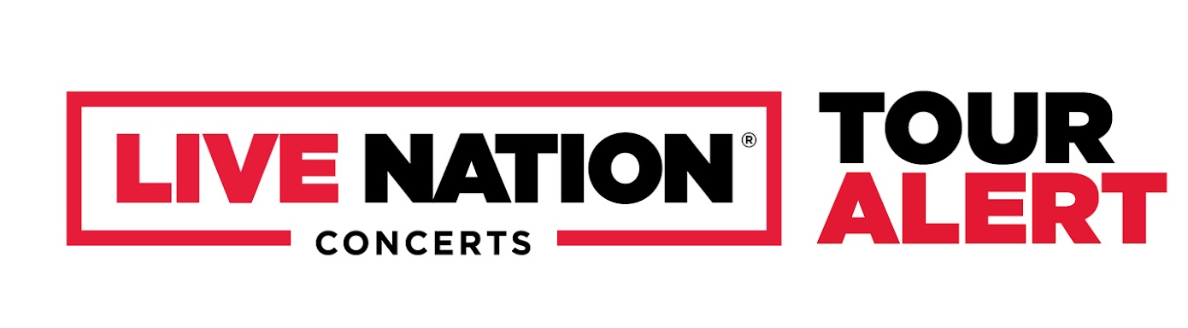

NOCAP ANNOUNCES THE BIRDNEST TOUR

PRESALES BEGIN THURSDAY, JULY 20
GENERAL ONSALE BEGINS FRIDAY, JULY 21 AT 12PM LOCAL TIME

THE BIRDNEST TOUR KICKS OFF SEPTEMBER 26 IN CHARLOTTE, NC

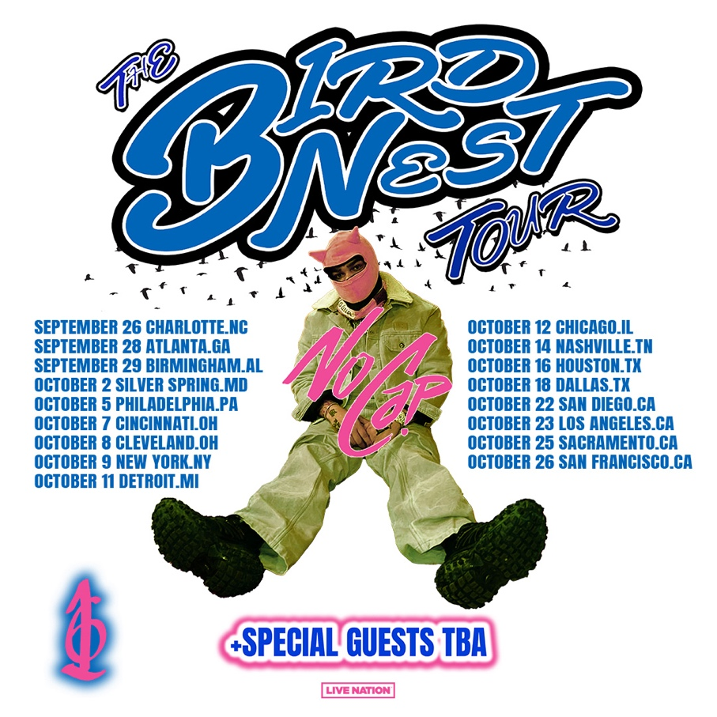

Today, NoCap announced The Birdnest Tour across North America this fall. The 17-date tour kicks off on Tuesday, September 26 in Charlotte, NC at The Fillmore, with stops in Atlanta, GA, New York, NY, Los Angeles, CA and more before wrapping up on Thursday, October 26 at The Midway in San Francisco, CA.

Tickets will be available starting with various presales beginning Thursday, July 20 at 9:00 AM local time. The general onsale will start Friday, July 21 at 12:00 PM local time at ticketmaster.com.

For approved artist images and hi-res tour art, please download HERE.

THE BIRDNEST TOUR

September 2023
Tue 26 – Charlotte, NC – The Fillmore
Thu 28 – Atlanta, GA – Coca-Cola Roxy
Fri 29 – Birmingham, AL – Avondale Brewing Co.

October 2023
Mon 02 – Silver Spring, MD – The Fillmore
Thu 05 – Philadelphia, PA – The Fillmore
Sat 07 – Cincinnati, OH – Bogart’s
Sun Oct 08 – Cleveland, OH – House of Blues
Mon Oct 09 – New York, NY – Irving Plaza
Wed Oct 11 – Detroit, MI – The Fillmore
Thu Oct 12 – Chicago, IL – Concord Music Hall
Sat Oct 14 – Nashville, TN – Marathon Music Works
Mon Oct 16 – Houston, TX – House of Blues
Wed Oct 18 – Dallas, TX – House of Blues
Sun Oct 22 – San Diego, CA – House of Blues
Mon Oct 23 – Los Angeles, CA – Hollywood Palladium
Wed Oct 25 – Sacramento, CA – Ace of Spades
Thu Oct 26 – San Francisco, CA – The Midway

ABOUT NOCAP:
By embracing the art of storytelling, NoCap narrates his life out loud. In between the wail of a guitar or a piano’s drone, the gold-certified Mobile, AL rapper and singer dips in and out of turbulent and triumphant memories alike with the same careful attention to detail. Audiences have hung on to every word since he emerged in 2017 with the Joker EP. He unleashed critically acclaimed projects at a head-spinning pace, including Neighborhood Hero, Rogerville with Rylo Rodriguez, The Backend Child, The Hood Dictionary, and Steel Human. Along the way, he picked up a gold plaque for “Ghetto Angels.” Meanwhile, he appeared on high-profile projects from Lil Baby, DaBaby, Quando Rondo, YFN Lucci, and YoungBoy Never Broke Again in addition to the Road To Fast 9 Mixtape. After spending half of 2021 behind bars, he doled out the single “Vaccine.” It marked his second gold-selling track, and Pitchfork went as far as to name it one of “The 38 Best Rap Songs of 2021.” Reeling in over 100 million streams, building a rapt fan base, and earning praise courtesy of The FADER, Brooklyn Vegan, Hypebeast, and many others, his story comes into focus like never before on his 2022 full-length debut album, Mr. Crawford, and much more on the horizon.
With the long-awaited release of MR. CRAWFORD, NoCap’s true story comes into focus like never before. MR. CRAWFORD includes tracks like “Shackles To Diamonds,” “I’ll Be Here,” “Vaccine,” “Very Special” and “Save The Day (Feat. Kodak Black).” Official music videos for these records can be found on his official YouTube channel HERE. The album also boasts notable features from YoungBoy Never Broke Again and Internet Money. Hailed by Pitchfork as “a standout voice in the Deep South,” NoCap celebrated MR. CRAWFORD with his biggest U.S. headline tour to date last Spring. NoCap followed up on the success of MR. CRAWFORD with a string of notable releases and his stand-out performance at last year’s Rolling Loud NYC in September. He ended the year with the release of The Main Bird 7-track EP.

About Live Nation Entertainment
Live Nation Entertainment (NYSE: LYV) is the world’s leading live entertainment company comprised of global market leaders: Ticketmaster, Live Nation Concerts, and Live Nation Sponsorship. For additional information, visit www.livenationentertainment.com.

CONNECT WITH NOCAP
OFFICIAL WEBSITE | TWITTER | FACEBOOK | INSTAGRAM | YOUTUBE

MEDIA CONTACTS

NOCAP
ARIANA WHITE | ARIANA.WHITE@ATLANTICRECORDS.COM
CHEVON DESHIELDS | CHEVON.DESHIELDS@ATLANTICECORDS.COM

LIVE NATION CONCERTS
MONIQUE SOWINSKI | MONIQUESOWINSKI@LIVENATION.COM
MAYA SARIN | MAYASARIN@LIVENATION.COM

To apply for media credentials for show coverage:
livenation.com/pressrequests

