FOR IMMEDIATE RELEASE
JULY 28, 2023

ALT-POP RENEGADE NOGA EREZ RELEASES NEW SINGLE “QUIET”

ORIGINAL TRACK WRITTEN FOR AND FEATURED IN
NETFLIX'S FORTHCOMING ACTION THRILLER, HEART OF STONE

HEART OF STONE PREMIERES AUGUST 11 GLOBALLY ON NETFLIX

LISTEN TO “QUIET” HERE

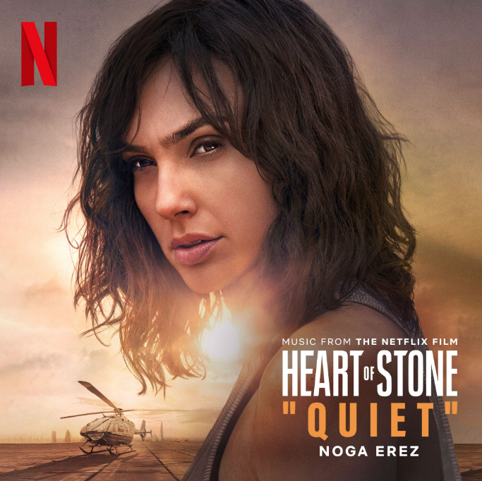
DOWNLOAD ARTWORK HERE

Alt-pop renegade Noga Erez is back with her scintillating new single, “Quiet,” written + produced with partner ROUSSO exclusively for Netflix’s upcoming action thriller, Heart of Stone, directed by Tom Harper and starring Gal Gadot, Jamie Dornan, Alia Bhatt, Sophie Okonedo, Matthias Schweighöfer, Paul Ready and Jing Lusi. The track, which is featured in the opening credits of the film, is available now via Neon Gold/Atlantic – Listen HERE. In addition, Erez’s previously released track “End of the Road” is featured in the first scene of the film. Heart of Stone premieres on Netflix on August 11.

“Quiet” marks Noga Erez’s first new music since last year’s smash single, “NAILS,” which has drawn over 6M global streams and over 1.1M video views to date. Co-written and produced by ROUSSO, the swaggering track was followed by an exclusive remix featuring 4x GRAMMY® Award-winning superstar Missy Elliott, “NAILS (Feat. Missy Elliott),” earning 3M worldwide streams and critical applause from such outlets as Consequence of Sound, which declared it a “shredding new rendition.”

Long hailed for her stunning live performances, Erez is currently traveling Europe on a series of eagerly awaited festival appearances through the summer. Last year saw Erez lighting up North American stages from coast to coast, spanning sold-out headline shows at such legendary venues as New York City’s Bowery Ballroom and Los Angeles, CA’s El Rey Theatre to a pair of unforgettable dates as special guest to Florence and the Machine at NYC’s world-famous Madison Square Garden. For all touring updates, please visit www.nogaerez.com.

Currently hard at work on her hugely anticipated third album, Erez and ROUSSO first joined forces with 2017’s Off The Radar, earning worldwide acclaim and a fast-growing international fan following. 2021’s KIDS proved a natural evolution and even greater success, garnering over 10M streams in the United States alone as well as a legion of famous fans that includes Gal Gadot, Britney Spears, Marion Cotillard, Katy Perry, Hayley Williams, Dove Cameron, Robbie Williams, Sofi Tukker, Meghan Trainor, Billie Eilish, and Finneas, the latter of whom declared it “one of the best albums I’ve ever heard.”

Named as one of the rising stars selected to join YouTube Music’s global artist development program, Foundry, Erez marked the exhilarating KIDS with dramatic live performances on ABC’s Jimmy Kimmel Live!, NBC’s The Kelly Clarkson Show, and more. In addition, the album spawned an array of innovative tracks featured across a wide range of film, TV, and promotional campaigns including NBC’s Good Girls, Apple’s Dickinson, Netflix’s Sex/Life, Russian Doll, How To Sell Drugs Online (Fast), Samsung, Apple’s Anthem and iPhone X, Snapchat, Orange 5G, ESPN, and more.

As thrilling live as in the studio, Erez and ROUSSO have brought their ambitious pop approach to stages around the globe, from sold-out headline concerts (including a packed hometown show at Tel Aviv’s legendary Menora Arena) to show-stopping festival sets at Bonnaroo, Primavera Sound, Austin City Limits, Outside Lands, and Lollapalooza (to name only a few). Now, with the arrival of “Quiet” and the promise of more new music to come, Noga Erez is poised to further cement her one-of-a-kind place among the innovative and formidable alt-pop artists of her era.

ABOUT HEART OF STONE
Rachel Stone (Gal Gadot) appears to be an inexperienced tech, on an elite MI6 unit headed up by lead agent Parker (Jamie Dornan). What her MI6 team doesn't know is that Stone actually works for the Charter — a covert peacekeeping organization, secret even from other spies, which uses cutting-edge technology to neutralize global threats. Rachel has been trained to be the consummate professional: a phenomenal field agent who sticks to the mission, follows the numbers, and trusts no one. When a routine mission is derailed by mysterious hacker Keya Dhawan (Alia Bhatt), Rachel’s two lives collide. As she races to protect the Charter and strives to beat the odds, her humanity might just be her biggest asset.

ABOUT NETFLIX
Netflix is one of the world's leading entertainment services with over 238 million paid memberships in over 190 countries enjoying TV series, films and games across a wide variety of genres and languages. Members can play, pause and resume watching as much as they want, anytime, anywhere, and can change their plans at any time.

DOWNLOAD PRESS PHOTO
CREDIT: JIMMY FONTAINE

CONNECT WITH NOGA EREZ
OFFICIAL SITE | INSTAGRAM | TIKTOK | TWITTER | YOUTUBE

CONNECT WITH HEART OF STONE
TRAILER | FILM STILLS | OFFICIAL SITE
For press inquiries, please contact:
Kelly McWilliam / Kelly.McWilliam@atlanticrecords.com

