FOR IMMEDIATE RELEASE
JULY 21, 2023

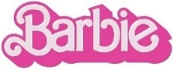
COME ON BARBIE, LET’S GO PARTY!
ATLANTIC RECORDS UNVEILS BARBIE THE ALBUM

ALL-NEW COMPANION ALBUM TO WARNER BROS. PICTURES’ HIGHLY ANTICIPATED FILM INSPIRED BY MATTEL’S BARBIE OUT NOW FEATURING “MAN I AM” FROM SAM SMITH AND “PINK” FROM LIZZO

STAR-STUDDED SOUNDTRACK ALREADY A WORLDWIDE POP PHENOMENON WITH OVER 500M+ GLOBAL STREAMS AND 4B+ SOCIAL IMPRESSIONS ACROSS LEAD SINGLES AND ICONIC VIDEOS FROM
DUA LIPA, BILLIE EILISH, NICKI MINAJ AND ICE SPICE, CHARLI XCX,
KAROL G FT. ALDO RANKS, PINKPANTHERESS AND FIFTY FIFTY FT. KALIII

HIGHLIGHTS INCLUDE RYAN GOSLING’S “IM JUST KEN” PLUS MASSIVE UNRELEASED TRACKS
FROM AN UNPRECEDENTED LINEUP OF GLOBAL SUPERSTARS INCLUDING
SAM SMITH, LIZZO, TAME IMPALA, THE KID LAROI, HAIM, KHALID, DOMINIC FIKE, AVA MAX AND GAYLE

SOUNDTRACK EXECUTIVE PRODUCED BY OSCAR, GOLDEN GLOBE AND
7X GRAMMY® AWARD WINNING ARTIST AND PRODUCER MARK RONSON

BARBIE THE ALBUM AVAILABLE EVERYWHERE NOW HERE

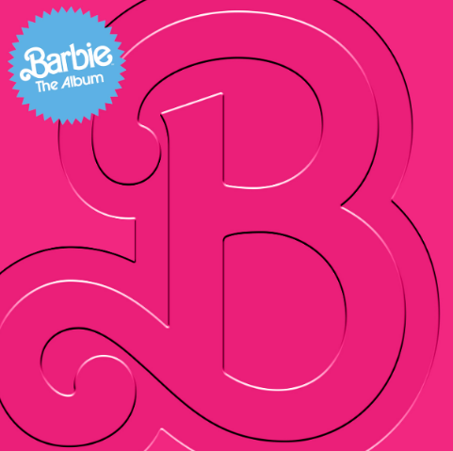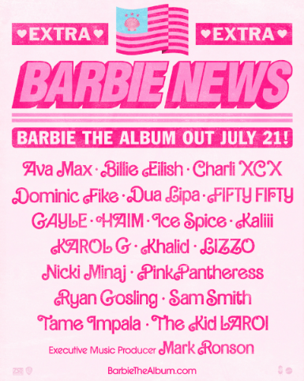
DOWNLOAD HI-RES IMAGES HERE

“#1 Movie Soundtrack of All Time” – COSMOPOLITAN
“the soundtrack of the summer, a cultural moment of pop music's biggest icons” – THE TODAY SHOW
“The soundtrack is more than just an accessory...it is a crucial element in bringing Gerwig’s creative vision to life” – PEOPLE

Atlantic Records has officially unveiled BARBIE THE ALBUM, the groundbreaking musical companion to the highly anticipated summer event film Barbie, starring Margot Robbie and Ryan Gosling as Barbie and Ken and distributed by Warner Bros. Pictures. The star-studded soundtrack is now available globally at all retailers and streaming services, featuring the recently announced track, “Man I Am,” from multi-platinum, GRAMMY®, BRIT, Golden Globe and Academy Award-winning artist, Sam Smith. The epic synth pop track was produced by the soundtrack’s executive producer, Mark Ronson alongside Ricky Reed and is written from the perspective of Ken. Further album highlights include Barbie star Ryan Gosling’s extraordinary, scene-stealing original song, “I’m Just Ken,” performed as his character, plus massive unreleased tracks from an unprecedented lineup of global superstars including Lizzo, Tame Impala, The Kid Laroi, HAIM, Khalid, Dominic Fike, Ava Max and GAYLE.

BARBIE THE ALBUM’s internet-breaking rollout first launched in May and the soundtrack has since become a critically acclaimed worldwide pop phenomenon, with more than 500M+ global streams and over 4B+ total social impressions to date across its electric singles and colossal videos. First came the electrifying lead single “Dance The Night” from 3x GRAMMY® Award-winning global superstar Dua Lipa, who also makes a special appearance in the film. Produced by Mark Ronson, Andrew Wyatt and the Picard Brothers, “Dance The Night” arrived alongside a dazzling official video featuring a special appearance from Barbie writer/director/executive producer Greta Gerwig (Little Women, Lady Bird) – watch HERE. Global recording artist KAROL G followed with her high-energy anthem, “WATATI (Ft. Aldo Ranks),” which was complemented by an official visual directed by Mike Ho (Nicki Minaj, Megan Thee Stallion, Saweetie) and stars KAROL as she enters the world of Barbie, shot on-site at the World of Barbie in LA – watch HERE. UK-based artist and producer PinkPantheress’ captivating track, “Angel,” dropped next, earning praise from THE NEW YORK TIMES for its “dreamy melody” as ELLE dubbed it “an unexpected party anthem.”

Global megastars Nicki Minaj and Ice Spice then teamed up to take over “Barbie World” with their iconic transformation of Aqua’s classic instantly trending with 600K+ creates across socials while its official TikTok sound boasts over 230M+ video views. First teased at the end of the global Barbie trailer, which hit over 40M views and reached #1 trending on YouTube, “Barbie World” made an explosive Top 10 debut on the BILLBOARD “Hot 100,” officially becoming the highest charting and streaming female rap debut of 2023. Watch the official visual, directed by Hannah Lux Davis and now approaching 28M views, HERE. Charli XCX’s “Speed Drive” continued the streak of hits from BARBIE THE ALBUM, garnering 10M+ streams and 6M+ TikTok views in its first week. The hottest new, history-making K-Pop group, FIFTY FIFTY’s “Barbie Dreams” arrived earlier this month, featuring Atlanta-bred rapper and viral “Area Codes” hitmaker, Kaliii and an interpolation of Janet Jackson’s “Together Again” – listen HERE. Last week saw the premiere of “What I Was Made For?” from the Oscar, Golden Globe and multiple GRAMMY® Award winning Billie Eilish, composed alongside and produced by her brother FINNEAS. The heart-rending ballad arrived with an official self-directed video – watch HERE.

BARBIE THE ALBUM continues the hugely successful partnership between Atlantic Records and Warner Bros. Pictures. The two companies previously teamed up for 2020’s BIRDS OF PREY: THE ALBUM which spawned the RIAA Certified 2x Platinum smash “Boss B*tch” by Doja Cat, along with the 2016’s GRAMMY® Award-nominated SUICIDE SQUAD: THE ALBUM, which topped album charts in over 70 countries around the world, including two consecutive weeks on the Billboard 200, and featured the RIAA Certified Diamond hit “Heathens” by Twenty One Pilots.

BARBIE THE ALBUM was executive produced by internationally renowned DJ and Oscar, Golden Globe and 7x GRAMMY® award winning artist and producer, Mark Ronson and Barbie writer/director/executive producer Greta Gerwig. The soundtrack album was Produced and overseen by Atlantic Records’ West Coast President, Kevin Weaver (Soundtrack Album Producer of The Greatest Showman, Suicide Squad, Daisy Jones & The Six, Birds Of Prey, Furious 7, The Fault in Our Stars, The Fate of the Furious) and Atlantic Records’ EVP and Co-Head of Pop/Rock A&R, Brandon Davis. Named by ROLLING STONE as a “soundtrack guru,” Weaver is a GRAMMY® Award winner and five-time nominee, who has produced numerous multi-platinum soundtrack projects that have amassed tens of millions of albums sold worldwide. Additional key players involved on the project include Soundtrack Album Co-Producers, Brandon Creed and Joseph Khoury, as well as the Barbie Music Supervisor and Album Executive Producer, George Drakoulias.

WHAT CRITICS ARE SAYING ABOUT BARBIE THE ALBUM
“an upbeat, immersive soundtrack full of pop gems from a global who’s who of top pop hitmakers” – BILLBOARD
“more memorable pop moments than most major motion picture soundtracks” – FADER
“a veritable toybox of the biggest pop stars today” – GRAMMY.COM
“BARBIE THE ALBUM is the gift that keeps on giving” – HYPEBAE
“a frontrunner for album of the summer” – THE DAILY BEAST
“The Barbie soundtrack is a pop lover's dream” – ESQUIRE
“a stellar musical experience” – FORBES

ABOUT THE FILM BARBIE
To live in Barbie Land is to be a perfect being in a perfect place. Unless you have a full-on existential crisis. Or you’re a Ken. Warner Bros. Pictures Presents a Heyday Films Production, a LuckyChap Entertainment Production, an NB/GG Pictures Production, a Mattel Production, Barbie. The film will be distributed worldwide by Warner Bros. Pictures and released in theaters only nationwide on July 21, 2023 and internationally beginning July 19, 2023. Directed by Greta Gerwig, Barbie stars Margot Robbie, Ryan Gosling, America Ferrera, Kate McKinnon, Issa Rae, Rhea Perlman, and Will Ferrell. The film is written by Greta Gerwig & Noah Baumbach, based on “Barbie” by Mattel, and produced by David Heyman, Margot Robbie, Tom Ackerley and Robbie Brenner. The executive producers are Gerwig, Baumbach, Ynon Kreiz, Richard Dickson, Michael Sharp, Josey McNamara, Courtenay Valenti, Toby Emmerich and Cate Adams. The film’s music supervisor is George Drakoulias, with music by Mark Ronson and Andrew Wyatt.

BARBIE THE ALBUM TRACKLIST

- Lizzo – Pink
- Dua Lipa – Dance The Night
- Nicki Minaj & Ice Spice – Barbie World (with Aqua)
- Charli XCX – Speed Drive
- KAROL G – WATATI (feat. Aldo Ranks)
- Sam Smith – Man I Am
- Tame Impala – Journey To The Real World
- Ryan Gosling – I’m Just Ken
- Dominic Fike – Hey Blondie
- HAIM – Home
- Billie Eilish – What Was I Made For?
- The Kid LAROI – Forever & Again
- Khalid – Silver Platter
- PinkPantheress – Angel
- GAYLE – butterflies
- Ava Max – Choose Your Fighter
- FIFTY FIFTY – Barbie Dreams (feat. Kaliii)

CONNECT WITH BARBIE THE ALBUM:
BARBIETHEALBUM.COM | INSTAGRAM | TIKTOK | TWITTER | FACEBOOK | PRESS SITE

BARBIE THE ALBUM PRESS CONTACT:
ANDREW GEORGE
ANDREW.GEORGE@ATLANTICRECORDS.COM

