FOR IMMEDIATE RELEASE
JULY 21, 2023

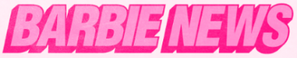

ATLANTIC RECORDS CELEBRATES THE RELEASE OF BARBIE WITH
BARBIE THE ALBUM (BEST WEEKEND EVER EDITION)
SURPRISE BONUS TRACKS NOW AVAILABLE INCLUDING
BRANDI CARLILE & CATHERINE CARLILE’S GORGEOUS COVER OF INDIGO GIRLS’ “CLOSER TO FINE”
AND RYAN GOSLING’S RENDITION OF MATCHBOX TWENTY’S “PUSH” FROM BARBIE

BARBIE THE ALBUM ALREADY A CRITICALLY ACCLAIMED WORLDWIDE POP PHENOMENON
WITH OVER 500M+ GLOBAL STREAMS PRIOR TO OFFICIAL RELEASE

STREAM BARRBIE THE ALBUM (BEST WEEKEND EVER EDITION) NOW
WATCH THE OFFICIAL SOUNDTRACK TRAILER

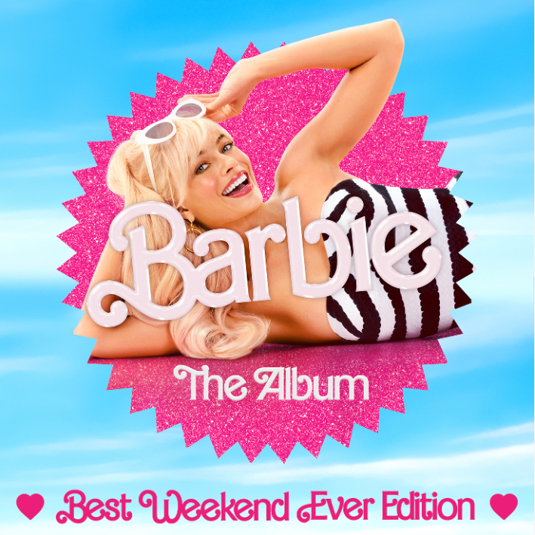
DOWNLOAD HI-RES IMAGES HERE

Atlantic Records is celebrating the official release of BARBIE THE ALBUM with BARBIE THE ALBUM (BEST WEEKEND EVER EDITION) available now at all retailers and streaming services. The special edition of the groundbreaking musical companion to the highly anticipated summer event film Barbie, features two surprise bonus tracks including Brandi Carlile’s stunning cover of longtime friends’ the Indigo Girls’ “Closer To Fine” with her wife, Catherine Carlile as well as Barbie star Ryan Gosling’s iconic cover of Matchbox Twenty’s “Push,” as performed in the film, Barbie. See below for full tracklisting and watch the official soundtrack trailer HERE.

FOR MORE INFO ON BARBIE THE ALBUM, DOWNLOAD THE OFFICIAL PRESS RELEASE HERE

WHAT CRITICS ARE SAYING ABOUT BARBIE THE ALBUM
“#1 Movie Soundtrack of All Time” – COSMOPOLITAN
“The soundtrack is more than just an accessory...it is a crucial element in bringing Gerwig’s creative vision to life” – PEOPLE
“an upbeat, immersive soundtrack full of pop gems from a global who’s who of top pop hitmakers” – BILLBOARD
“the soundtrack of the summer, a cultural moment of pop music's biggest icons” – THE TODAY SHOW
“more memorable pop moments than most major motion picture soundtracks” – FADER
“a veritable toybox of the biggest pop stars today” – GRAMMY.COM
“BARBIE THE ALBUM is the gift that keeps on giving” – HYPEBAE
“a frontrunner for album of the summer” – THE DAILY BEAST
“The Barbie soundtrack is a pop lover's dream” – ESQUIRE
“a stellar musical experience” – FORBES

BARBIE THE ALBUM (BEST WEEKEND EVER EDITION) TRACKLIST

- Lizzo – Pink
- Dua Lipa – Dance The Night
- Nicki Minaj & Ice Spice – Barbie World (with Aqua)
- Charli XCX – Speed Drive
- KAROL G – WATATI (feat. Aldo Ranks)
- Sam Smith – Man I Am
- Tame Impala – Journey To The Real World
- Ryan Gosling – I’m Just Ken
- Dominic Fike – Hey Blondie
- HAIM – Home
- Billie Eilish – What Was I Made For?
- The Kid LAROI – Forever & Again
- Khalid – Silver Platter
- PinkPantheress – Angel
- GAYLE – butterflies
- Ava Max – Choose Your Fighter
- FIFTY FIFTY – Barbie Dreams (feat. Kaliii)
- Brandi Carlile & Catherine Carlile – Closer To Fine
- Ryan Gosling – Push

CONNECT WITH BARBIE THE ALBUM:
BARBIETHEALBUM.COM | INSTAGRAM | TIKTOK | TWITTER | FACEBOOK | PRESS SITE

BARBIE THE ALBUM PRESS CONTACT:
ANDREW GEORGE
ANDREW.GEORGE@ATLANTICRECORDS.COM

