SAM AUSTINS RELEASES DECADENT, GLAM VIDEO FOR “SWEET TOOTH”

COMES OFF COSMIC, SWAGGERING EP BOY TOY OUT NOW VIA ATLANTIC

WATCH IT HERE

BUY/STREAM BOY TOY HERE

Critical praise for Sam Austins:

“A surging slice of energy that fuses 00 indie – think the Strokes, or the Walkmen – with his own patent brand of ultra-individual pop music” – CLASH
“Spearheading Detroit’s musical renaissance” – NME
“Chic…90s-inflected alternative and R&B grooves…melds past experience and future fantasy into powerful sonic motifs” – The Line Of Best Fit

Photo by Devon Williams

Today, Detroit-raised and LA-based Sam Austins releases a red-hot video for “Sweet Tooth,” which comes off his recent psych-rock EP Boy Toy that arrived last month via Atlantic Records. “Sweet Tooth” is a buoyant and glittering track with a glossy guitar-led soundscape that’s juxtaposed with the poignant lyrics about feeling rejected. The romantic, lo-fi video directed by mothermary starts with Austins draped in satin with an invitation to a feast and ends with a harem of women poisoning him and displaying his head as the dinner party’s centerpiece.

BOY TOY is Austins’ most sophisticated work to date, showcasing his unparalleled growth with an enthrallingly catchy blend of alt-rock and psych-pop, reflecting on his tumultuous past that saw a period of homelessness. Austins has named Radiohead, Outkast and D’Angelo as some of his sonic influences on the EP with Michigan’s rich musical history woven throughout. BOY TOY’s guitars are reminiscent of Jack White’s, while his vocals exude Prince’s swagger.

The release of BOY TOY follows recent singles “Oatmeal Pancakes,” “Keep You Company,” “Dancing With The Devil,” and “Matador,” which follow his 2021 debut LP HOMELESS STAR. Austins’ sound morphs with the malleability of a living and breathing entity, reforming to reflect his emotions and, ultimately, reshaping what alternative music can be with a series of independent releases. He earned placements on major television shows like HBO’s Euphoria, and shared stages with Vince Staples, Danny Brown, and Playboi Carti, to name a few. He released HOMELESS STAR in 2021, his debut for Atlantic Records that gathered millions of streams and landing looks from Vogue, HYPEBEAST, and Pigeons & Planes.

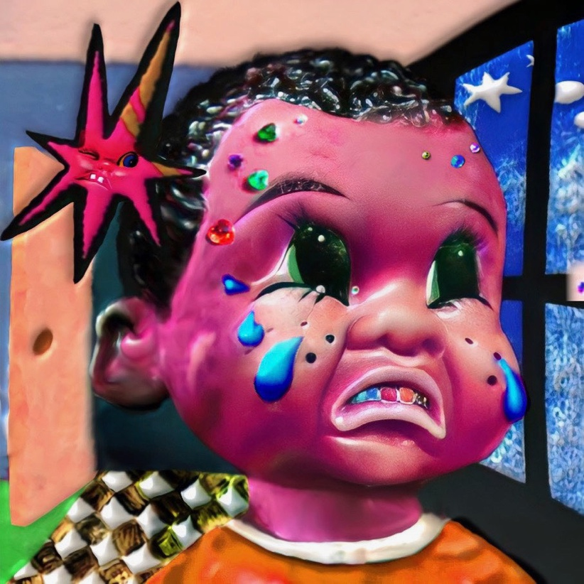

CONNECT WITH SAM AUSTINS
WEBSITE | FACEBOOK | INSTAGRAM | TWITTER | YOUTUBE

PRESS CONTACTS
Fairley McCaskill | Fairley.McCaskill@atlanticrecords.com
Katy Carmichael (Tour) | Katy.Carmichael@atlanticrecords.com

Carrie Tolles | carrie@tcbpr.com
Alison Smith | Alison@tcbpr.com
Claire Marcus | Claire@tcbpr.com

