FOR IMMEDIATE RELEASE
JULY 24, 2023

TRAETWOTHREE PRESENTS “FEEL GOOD (FEAT. KALAN.FRFR)”

SOUTH CENTRAL R&B ARTIST SHARES OFFICIAL MUSIC VIDEO FOR BUOYANT NEW SINGLE

SOPHOMORE EP, LONG STORY SHORT, AVAILABLE NOW
VIA NCREDIBLE / ART@WAR / ATLANTIC RECORDS HERE

LISTEN TO “FEEL GOOD (FEAT. KALAN.FRFR)” | WATCH OFFICIAL MUSIC VIDEO

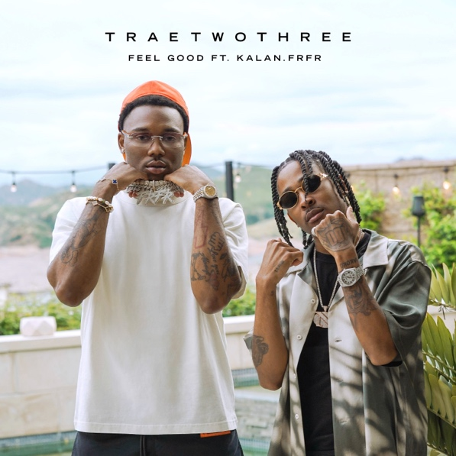
Download High-Res Artwork

South Central R&B sensation TRAETWOTHREE has shared the official music video for his latest single, “Feel Good (Feat. Kalan.FrFr),” directed by filmmaker Keoni Mars (Roddy Ricch, Ty Dolla $ign, Lil Wayne) and premiering today at YouTube HERE

“Feel Good (Feat. Kalan.FrFr)” is but one of the highlights found on TRAETWOTHREE’s sophomore EP, LONG STORY SHORT, available now via Ncredible / Art@War / Atlantic Records HERE. The project further includes such recent hit singles as “Outside Like This” and “Watch It Grow (Feat. Sevyn Streeter),” both joined by companion videos directed by Mars and streaming now at TRAE’s official YouTube channel HERE.

Last year saw the release of TRAETWOTHREE’s debut mixtape, OUT THE DISTRICT, available for streaming and download HERE. The project includes such tracks as “710 (Feat. DW Flame),” “Stuck In My Ways (Feat. Blueface),” “Done Done,“ “Worth It (Feat. DDG), and “Keep Doing You,” the latter of which is joined by an official music video streaming HERE. In addition to millions of

(-more-)
worldwide streams, OUT THE DISTRICT earning acclaim from such outlets as Billboard, VH1, Rated R&B, and AllHipHop.com, the latter of which applauded TRAE for a “different sound that people have never heard before.” TRAETWOTHREE will celebrate the one year anniversary of OUT THE DISTRICT on July 27th.

TRAETWOTHREE embodies the best elements of his native Los Angeles. He switches lanes between the smooth hip-hop of a Sunday afternoon backyard party in South Central and the smoked-out woozy R&B of a joyride from Venice Beach to Malibu. At the same time, he channels Afrobeats rhythms befitting of the city’s African enclaves and his own Nigerian roots. The Crenshaw-raised singer and songwriter invite listeners to sit in the passenger seat as he cruises the place he proudly calls home and experiences trials, tribulations, and triumphs after dark. As the story goes, he rotated between homes, living with his mom, dad, and grandma. With his parents as Jehovah’s Witnesses, he absorbed faith through his family. He played saxophone throughout middle school and spun records by the likes of Gerald Albright, David Sanborn, Candy Dulfer, Tank, Tyrese, Erykah Badu, and The Isley Brothers. Embracing Drake, J. Cole, and Nipsey Hussle, he wrote and recorded music in his bedroom at the age of sixteen, fashioning a fresh and fiery perspective on R&B. He serendipitously linked up with Ncredible when team members bought sneakers from him during his part-time gig at Dick’s Sporting Goods. Nick Cannon heard his music and signed him. “TRAETWOTHREE is a fresh new voice in R&B. I have the same feeling about him as I did when I found Kehlani.”

TRAE’s deal with Ncredible / Art@War – the innovative label founded by Nick Cannon in conjunction with entertainment executive James McMillan’s Art@War venture – and Atlantic Records soon saw tracks like “4am In The District,” “High Tec,” and Hitman Holla’s “Drownin” quickly earn over 650K Spotify streams and close to 500K YouTube views. TRAETWOTHREE also teamed with Nick Cannon on his THE EXPLICIT TAPE: RAW & B album and “Nick Cannon Presents: Wild 'N Out” North American arena tour, showing the world a different side of the South Central story with his music.

# # #

CONNECT WITH TRAETWOTHREE
FACEBOOK | INSTAGRAM | TWITTER | YOUTUBE

PRESS CONTACT
FAIRLEY MCCASKILL | FAIRLEY.MCCASKILL@ATLANTICRECORDS.COM

