TY DOLLA $IGN RETURNS TO THE ROAD ON THE
“MORE MOTION LESS EMOTION TOUR”

WITH SPECIAL GUESTS SYMBA & LEON THOMAS
SOUNDS BY DRE SINATRA

ACCLAIMED MUSICAL POWERHOUSE’S NORTH AMERICAN TOUR
KICKS OFF SEPTEMBER 15 IN SAN DIEGO, CA

TICKETS GO ON SALE THIS FRIDAY, JUNE 23 AT 10AM LOCAL

FOR ALL TICKET INFORMATION & PRE-SALE ACCESS, VISIT WWW.DOLLASIGNWORLD.COM/TOUR

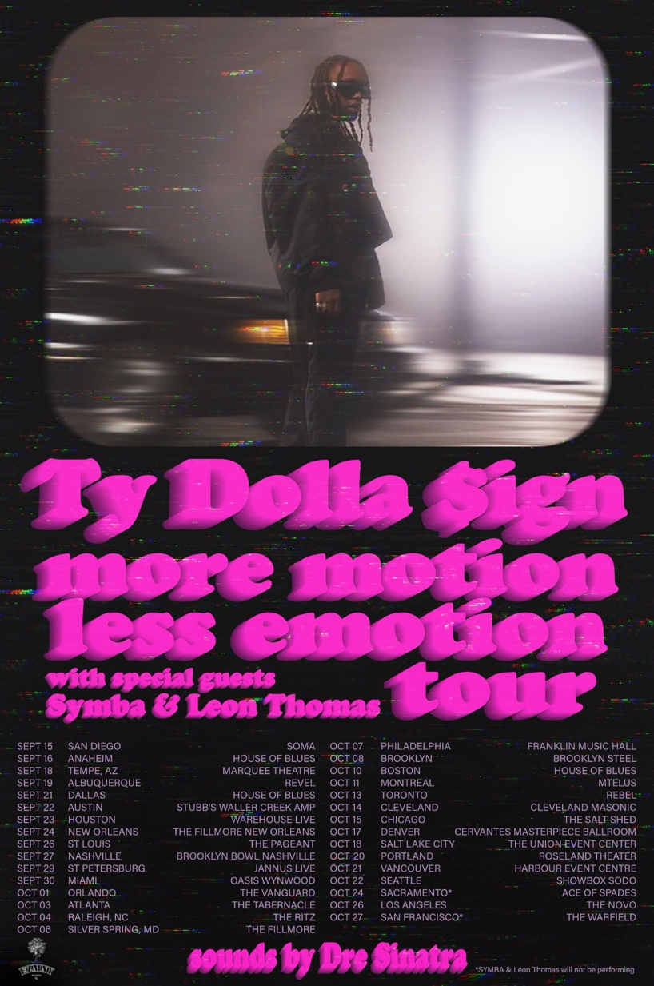

(Los Angeles, CA – June 20, 2023) – Acclaimed singer/songwriter/producer TY DOLLA $IGN makes his triumphant return to the stage with his upcoming “MORE MOTION LESS EMOTION TOUR.” The 31-city tour kicks off on September 15 in San Diego, CA and will feature special guests rising West Coast rapper, Symba & rising R&B singer, Leon Thomas, who is signed to Ty’s EZMNY label imprint, as well as sounds from Ty’s longtime DJ, Dre Sinatra.

General ticket on-sale begins this Friday, June 23 at 10am local time. For all ticket information & pre-sale access, please visit www.dollasignworld.com/tour.

Today’s announcement of the ”MORE MOTION LESS EMOTION TOUR” comes on the heels of the release of Ty’s new single “Motion,” which The New York Times praised Ty who “…found a new groove on the breezy, house-inflected summer-ready track,” while FADER declared the single is “…custom-built for the summer heat.” Download/Stream | Watch official music video

“Motion” is the first single off the Los Angeles native’s forthcoming new EP due out this Summer. This July, Ty will celebrate the 10-year anniversary of his acclaimed mixtape, BEACH HOUSE 2, which featured the classic songs “Paranoid,” “Irie” and more.

* * *

ABOUT TY DOLLA $IGN
Hailed as “one of the richest R&B talents of the last decade” by The New York Times, Ty Dolla $ign is a multiple GRAMMY-nominated musical powerhouse who has single-handedly shaped the music industry with his undeniable classic songs (“Paranoid,” “Or Nah,” “Blasé”,) chart-topping collaborations (“Psycho” with Post Malone, “Work From Home” with Fifth Harmony) and genre-defying songwriting and production contributions (JAY-Z & Beyonce, Kanye West, Rihanna, Mariah Carey, Drake, Chris Brown, Christina Aguilera, Khalid, Wiz Khalifa and more.)

With over 10 billion streams, 10 million singles sold and a career-to-date total of over 50 RIAA platinum and gold certifications, the Los Angeles native’s solo discography features the critically acclaimed albums Free TC (2015), Beach House 3 (2017) and Featuring Ty Dolla $ign (2020) and the timeless mixtapes Beach House, Beach House 2, Sign Language, Airplane Mode and Campaign.

For all Ty Dolla $ign press inquiries, please contact:
Jason Davis | Jason.Davis@atlanticrecords.com

* * *

‘MORE MOTION LESS EMOTION TOUR’ DATES
** dates without Symba & Leon Thomas

SEPTEMBER
9/15 – San Diego, CA - SOMA
9/16 – Anaheim, CA – House of Blues
9/18 – Tempe, AZ – Marquee Theatre
9/19 – Albuquerque, NM – Revel
9/21 – Dallas, TX – House of Blues
9/22 – Austin, TX – Stubb’s Waller Creek Amphitheater
9/23 – Houston, TX – Warehouse Live
9/24 – New Orleans, LA – The Fillmore New Orleans
9/26 – St. Louis, MO – The Pageant
9/27 – Nashville, TX – Brooklyn Bowl Nashville
9/29 – St. Petersburg, FL – Jannus Live
9/30 – Miami, FL – Oasis Wynwood

OCTOBER
10/1 – Orlando, FL – The Vanguard
10/3 – Atlanta, GA – Tabernacle
10/4 – Raleigh, NC – The Ritz
10/6 – Silver Spring, MD – The Fillmore Silver Spring
10/7 – Philadelphia, PA – Franklin Music Hall
10/8 – Brooklyn, NY – Brooklyn Steel
10/10 – Boston, MA – House of Blues
10/11 – Montreal, QC – MTELUS
10/13 – Toronto, ON – Rebel
10/14 – Cleveland, OH – Masonic Cleveland
10/15 – Chicago, IL – The Salt Shed
10/17 – Denver, CO – Cervantes’ Masterpiece Ballroom
10/18 – Salt Lake City, UT – The Union Event Center
10/20 – Portland, OR – Roseland Theater
10/21 – Vancouver, BC – Harbour Event & Convention Centre
10/22 – Seattle, WA – Showbox SoDo
10/24 – Sacramento, CA – Ace of Spades**
10/26 – Los Angeles, CA – The Novo
10/27 – San Francisco, CA – The Warfield**

Connect with Ty Dolla $ign:
Instagram | Twitter | Facebook | YouTube | Website

