BIZZY BANKS RELEASES LYRIC VISUAL FOR LATEST SINGLE “FEELINGS”

OFFICIAL VISUAL AND AUDIO RELEASED LAST WEEK

FOLLOW-UP TO THE PREVIOUSLY RELEASED SINGLE “OK OK OK”

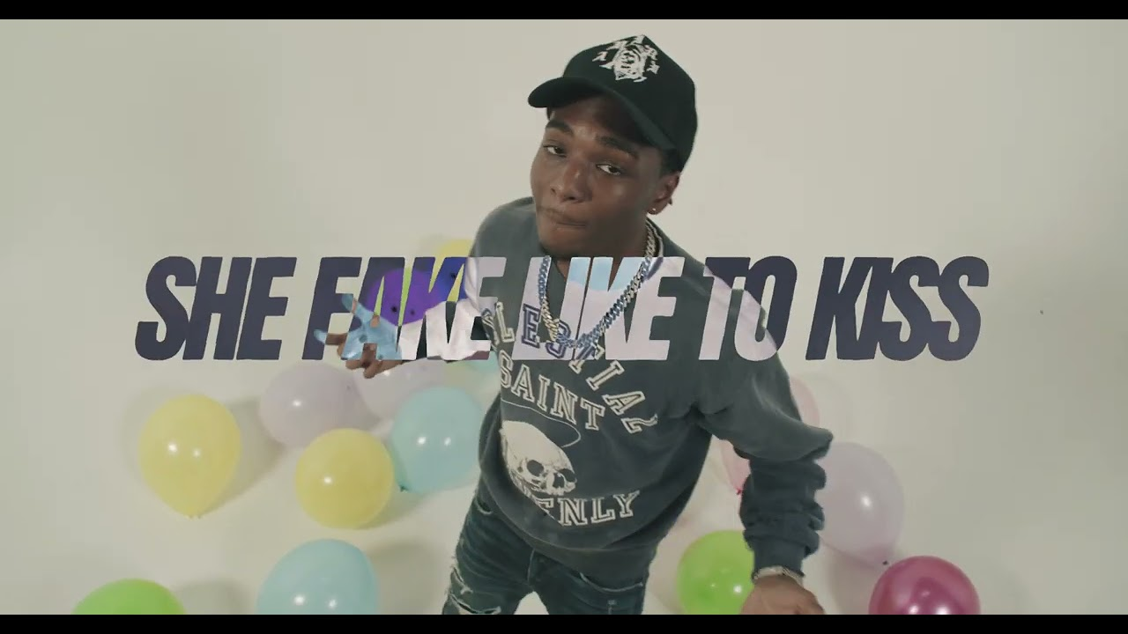
WATCH HERE | DOWNLOAD HERE

# # #

BIZZY BANKS
In the short time since Bizzy emerged on the New York drill scene, he has racked up co-signs from some of the most notable names like NY heavyweights like Lil Tjay and Pop Smoke before his passing. His feature on Pop Smoke’s FAITH album, “30”, was touted by Brooklyn Vegan as the “best collab on the album” and received critical acclaim while sitting on the OCC for its 62nd week. Pitchfork named “Top 5”, a release from Bizzy’s 2020 label-debut mixtape “G.M.T.O. Vol. 1 (Get Money Take Over)” as one of “The 36 best rap songs of 2020” and is currently sitting at 5.9 million views. His single “Don’t Start Pt. 2” is a certified hit boasting over 8.8 million views on YouTube. The finesse and astute lyricism showcased on his debut mixtape won Bizzy a nomination for the XXL 2021 Freshman class as well as the #10 spot on Rolling Stone’s “Breakthrough 25” highlighting the fastest rising artists. Since the start of 2022, Bizzy has released three singles to add to his burgeoning catalog, “Don’t Know How To Act,” “I Can’t,” and “No Passes.” Bizzy was also brought out on J.I.’s “Young and Restless” Tour in September 2022.

Bizzy’s previously released single “No Passes,” proved that the young star has no signs of slowing down. Premiered by DJ Whoo Kidd on his Shade 45 radio show and accompanied by Bizzy’s basketball clinic for fans, Bizzy continues his return to the front of Brooklyn drill scene. “I Can’t” marked the first official single since Bizzy’s release and was accompanied by not only the visual but also his On The Radar freestyle that is now at over 508K views. “Don’t Know How To Act” was the long-anticipated follow-up to last year’s stand-out mixtape, SAME ENERGY, available now at all DSPs and streaming services HERE. SAME ENERGY includes such singles as “Bandemic,” “My Shit,” “Azul,” “Driftin’,” “City Hot,” and “Adore You (Feat. PnB Rock),” all accompanied by official music videos streaming now at YouTube HERE. Produced by D.A. Got That Dope (Megan Thee Stallion, Da Baby), “Adore You,” featuring the late PnB Rock, was met with praise from such outlets as XXL, which raved, “Bizzy can jump from flow to flow, plus his references are clever…The slow groove puts the rhymer in a prime position to keep evolving.” “Some of the best music he's released yet,” enthused Brooklyn Vegan. “(Bizzy) seems poised to be one of New York drill's biggest breakouts since the untimely death of Pop Smoke.”

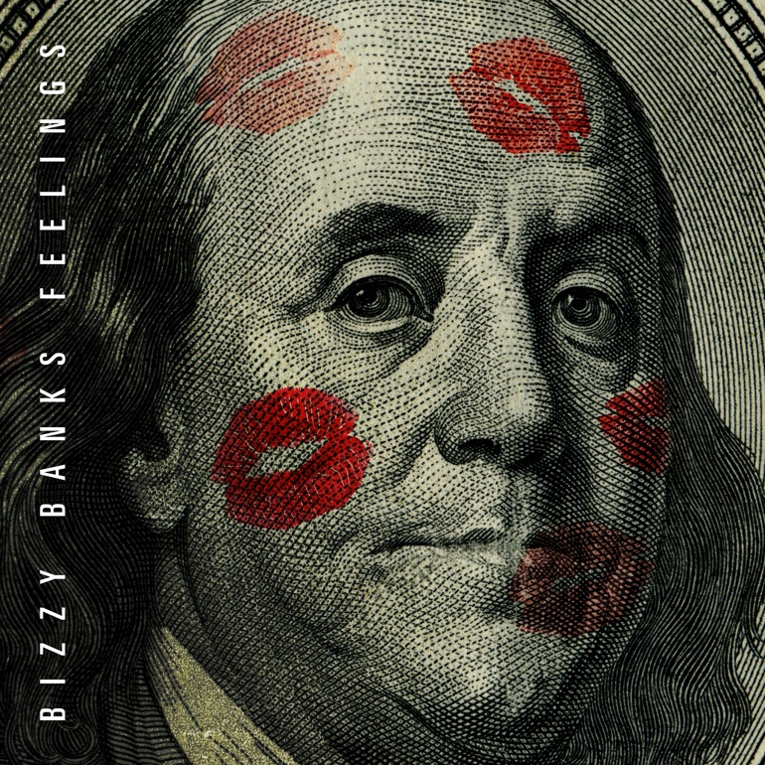
DOWNLOAD HI-RES ARTWORK

CONNECT WITH BIZZY BANKS
INSTAGRAM | TWITTER | YOUTUBE

FOR ALL INQUIRIES, CONTACT
ARIANA.WHITE@ATLANTICRECORDS.COM

