FOR IMMEDIATE RELEASE
AUGUST 22, 2023

daniel leggs lifts the curtain on “part of the play”

rising alt-pop star continues prolific year with latest single

“part of the play” available now via Overall Recordings/Atlantic Records

listen to “part of the play”

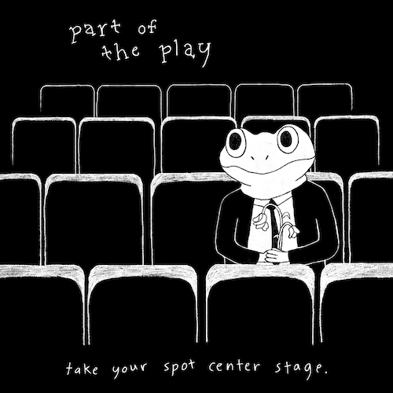
download hi-res artwork

Alt-pop singer-songwriter-producer Daniel Leggs has shared his eagerly awaited new single, “part of the play,” available now via Overall Recordings/Atlantic Records.

“I wrote ‘part of the play’ about the American dream,” shared Daniel. “It’s a story about a girl who is watching all of her dreams as a performer come true and the ups and downs that come with it. When I made the song I imagined a room full of observers including myself, waiting to see what she does next on stage. There’s something super intense and fun about that one moment being blown into a big, dramatic song.”

“part of the play” continues an ongoing run of new music from Daniel Leggs, including such recently released tracks as “the banker” and “good kid,” both available everywhere now. This year also saw the arrival of Leggs’ long-awaited debut EP, runaway, available everywhere now HERE. The final installment in a remarkable series of monthly song premieres, the EP collects warm-hearted tracks like “sausalito,” “gatsby,” “stay in my dreams,” “ticket home” (co-written with 6x RIAA Platinum-certified singer-songwriter gnash), and the viral favorite, “crutches,” the latter of which is joined by a whimsical animated music video streaming HERE.

In a world of emotional uncertainty, music is the only thing Daniel Leggs is sure of. Growing up as a concert-trained pianist too shy to express himself in daily life beyond gratitude and kindness, the 23-year-old tunesmith has found himself via a series of intimate, ingenious pop ditties which expertly capture the ups, the downs, the heartbreak, and longing for something more of a gifted young artist making his way in 21st century New York City. Written, recorded, mixed, and mastered in a central Rhode Island basement studio, Leggs’ budgeted studio model produces a distinctive sound that combines relatable lyrics with experimental imperfections to manifest something beautiful and all his own.

“I’m definitely an observer. I believe there’s so much power in the little things—whether it’s a phrase you hear a million times such as ‘good kid’ or a ‘small’ life event like a first date,” says Daniel Leggs. “I love turning these ‘details’ into songs. In a way, my music magnifies these little moments as big as possible. I believe by sharing them with one another we realize that they’re not so small after all. I hope I can just write the soundtrack to being human.”

# # #

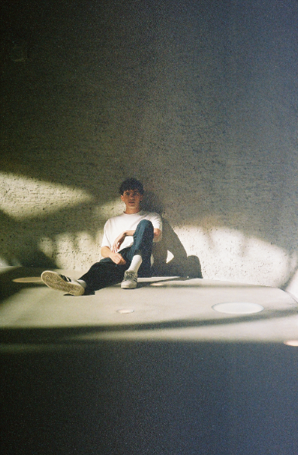
download hi-res image // photo credit: rosabelle eales
CONNECT WITH DANIEL LEGGS
OFFICIAL | INSTAGRAM | SOUNDCLOUD | TIKTOK | TWITTER | YOUTUBE

For press inquiries, please contact:
Jessica Nall // Jessica.Nall@atlanticrecords.com

