FOR IMMEDIATE RELEASE
AUGUST 11, 2023

DANIEL SEAVEY SURPRISES FANS WITH DANCING IN THE DARK
LONG-AWAITED DEBUT SOLO EP AVAILABLE NOW
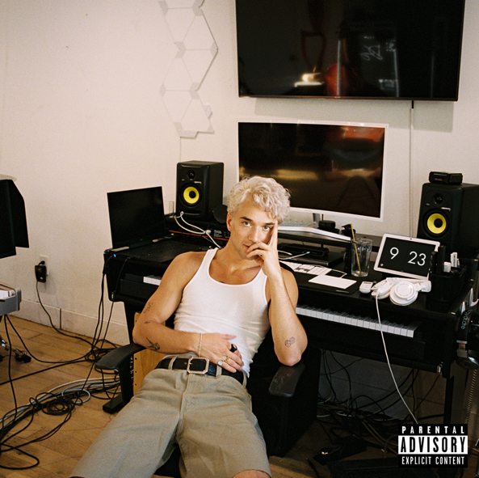
DOWNLOAD HIGH-RES ART/IMAGES

STREAM DANCING IN THE DARK EP: LINK

“Daniel Seavey is ready to showcase his impeccable production skills, stellar vocals, and personal artistry in his music as a solo artist” – ROLLING STONE

“… this solo leg of his musical journey is to be one overflowing with potential.” – WONDERLAND

“With Seavey on his own, it’s clear he’s overflowing with ideas — and wasting no time exploring them all at once” – BILLBOARD

“Music came naturally for Daniel Seavey — so there was no denying what his true calling was.” – PEOPLE

Multi-platinum singer/songwriter, multi-instrumentalist and producer Daniel Seavey has surprised dropped his debut solo EP Dancing in the Dark – available now. The 7-track collection marks the first release from Seavey in over 7 months, amidst his ongoing legal battle for musical freedom that left him in creative limbo.

“While time has passed and I’ve lived with these songs for awhile, they are still just as dear to me as the day I made them (if not more) and I’m so excited to finally share them with my fans – especially the ones that screamed the lyrics back to me every night on the road. This EP represents my journey out of the darkness and into the light, it represents the power of music.”
– Daniel Seavey (full statement via PEOPLE.com)

Dancing in the Dark features Seavey’s most recent single “I Tried,” which was named among The Best Songs of 2023 So Far by Rolling Stone, following his debut solo releases “Can We Pretend That We’re Good?” and “Runaway.” The explosive self-penned/produced trio were deemed “punchy and experimental” by Billboard, while Rolling Stone further praised Seavey for his “impeccable production skills, stellar vocals, and personal artistry.” The songs have tallied over 40 million global streams collectively since release, further highlighted by alternate versions showcasing the artist’s versatile musicality across over 20 instruments.

Embarking on a new chapter of his career, Seavey made his solo debut in late 2022 and quickly followed with a sold-out 2023 Introducing Daniel Seavey headline tour. The 17-show run sold out in minutes, with the skilled set featuring a mix of new tracks and dynamic covers produced live in real time for fans. Initially premiered on the road, Dancing in the Dark includes hotly anticipated cuts from the show’s setlist including fan-favorites “Leave Me Alone” and “Fall Into You.”

In 2016, Seavey co-founded Why Don’t We and embarked upon an unbelievable six-year journey highlighted by over 4 billion global career streams, two RIAA Platinum-certified singles, five RIAA Gold-certified singles, two Top 10 albums on the Billboard 200 chart, and sold out tours with multiple stops at legendary venues such as Radio City Music Hall and more. On the road, he often penned and produced nascent ideas that would eventually become the foundation of his own unique sound. In 2022, he hunkered down in his home studio and wrote and recorded what he anticipated would become his debut album. He not only sang and produced, but he also played every instrument, infusing a piece of himself upon each facet. Now following an excruciating legal process, Seavey is prepped to enter 2024 as a free artist. By releasing his work thus far on Dancing in the Dark, he hopes to hold fans over as he begins creating an album he describes as “full of more experience, more joy, and more weightlessness than ever before.”

Dancing in the Dark EP
1. Fall Into You
2. Give It A Week
3. Nothing Compares To You
4. Can We Pretend That We’re Good?
5. I Tried
6. Leave Me Alone
7. Runaway

CONNECT:
DanielSeavey.com | Instagram | TikTok | Twitter | YouTube | SoundCloud | Press Assets

CONTACT:
Ted Sullivan (Atlantic Records) | ted.sullivan@atlanticrecords.com

