FOR IMMEDIATE RELEASE
MAY 12, 2023

BROOKLYN SONGSTRESS ENISA RETURNS WITH LATEST SINGLE
“BLAME IT ON ME”

ACCOMPANIED BY AN OFFICIAL COMPANION VISUAL

FOLLOW-UP TO RELEASE OF WORLD CUP TRIBUTE SONG “OLÈ”

COMES ON THE HEELS OF HEADLINING SHOW AT MUSIC HALL OF WILLIAMSBURG

WATCH/SHARE “BLAME IT ON ME”
DOWNLOAD/STREAM “BLAME IT ON ME”

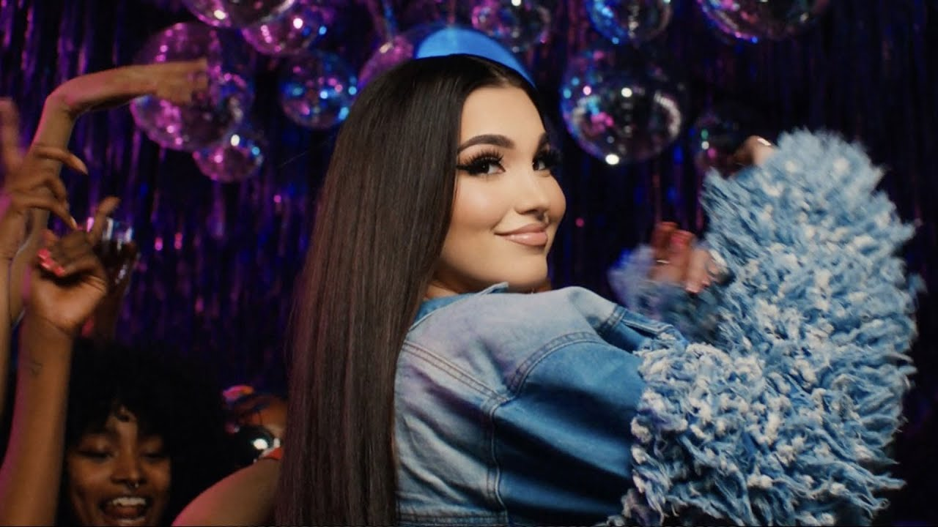

Brooklyn-based songstress Enisa has shared her latest single, “Blame It On Me.” "Blame It On Me" brings fun, youthful energy to listeners accompanied by an official video that includes a night out dancing with friends. The single also comes on the heels of her World Cup tribute song “Olè” and “Just A Kiss (Muah).” The latter has now surpassed over 19M audio streams worldwide and over 10M views. Last week, the rising star headlined a New York show at the Music Hall of Williamsburg and played several songs from her growing catalog. This performance comes on the heels of her appearance and performance at the 2023 Business of Women’s Sports Summit.

Enisa continues her run of fun and lively single releases with “Blame It On Me.” "We all have stresses and things we worry about in our lives on a daily basis” says Enisa. “I wrote this song about wanting to break free from all those worries and just let loose for one day! It’s a feeling that I know everyone has once felt & I feel like can relate too! Whatever crazy stuff that happens for this one night, you can just BLAME IT ON ME!” Enisa collaborated with T.I Jakke and Carmen Reece for this exciting release.

Enisa used 2022 to her advantage releasing a flurry of exciting singles this year following the release of her Fake Love EP. These releases include official visuals and in-studio performances for “Zoom” and “Just A Kiss (Muah).” She followed up these releases with her World Cup tribute song, “Olè,” which has now accumulated over 2.8M views. Enisa made her TV debut with her performance of her song “Green Light” on NBC’s American Song Contest.

With over 187M worldwide streams and more than 315M total video views, Enisa has proven a truly global favorite, earning chart-topping success in Albania, Turkey, Germany, Switzerland, France, Nigeria, Gambia, Portugal, Algeria, Tunisia, Morocco, Sri Lanka, and India, to name a few. “Get That Money” marked one of several singles in a continuing series of increasingly popular releases from the First Lady of Highbridge The Label, following “Tears Hit The Ground” (2.9M views), “Love Cycle” (17M views), “Dumb Boy” (16M views), and the smash hit, “Count My Blessings” (62M views).

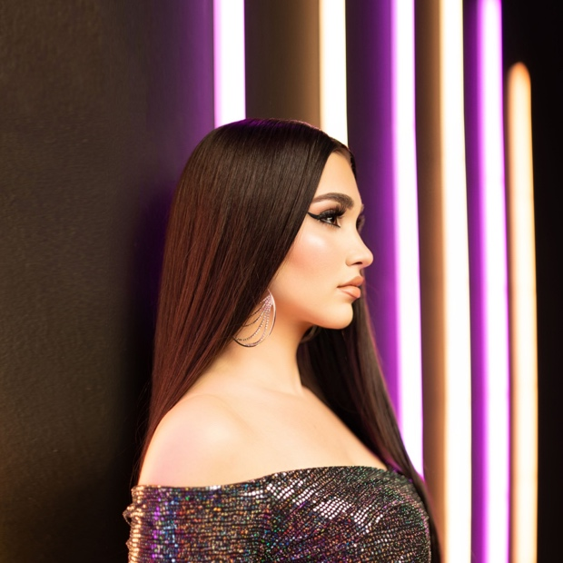
DOWNLOAD HI-RES PHOTO

ABOUT ENISA
Enisa has spent her whole life preparing for this journey as a first-generation American born to Albanian immigrant parents. Following her graduation from Brooklyn’s esteemed Edward R. Murrow High School, she attended Brooklyn College where she continued to develop her unique musical vision. A series of distinctive cover versions exploded across social media, earning her millions of views and critical acclaim from the likes of Complex, XXL, ThisSongIsSick, and more. With the wind at her back, Enisa continued to hone her diverse musical approach, infusing contemporary soul pop with Balkan and Middle Eastern flourishes with a touch of European pop inspired by her own Muslim heritage. Track releases like Scridge and Genda’s viral smash “Karma (Remix)” and such solo singles as “Burn This Bridge” and “Wait for Love” showcased a spectacular knack for raw soul and endless attitude, earning her more than 16M views and over 3M global streams as an independent artist.

2021 proved a milestone year for Enisa, highlighted by a cover appearance in Out Now, debut live performances at NYC’s legendary SOB’s and Sacramento, CA’s Lost In Riddim festival, and a social media explosion that now sees close to 9M total followers around the world, including 5.6M on TikTok and over 1.44M YouTube subscribers.

Early 2022 saw the release of Enisa’s Fake Love EP, a body of work that Enisa describes as “empowering” and “authentic” which features the standout tracks “Tears Hit The Ground” and “One Thing,”. The new year also brought with it, Enisa’s television debut as a contestant on the NBC musical reality competition “American Song Contest” in which she represented her home state of New York. With so much in the works, it’s clear that 2022 will be another blockbuster year for the Brooklyn-based songstress. Since then, Enisa has blessed fans with a flurry of releases including standout hits “Zoom” and “Just A Kiss (Muah).” She ended the year with a World Cup tribute song, “Olè,” which now boasts over 2.8M views.

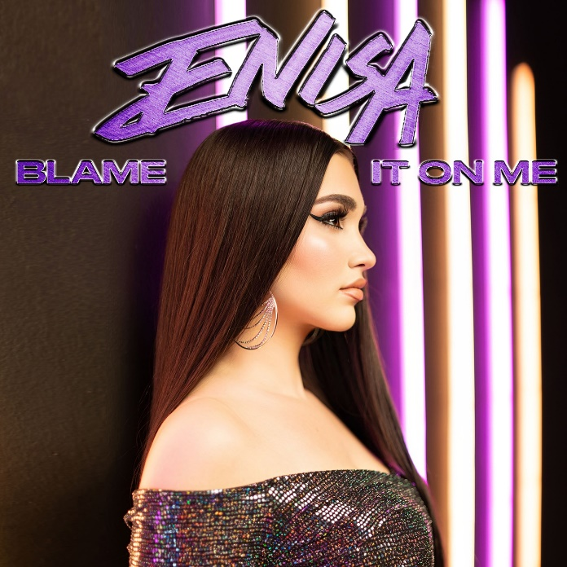
DOWNLOAD HI-RES ARTWORK

CONNECT WITH ENISA
OFFICIAL | INSTAGRAM | FACEBOOK | TWITTER | TIKTOK | YOUTUBE

FOR ALL INQUIRIES
SELAM BELAY
SELAM.BELAY@ATLANTICRECORDS.COM

