FOR IMMEDIATE RELEASE
AUGUST 4, 2023

FAOUZIA KICKS OFF HER DOLL SUMMER WITH “LA LA LA”

INTERNATIONALLY ACCLAIMED ARTIST CELEBRATES NEW ERA
WITH FIERCELY ENERGETIC SUMMER ANTHEM

LISTEN TO “LA LA LA” HERE


DOWNLOAD HI-RES ARTWORK HERE

“One of the most powerful new voices you’ll hear this year.”
– BILLBOARD

“Faouzia is the Next Big Thing”
– BUSTLE

Internationally acclaimed Moroccan-Canadian singer/songwriter/multi-instrumentalist Faouzia is kicking off her new era of “DOLL SUMMER” with today’s premiere of the fiercely energetic “La La La” - Listen HERE.

“‘I love you’ sounds like ‘la la la,’” says Faouzia. “I’ve had times in life where people have gone too far and apologies start to sound like excuses. Once you cross that line, everything you say starts to sound insincere. So, it’s better to drown it out – la la la.”

“La La La” – which showcases the iconic new visual imagery of what Faouzia has declared “DOLL SUMMER” – marks the latest in a string of spectacular new dance-pop tracks that includes the recently released “Don’t Call Me” and “Plastic Therapy,” both produced by Ryan McMahon (Marina, Addison Rae). In addition, Faouzia recently released “Now Or Never” with Martin Solveig – Watch HERE.

“Don’t Call Me” and “Plastic Therapy” in turn follow this spring’s “I’m Blue.” A haunting and ethereal new rendition of Eiffel 65’s worldwide #1 hit, “Blue (Da Ba Dee),” the track was first recorded by Faouzia more than three years ago, earning millions of worldwide streams and close to 5M video views via YouTube HERE. “I’m Blue” was also featured in the smash Netflix series, Red Rose, rocketing it to Shazam’s “Top 200” in Germany, France, and the UK.

With collaborations with John Legend, Kelly Clarkson, David Guetta, and more, Faouzia has been named an “Artist to Watch” by Variety, Entertainment Weekly, and PEOPLE Magazine, as well as a “Style Star to Watch” by Vogue. With over 1.1B global streams and a combined social reach of over 11M followers – including over 2.26M YouTube subscribers, 2M Instagram followers and more than 3.4M Tik Tok followers – Faouzia has cemented herself as a surefire artist to watch.

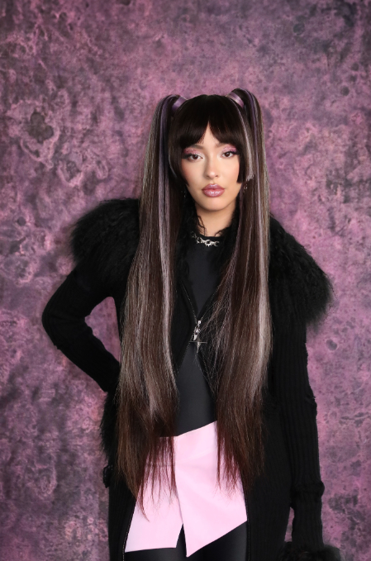
DOWNLOAD PRESS PHOTO HERE

CONNECT WITH FAOUZIA
WEBSITE | FACEBOOK | INSTAGRAM | TIK TOK | TWITTER | YOUTUBE

CONTACT

ATLANTIC RECORDS
Jessica Nall // Jessica.Nall@AtlanticRecords.com

ALIGN PR
Lauren Morris // lmorris@align-pr.com
Sarah Cramer // sarah@align-pr.com
Tatum Norton // tnorton@align-pr.com

