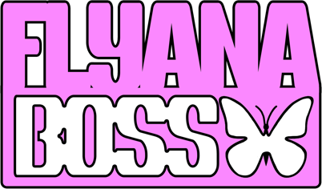
Hailing from Detroit, MI and Dallas, TX - MCs and multi-instrumentalists Bobbi LaNea and Folayan met at a music college in Los Angeles, CA. They immediately hit it off and began collaborating, eventually naming their group, Flyana Boss, (rhymes with Diana Ross). Embodying the spirit of flyness and bossness, this fierce duo repping the vagina dynasty aim to entertain, make you laugh and always remind you that you are listening to the direct descendants of all the boss-ass bitches that came before them through generations of humanity, from Cleopatra to Harriet Tubman to Michelle Obama to Beyoncé!

Bobbi LaNea brings her knack for storytelling and infuses her music with authenticity and vulnerability. Folayan effortlessly switches between different styles and genres, adding depth and dimension to Flyana Boss' music. Together, Bobbi and Folayan form a formidable duo that pushes the boundaries of contemporary hip hop. Their collaborative synergy is evident in every track they create, as they seamlessly blend their individual strengths to create a sound that is distinctively Flyana Boss. Their chemistry is palpable, two besties doing music together.
Most recently Flyana Boss has burst onto the scene with their breakout single, "You Wish”, produced by rising hitmaker, Marky Style. The track, which combines catchy hooks, clever wordplay, and infectious melodies, quickly garnered attention across social media platforms, DSPs, and has instigated a spirited viral discussion regarding the word and uses of, Kanekalon. This new-found stronghold on our collective consciousness has garnered new connections with hip-hop legends Missy Elliott and Timbaland as well as upcoming features from the likes of Variety, Complex, Nylon and Rolling Stone among many others.

True ambassadors of a new era of digital promotion, Folayan and Bobbi have become artisans of content creation, rocketing their way to a #1 debut on Spotify’s Viral 50 in the US and #6 globally. What started as a jog down the block at home in LA has culminated in a social media sensation, with the duo found running through YouTube's HQ, Disneyland, and daily invites from brands and creators across the US eager to be a part of the “You Wish” wave. A recent performance at Essence Festival of Culture in New Orleans, which included a twerkable moment on stage with Megan Thee Stallion during her set, has Flyana Boss poised to take their brand of Boss-Life out of our phones and on to the world stage.
The duo’s rising popularity and memorable performances make them a must-see act in the hip hop scene. As they continue to make their mark, Flyana Boss remains focused on creating music that reflects their experiences and resonates with their listeners. They are committed to pushing boundaries, embracing their uniqueness, and uplifting others through their art. With their talent, ambition, and unwavering drive, Flyana Boss is destined to become a prominent force in the hip hop industry, leaving an indelible mark on the hearts and minds of music lovers worldwide.

###

