GAYLE RELEASES “LEAVE ME FOR DEAD”

GRAMMY® AWARD-NOMINATED, MULTI-PLATINUM-CERTIFIED ARTIST
CONTINUES EPIC SUMMER WITH NEW SINGLE + VIDEO RELEASE

THE SCARED BUT TRYING TOUR GETS UNDERWAY OCTOBER 17 IN TAMPA, FL

LISTEN | WATCH

“this song is a eulogy to my past relationships and the intensity of the feeling that someone leaving me is a permanent decision. once you leave, you’re gone. you have to make the decision to leave me for dead.” -GAYLE

DOWNLOAD HI-RES IMAGES

GRAMMY® Award-nominated, Multi-Platinum-certified artist GAYLE has shared her new single, “leave me for dead,” available HERE. Written by GAYLE with Lostboy (Tiesto’s “The Business” and “The Motto” with Ava Max), Cleo Tighe (Kehlani, P!NK, Noah Cyrus), and Starsmith (Kehlani, Ellie Goulding), “leave me for dead” is accompanied by a deliciously dark companion music video in which GAYLE mischievously stages her own funeral, directed by filmmaker Acacia Evans (Miranda Lambert, Yellowcard) and premiering HERE.

“leave me for dead” – which GAYLE introduced to fans while traveling Europe and the United Kingdom as special guest on Pink’s Summer Carnival 2023 – marks the latest in a series of new songs from GAYLE, including the rebellious “don’t call me pretty.” First previewed live during her special guest run on the blockbuster Taylor Swift | The Eras Tour, “don’t call me pretty” is joined by an diy music video featuring vlog scenes from the road, streaming HERE.

In addition, GAYLE recently contributed “butterflies” to BARBIE THE ALBUM, Atlantic Records’ global chart-topping musical companion to the landmark summer event film, Barbie, starring Margot Robbie and Ryan Gosling as Barbie and Ken and distributed by Warner Bros. Pictures. BARBIE THE ALBUM is available HERE.

Other recent highlights include high-profile collaborations as co-writing Kelly Clarkson’s smash new ballad, “me,” as well as a feature on Lauren Spencer Smith’s “Fantasy (with GAYLE & Em Beihold),” the latter praised by such as Billboard for the trio’s ability to “make room for all of their respective styles, finding cohesion around a lovely piano line and the type of clouds-high chorus that the three artists have previously mastered on their own.”

GAYLE will celebrate her new music and much more on her upcoming North American headline tour, The Scared But Trying Tour, getting underway at Tampa, FL’s Crowbar on October 17 and then continuing through a hometown show at Nashville, TN’s famed Basement East on November 15. For full details and ticket information, please see www.gayleofficial.com.

The Scared But Trying Tour continues an epic summer from GAYLE, including a just-wrapped series of North American stadium shows as special guest on the blockbuster Taylor Swift | The Eras Tour. GAYLE kicked off the year with the release of riff-driven rock song, “everybody hates me.” Released after the artwork was first revealed via her new Discord server, “everybody hates me” marked GAYLE’s first new music since 2022’s a study of the human experience volume two and a half, collecting alternate versions of select tracks from her two acclaimed debut EPs, a study of the human experience volume one and a study of the human experience volume two.

2022 marked a triumphant breakthrough year for GAYLE, with a “Song of the Year” GRAMMY® Award nomination for “abcdefu“ marking the latest in an ever-increasing list of global honors and international accolades. Other achievements include an American Music Awards nomination for “New Artist Of The Year,” a People’s Choice Awards nomination for “The New Artist of 2022,” a Kids’ Choice Awards nomination for “Favorite Breakthrough Artist,” two nominations from the 2022 MTV EMAs (and an electrifying performance of “abcdefu” streaming HERE), two MTV Video Music Awards nominations, being named a Billboard Music Awards finalist, and featured placement on both Billboard’s influential “21 Under 21” list and Variety’s 2022 “Power of Young Hollywood” Impact List.

GAYLE’s monumental year kicked off with the release of her breakthrough debut EP, a study of the human experience volume one. The EP includes the 4x RIAA Platinum-certified hit “abcdefu.” Declared ”the breakout song of 2022” by NYLON and a ”gloriously caustic grunge-pop smash” by the Los Angeles Times, “abcdefu” proved a landmark debut for GAYLE, holding #1 on the Billboard Global 200 for nine consecutive weeks while peaking at #3 on the Billboard ”Hot 100” in the US after three consecutive weeks atop Top 40 radio charts nationwide. “abcdefu” has since been named among the “Best Songs of 2022” by Billboard, Rolling Stone, and UPROXX.

# # #

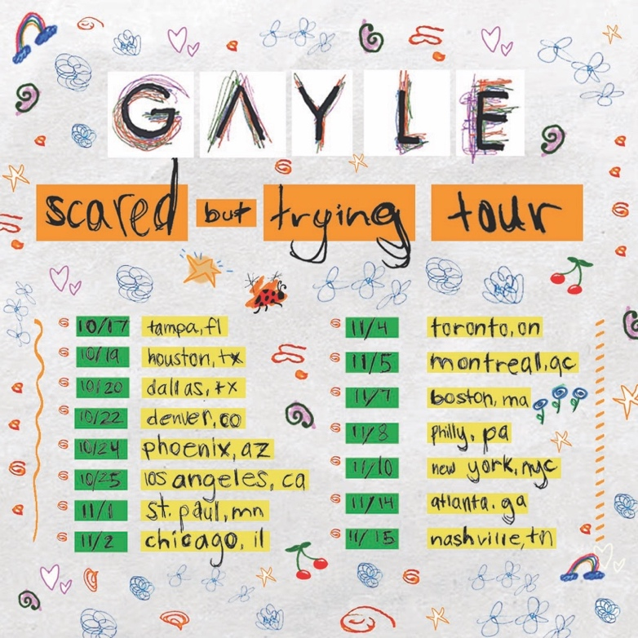
DOWNLOAD HI-RES ADMATS

GAYLE
SCARED BUT TRYING TOUR 2023

OCTOBER
17 – Tampa, FL – Crowbar
19 – Houston, TX – The Studio at Warehouse Live
20 – Dallas, TX – The Studio at The Factory
22 – Denver, CO – Bluebird Theater
24 – Phoenix, AZ – Valley Bar
25 – Los Angeles, CA – El Rey Theatre

NOVEMBER
1 – Minneapolis, MN – Amsterdam Bar & Hall
2 – Chicago, IL – Lincoln Hall
4 – Toronto, ON – Velvet Underground
5 – Montreal, QC – Bar Le Ritz PDB
7 – Boston, MA – Brighton Music Hall
8 – Philadelphia, PA – The Foundry
10 – New York, NY – Racket NYC
14 – Atlanta, GA – The Loft
15 – Nashville, TN – Basement East

# # #

