FOR IMMEDIATE RELEASE
AUGUST 30, 2023

GALANTIS PREMIERES “KOALA”

PERFORMING THIS WEEKEND AT EZOO + MORE LIVE DATES TO BE ANNOUNCED SOON

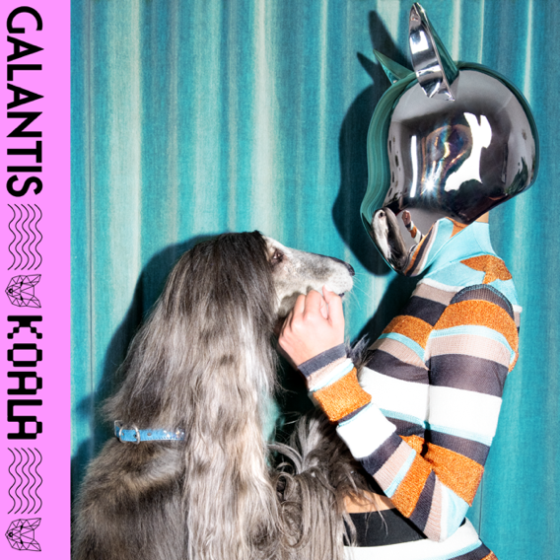
DOWNLOAD HIGH-RES IMAGES/ARTWORK (PHOTO CREDIT: TUNG WALSH)

WATCH/STREAM “KOALA”: LINK

Internationally-acclaimed dance music powerhouse Galantis has premiered new track “Koala” – available now via Big Beat Records alongside an Anastasia Duchess-directed visual starring Piiper as an enigmatic party-starter (watch here). “Koala” marks the third co-write between Galantis and BullySongs, the first being the former’s 2017 smash hit “No Money.”

“Koala” follows “BANG BANG! (My Neurodivergent Anthem),” released earlier this summer with Billboard praising “the slick up-tempo pep Galantis has always delivered” while Rolling Stone declared it “an upbeat festival-ready banger.” The latter also exclusively premiered a Dano Cerny-directed video companion and candid statement from Christian Karlsson revealing his ADHD diagnosis and neurodivergent journey. The new releases have kicked off the hotly anticipated fourth Galantis album era, which will mark the first full-length since 2020’s Church.

One of dance music's most dynamic and in-demand live performers, Galantis returns this Friday to New York City for Electric Zoo Festival – following back-to-back sold out headline shows at Brooklyn Mirage in June. Additional dates in North America to be announced soon, for full live routing and ticket information please visit wearegalantis.com.

Galantis is the dance music project of Christian Karlsson (aka Bloodshy). Their RIAA gold-certified debut album Pharmacy reached No. 1 on the Billboard Dance album chart on the strength of gold-certified single “Peanut Butter Jelly” and 3x platinum certified smash “Runaway (U & I)” – the latter of which earned a GRAMMY nomination for “Best Dance Recording” – while 2017’s sophomore album The Aviary (featuring platinum-certified single “No Money”) saw a top 10 debut in 23 countries. The third Galantis album, 2020’s Church, featured the chart-topping gold-certified single “Faith” with country music icon Dolly Parton featuring Mr. Probz, which saw a #1 debut on Billboard’s Dance/Electronic Chart before quickly reaching #1 on the Dance/Mix Show Airplay Chart where it remained for 5 weeks. Meanwhile, gold-certified collaborative single “Heartbreak Anthem” with David Guetta & Little Mix proved a global sensation, spending 10 weeks on the Billboard Global 200 chart and 13 consecutive weeks in the top 10 on the UK Official Chart. Galantis has received over 5 billion cumulative worldwide streams and over 1.8 billion video views to date.

Karlsson has been at the helm of Galantis since 2009 before officially debuting the project at 2014’s Coachella Valley Music and Arts Festival. His career has spanned across the musical genres of punk-rock, hip-hop and pop – including work as one half of acclaimed production duo Bloodshy & Avant and one third of indie pop band Miike Snow. Karlsson’s songwriting/production credits have included the likes of Madonna, Kylie Minogue, Katy Perry and extensive work with Britney Spears (including “Toxic” which earned a GRAMMY for “Best Dance Recording” and her widely acclaimed 2007 album Blackout). As Galantis, he has crafted remixes for the likes of Coldplay, Selena Gomez, Ed Sheeran, Sam Smith & more. Declared “pop’s mastermind producer” by UPROXX and “eternally effervescent” by Billboard, the Swedish-born artist continues to evolve and push the boundaries of songwriting within the world of dance music and beyond.

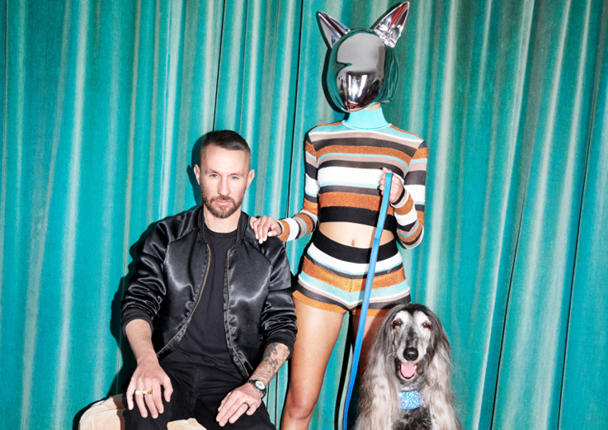
DOWNLOAD HIGH-RES IMAGES/ARTWORK (PHOTO CREDIT: TUNG WALSH)

GALANTIS LIVE:
Sept 1 – Electric Zoo Festival – New York, NY
Sept 1 – Electric Zoo Afterparty @ Musica – New York, NY
Sept 2 – Liv – Miami, FL
Sept 3 – New City Gas – Montreal, QC
Sept 22 – Quarry Studios – Mexico City, MX
Nov 4 – EDSea – Miami, FL
Nov 9 - Echostage - Washington, D.C.
Nov 11 – Big Night Live – Boston, MA

CONNECT WITH GALANTIS:
WeAreGalantis.com | Twitter | Facebook | YouTube | Instagram | Assets

CONTACT:
Ted Sullivan | Ted.Sullivan@atlanticrecords.com

