JESSE® JUST WANTS TO “PLAY”

DIAMOND-CERTIFIED SINGER/SONGWRITER/PRODUCER CONTINUES NEW SOLO CHAPTER WITH LATEST SINGLE

​​ “PLAY” ARRIVES WITH A VISUAL DIRECTED BY ZACK SEKULER

DOWNLOAD/STREAM | WATCH

“I’m sick of being sad & scared & insecure & soooo serious all the time –
so this will be the last emo track for awhile. i’m trying to be a social slutterfly this summer. spooky bangers on the way. buckle up. hold your breath. count to 30, exhale. do it again a few times. rock & roll”

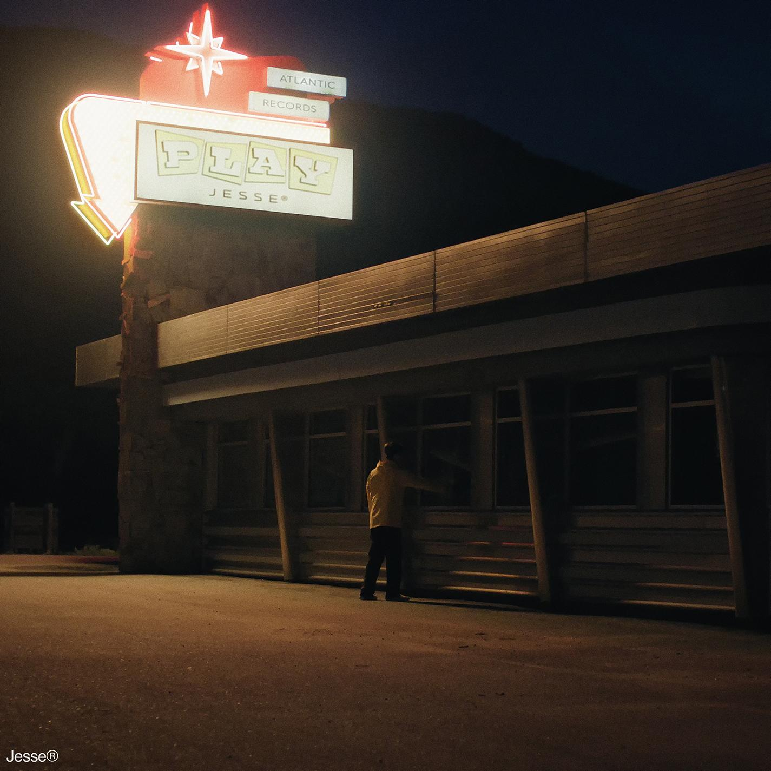
(Photo Credit: Daniel Prakopcyk; download photos & artwork)

(June 30, 2023 – NEW YORK, NY) Acclaimed singer/songwriter/producer & creator of Diamond-certified band The Neighbourhood, Jesse®, continues this new solo chapter with “Play,” out today via Atlantic Records: Download/Stream here.

“Play” arrives alongside a companion visual directed by Zack Sekuler : watch here.

The new single follows “Joker” and “Rainbow,” which Jesse® released earlier this year to kick off the musician’s new solo chapter with Atlantic Records. Download/Stream “Joker” & “Rainbow.”

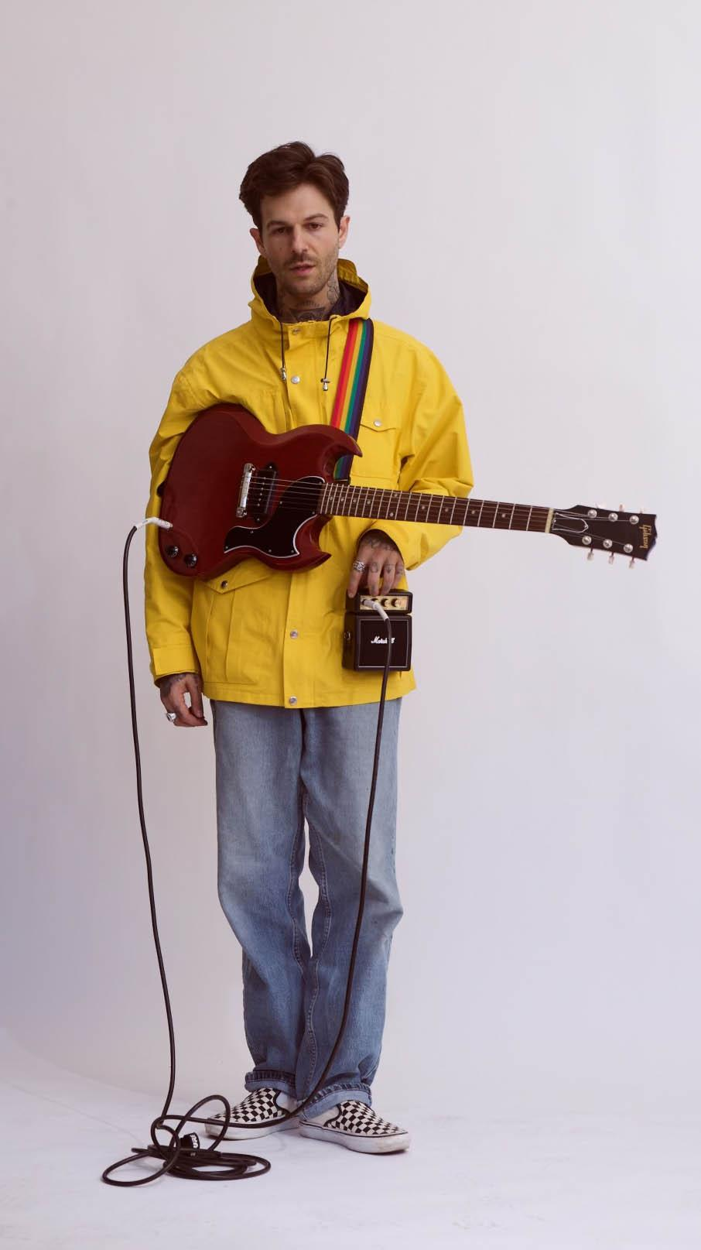
(Photo Credit: Daniel Prakopcyk; download photos & artwork)

For all Jesse® press inquiries, please contact:
Jason Davis jason.davis@atlanticrecords.com

ABOUT JESSE®
Jesse® explores identity through music and has occupied a curious corner of popular culture in doing so as lead singer for multi-platinum, chart-topping alternative stalwarts The Neighbourhood, as a sought-after collaborator, and as a solo artist. However, it’s via this solo artistry that you’ll get as close to Jesse as possible. After The Neighbourhood had finished out their record contract with the delivery of 2020’s full-length LP, Chip Chrome & The Mono-Tones, it was time for a new journey. With billions of streams, multi-platinum singles and albums, and widespread critical acclaim under their collective belt, the group sold out Forest Hills Stadium in Queens, NY and enjoyed a rapturous packed-to-the-rafters homecoming at The Hollywood Bowl in Los Angeles, CA. Since The Neighbourhood “had nothing on the schedule,” Jesse picked up and moved to New York City to re-calibrate & grow as an individual. Now, the singer, songwriter, producer and multi-instrumentalist embarks on the next chapter
with Atlantic Records introduced by “Joker” and “Rainbow.”

# # #

