JACK HARLOW ANNOUNCES NO PLACE LIKE HOME: THE KENTUCKY TOUR

KENTUCKY-BRED SUPERSTAR TAKES HIS 3RD ANNUAL HOMETOWN SHOWS TO A NEW LEVEL WITH FIRST-OF-ITS-KIND,
6-CITY TOUR THROUGHOUT KENTUCKY

Registration for Access to Tickets is Open Now Through Sunday, August 20 on Ticketmaster.com/jackharlow

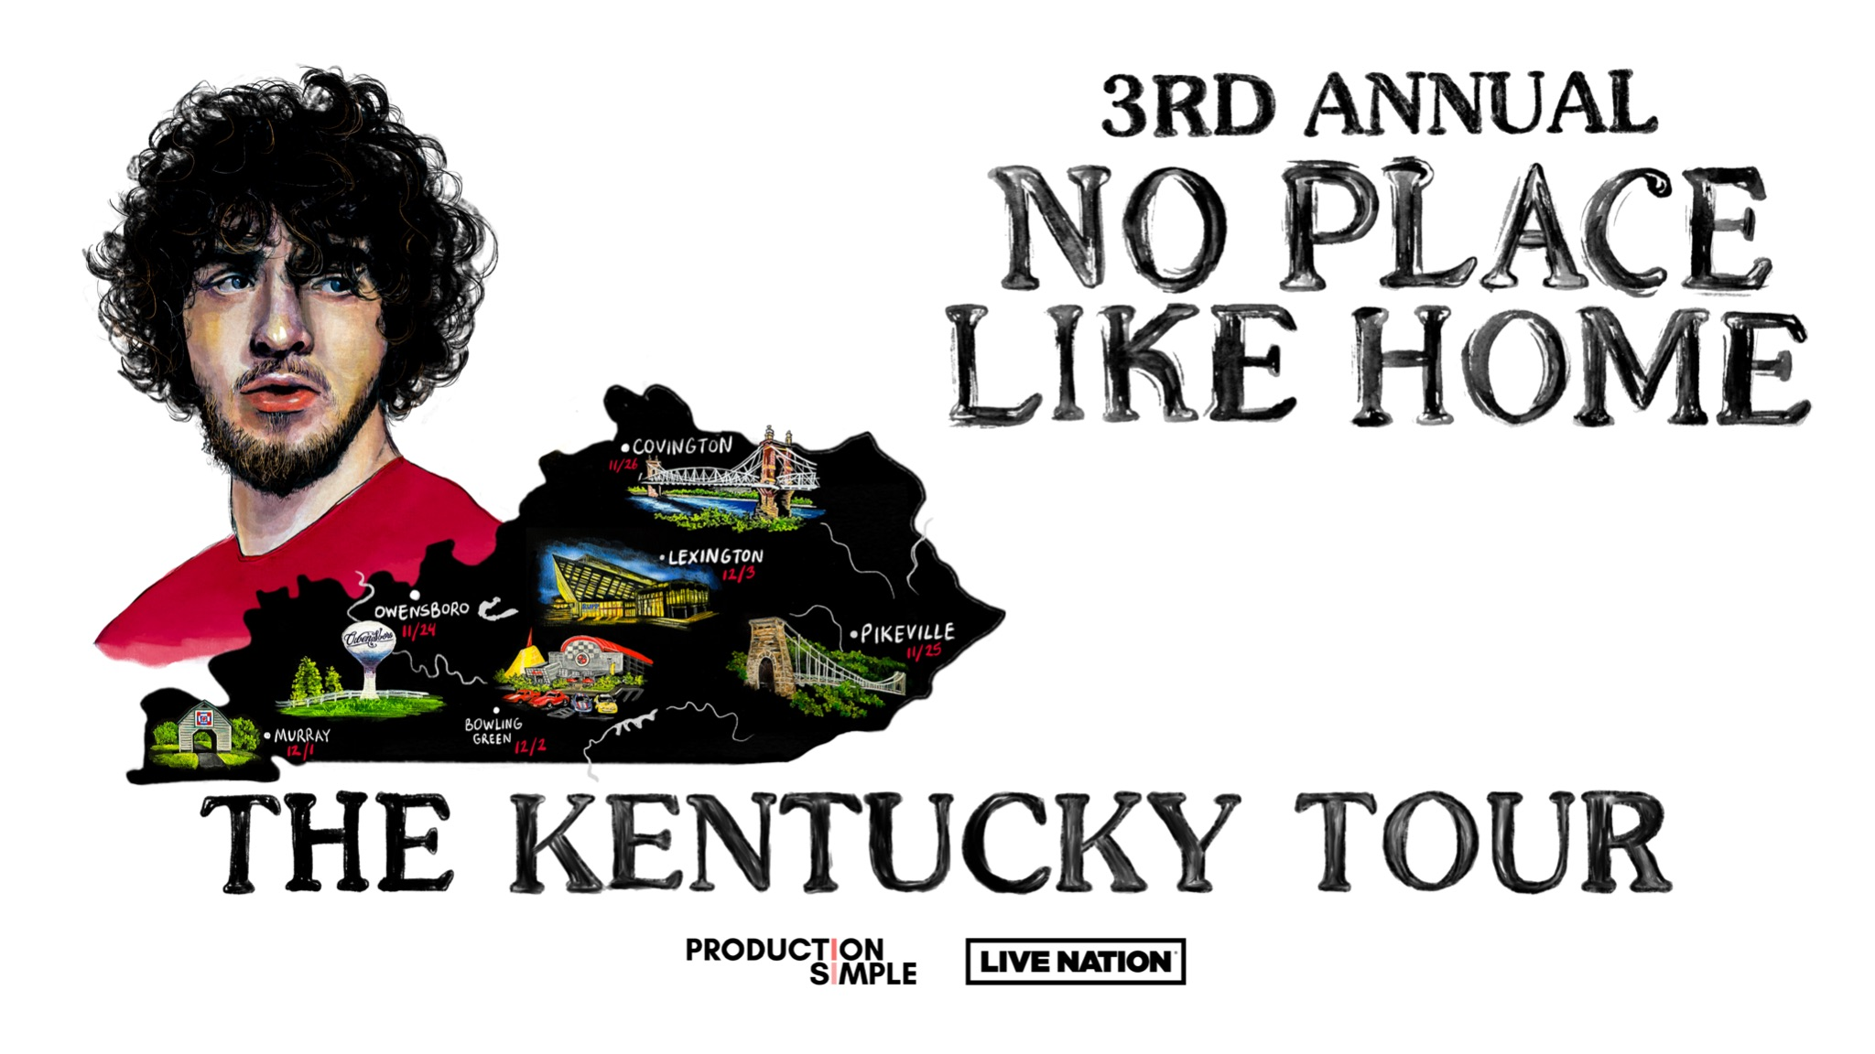

For approved artist images and tour art, please download HERE.

Multiple GRAMMY-nominated rapper, actor, entrepreneur, and philanthropist Jack Harlow announces first-of-its-kind, No Place Like Home: The Kentucky Tour. Produced by Live Nation and Production Simple, the Kentucky superstar will take his 3rd annual hometown shows to a new level with an exclusive 6-city tour, with stops across Kentucky. The tour will kick off on Friday, November 24th at Owensboro Sports Center in Owensboro and will wrap up in Lexington at Rupp Arena on Sunday, December 3rd.

TICKETS: Tickets for No Place Like Home: The Kentucky Tour will be using advance registration to ensure more tickets get into the hands of fans directly by helping to filter out bots and scalpers from the ticket purchase process. Fans can register now through Sunday, August 20 @ 11:59pm ET HERE for both the Artistl presale as well as a Citi presale (details below). Once registration closes, fans will be randomly selected to receive a code that grants them access to the presales starting on Tuesday, August 22 and Wednesday, August 23. Additional presales will run throughout the week.

CITI PRESALE: Citi is the official presale partner of No Place Like Home: The Kentucky Tour. After registering, Citi cardmembers may have the opportunity to access the Citi presale for No Place Like Home: The Kentucky Tour dates. Citi cardmembers can register now through Sunday, August 20 at 11:59pm ET local time for a chance to unlock access to tickets and use their Citi card to complete the ticket purchase if selected. The Citi Presale begins Tuesday, August 22 at 10 AM local time. To register for the Citi Presale visit www.citientertainment.com.

GENERAL ONSALE: A limited number of tickets will be available during a general onsale starting Friday, August 25 at 10AM local time at Ticketmaster.com while supplies last.

NO PLACE LIKE HOME: THE KENTUCKY TOUR
Fri Nov 24 – Owensboro, KY – Owensboro Sports Center
Sat Nov 25 – Pikeville, KY – Appalachian Wireless Arena
Sun Nov 26 – Covington, KY – Truist Arena
Fri Dec 1 – Murray, KY – CFSB Center
Sat Dec 2 – Bowling Green, KY – E.A. Diddle Arena
Sun Dec 3 – Lexington, KY – Rupp Arena

ABOUT JACK HARLOW
Hailed as the “hitmaker of tomorrow” by Variety, multiple GRAMMY-nominated rapper, actor, entrepreneur, and philanthropist Jack Harlow is one of music’s brightest stars. The Louisville, KY native boasts six GRAMMY Award nominations, two #1 singles, nearly 30 RIAA platinum certifications, and over 10 billion career streams to date. Harlow released his critically acclaimed, RIAA platinum certified debut album, THATS WHAT THEY ALL SAY in December 2020, which featured the chart-topping, 8x Platinum worldwide hit, “WHATS POPPIN,” which earned him his first GRAMMY nomination for “Best Rap Performance,” along with a wide array of other award nominations.

The Generation Now/Atlantic Records rap superstar reached even greater heights in May 2022, with his Gold-certified sophomore album, COME HOME THE KIDS MISS YOU, highlighted by the bombastic Platinum-certified lead single “Nail Tech” and the chart topping, multiple-GRAMMY-nominated, 2X platinum single “First Class,” which made a spectacular debut at atop the Billboard “Hot 100,” marking his first solo #1 single, while earning the biggest streaming week of 2022. In April 2023, Harlow returned with his third studio album, Jackman., which critics call his most mature and in-depth work to date.

Harlow has graced the covers of Rolling Stone, GQ, Forbes, Variety, Complex, SPIN, Footwear News and XXL’s coveted Freshman Class Issue, and brought his captivating live show to TV with performances on Saturday Night Live, The Tonight Show Starring Jimmy Fallon, Jimmy Kimmel Live!, MTV Video Music Awards, BET Awards and Kids Choice Awards, to name a few. This Spring, Harlow made his acting debut, starring in the remake of the cultural classic, “White Men Can’t Jump.”

About Production Simple
Launched in 2005, Production Simple is a boutique talent-buying, promotion company based in Louisville, KY. Since its inception the ProSim team has worked with Louisville’s premiere venues, including its sister company and flagship venue, Headliners Music Hall, Kentucky Performing Arts, Old Forester's Paristown Hall, Iroquois Amphitheater, The Louisville Palace and Waterfront Park as well as regionally in Lexington, Covington, Cincinnati and Pikeville.

With 50 years of combined experience in the concert and event promotion field they are dedicated to delivering the highest level of quality to fans and artists. From the most intimate of venues to the large scale outdoor events, they continue to nurture and grow these artists along the way and to bring the best and brightest entertainment to the ever growing Louisville music scene. Production Simple is proud to be a part of the Louisville community and part of keeping it local and “weird.”

About Live Nation Entertainment
Live Nation Entertainment (NYSE: LYV) is the world’s leading live entertainment company comprised of global market leaders: Ticketmaster, Live Nation Concerts, and Live Nation Sponsorship. For additional information, visit www.livenationentertainment.com.

MEDIA CONTACTS:

Jack Harlow
Jason Davis | jason.davis@atlanticrecords.com

Live Nation Concerts
Monique Sowinski | moniquesowinski@livenation.com
Navier Grimes | naviergrimes@livenation.com

Production Simple
Paige Peterson | paige@productionsimple.com

To apply for media credentials for show coverage:
livenation.com/pressrequests

