FOR IMMEDIATE RELEASE
AUGUST 2, 2023

James Blunt Returns With New Album Who We Used To Be – Out October 27th

New Track “Beside You” Out Now

DOWNLOAD HIGH-RES IMAGES/ARTWORK

STREAM “BESIDE YOU”: https://jamesblunt.lnk.to/BesideYou
PRE-ORDER WHO WE USED TO BE: https://JamesBlunt.lnk.to/WhoWeUsedToBe

James Blunt is back with a sparkling new album Who We Used To Be – arriving October 27th via Atlantic Records, featuring the bright and breezy up-tempo rocker “Beside You.”

Produced by The Six, a Manchester collective who have worked with Clean Bandit, Marshmello and James Arthur, “Beside You” is a feel -good summer anthem. “It’s a bit of a celebration,” James says. “An upbeat banger about finally being with the one you’ve been searching for your whole life.” Who We Used To Be also sees James working with a variety of acclaimed producers including Jonny Coffer (Beyoncé, Miley Cyrus), Red Triangle (Louis Tomlinson, Lukas Graham), Jack & Coke (Tove Lo, Charli XCX) and Steve Robson (Olly Murs, 5 Seconds of Summer).

Who We Used To Be is James’ first studio album since 2019’s Once Upon A Mind, which featured standout single “Monsters” – a heartfelt song for his father who was gravely ill with stage four chronic kidney disease. The song took on new life this year after a touching performance by American Idol winner Iam Tongi in dedication to his late father, with James joining for an incredibly emotional duet on the show’s season finale (watch here).

James Blunt has become something of a national treasure as he approaches the 20th anniversary of his 2004 debut album Back to Bedlam, named as one of the top 10 best selling albums of that decade. The album features singles “Goodbye My Lover” and the 4x Platinum, 3x GRAMMY-nominated #1 hit “You’re Beautiful.” His most recent release, 2021’s greatest hits collection The Stars Beneath My Feet, also features catalog highlights “1973,” “Bonfire Heart,” “Stay The Night” & more.

Over his two-decades in music, James has totalled over 24 million in record sales worldwide and has won two Brit Awards, two Ivor Novello Awards, two MTV Video Music Awards and received five GRAMMY nominations. He is respected for his honesty, wit, and charm as showcased on record, onstage (having toured extensively on both international headline runs and in support of Elton John, Ed Sheeran & more), and with his ever engaging Twitter account (where he has amassed a following of over 2 million and gone viral countless times over).

Who We Used To Be
1. Saving A Life
2. Some Kind Of Beautiful
3. Beside You
4. Last Dance
5. All The Love That I Ever Needed
6. The Girl That Never Was
7. Cold Shoulder
8. I Won’t Die With You
9. Dark Thought
10. Glow

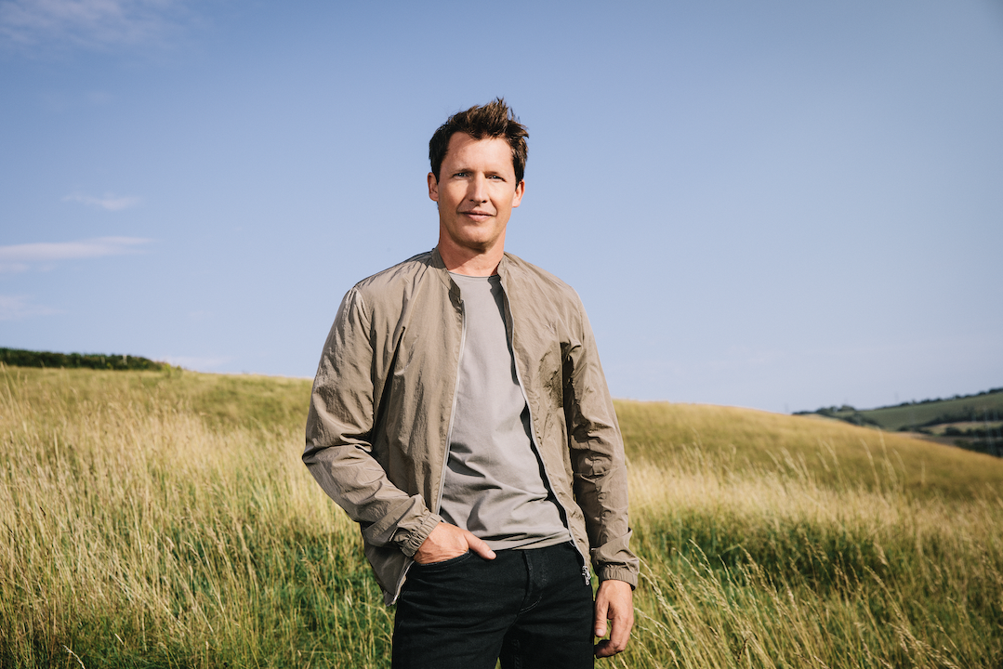
DOWNLOAD HIGH-RES IMAGES/ARTWORK

CONNECT:
JamesBlunt.com | Twitter | Instagram | YouTube | TikTok | Facebook | Press Assets

CONTACT:
Ted Sullivan | ted.sullivan@atlanticrecords.com

