JOHNNY YUKON IS BACK WITH “GLORIA !”

RISING SINGER-SONGWRITER-PRODUCER SHARES GLITTERING NEW SINGLE

OFFICIAL COMPANION VISUAL PREMIERES TODAY

DOWNLOAD/STREAM | WATCH VISUAL HERE

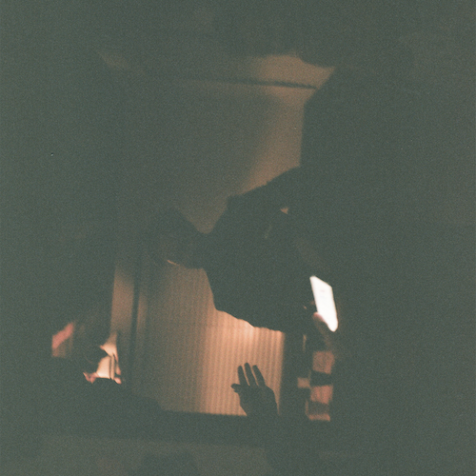
DOWNLOAD HI-RES ARTWORK

New York, NY (May 12, 2023) – Rising singer-songwriter-producer Johnny Yukon is back with the electrifying new song, “Gloria !” – available today via Atlantic Records. Written and produced solely by Yukon, the glittering new track is joined by an official companion visual premiering today at YouTube HERE.

“Gloria !” marks the latest in a series of increasingly impressive releases from Yukon, including the energetically charged “Do You Feel It?,” produced by by Tiggi (Drake, Roddy Ricch, 21 Savage, DJ Khaled), the track arrived alongside an official music video, directed by GiRLFRIEND – Watch HERE.

With a goal to “make bigger music that reaches a lot of people,” Yukon kickstarted a prolific creative streak with “Moment” which tallied over 1.2 million Spotify streams followed by “Video Killed The Radio Star,” “Whatever You Want,” and “Comet.”
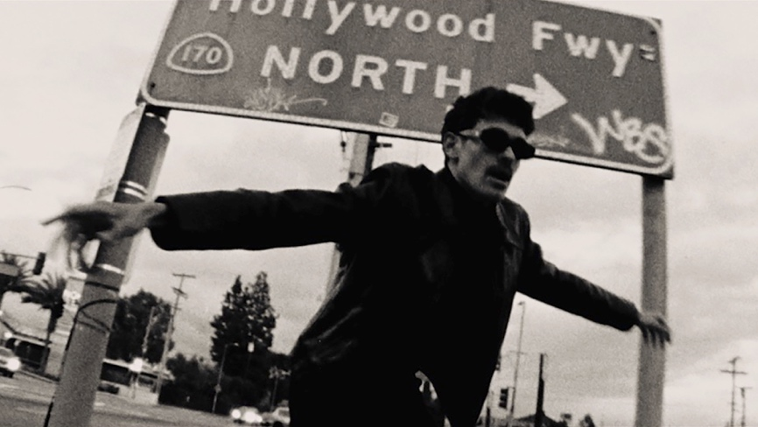

Yukon is best known for pairing his projects with grainy visuals captured on Super 8 film and fashion-forward stills rooted in vintage, yet modern panache, Yukon upholds consistent cinematic motifs across sound and style. His world draws as much from Kubrickian attention to detail and Christopher Nolan-style scope as it does from unpredictable production and hazy melodicism.

“I really feel like I’m being myself in this music,” says Johnny Yukon. “I’m trying to make songs that either brighten your day or help you through something. Maybe, it will get your morning started right or keep your mental health okay. I love sad songs, but I don’t take myself too seriously. At the moment, I just want to encourage people to dance and have fun.”

ABOUT JOHNNY YUKON
Johnny Yukon uplifts by crafting the soundtrack to the best night of your life—whether it be for gazing at the stars, falling in love under the disco ball, or when you just need something to belt along to at drunken karaoke. The Pennsylvania-born and Los Angeles-based singer, songwriter, and producer has continued to widen his imprint across popular culture. He initially established himself as a sought-after collaborator. As a songwriter and producer, his catalog has expanded with cuts for everyone from Young Thug and Ty Dolla $ign to Camilla Cabello and G-Eazy. Various highlights have included co-writing Internet Money’s quadruple-platinum Billboard Hot 100 Top 10 “Lemonade,” Louis Tomlinson’s “Too Young,” and Lil Wayne’s “Open Letter” and “What About Me” in addition to co-producing PARTYNEXTDOOR’s “Trauma.” Not to mention, he ignited the F9 Soundtrack, penning “Lane Switcha” by Skepta, Pop Smoke, A$AP Rocky, Juicy J, and Project Pat. As a solo artist, he has notably served up fan favorite projects such as Installation I [2018] and Flight Plan 001 [2021]. Of the latter, Variance proclaimed, “The singer-producer is soaring into the stratosphere.” He has piled up tens of millions of streams as a solo artist as well. However, he only magnifies his presence on a series of singles for Atlantic Records and much more to come in 2023 and beyond.

Connect with Johnny Yukon
Instagram | Twitter | YouTube | TikTok

For all press inquires please contact:
Jason Davis – Jason.Davis@atlanticrecords.com

