FOR IMMEDIATE RELEASE
AUGUST 24, 2023

KALIII RETURNS WITH THE OFFICIAL REMIX TO HER LATEST HIT SINGLE
“K TOVEN”

THE “DJ 809 MIX” SERVES AS THE FOLLOW-UP TO THE ORIGINAL’S VISUAL RELEASE

RELEASE COMES ON THE HEELS OF KALIII’S ‘BEST NEW ARTIST’ NOMINATION
AT THIS YEAR’S MTV VIDEO MUSIC AWARDS

KALIII WILL ALSO BE DIRECT SUPPORT FOR A BOOGIE’S UPCOMING ‘ME VS. MYSELF’ TOUR

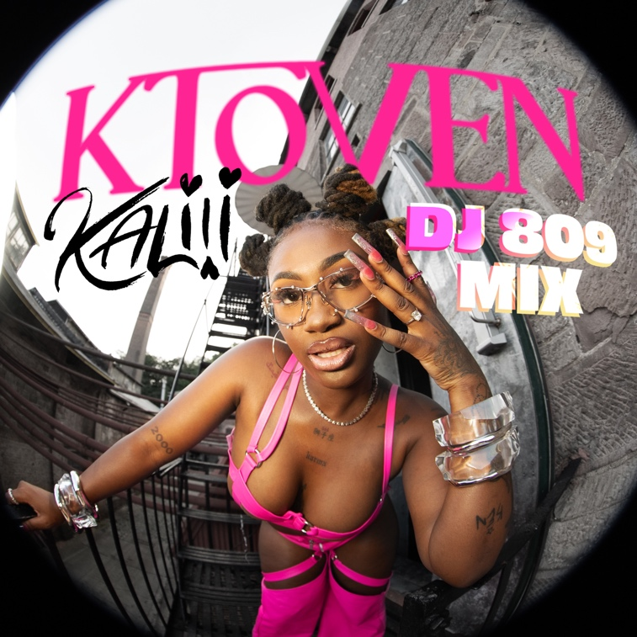
STREAM HERE

# # #

ABOUT KALIII
Kaliii’s has had a landmark year in 2023. Kaliii kicked off the year with her explosive viral hit “Area Codes” which has now spawned several regional remixes. The remixes are a part of Kaliii’s #ToxicThursday release series and have thus far included New York’s Kenzo B on the “718 Remix,” The Bay Area’s Lil Kayla on the “415 Remix,” St. Louis’s Sexyy Red on the “314 Remix,” and Tallahassee’s Luh Tyler on the “850 Remix.” She followed up by releasing the remixes as a combined pack aptly titled, Area Codes: The Remixes and a visual for “Area Codes (718 Remix)” featuring Kenzo B. Kaliii continued her “Area Codes” reign with the release of the project Toxic Chocolate: Area Codes Edition. Rap’s it-girl has stayed quite active since with her inclusion on the Barbie soundtrack, her nomination for ‘Best New Artist’ at the 2023 MTV Video Music Awards, and the release of her follow-up hit “K Toven.”

Making her label debut with the release of her highly acclaimed EP Toxic Chocolate, Kaliii was admitted into the XXL 2022 Freshman Class and created the foundation for her now monumental success. She continued her run with the release of the singles “FNF (Freestyle)” and “Wet” with each visual at over a combined 1M views via YouTube. Toxic Chocolate – available now at all DSPs and streaming services – arrived earlier in 2022 amidst both popular and critical acclaim, with Hot New Hip Hop simply declaring her “Rap's Next ‘It’ Girl.” The EP is highlighted by the incendiary singles, “UonU (Feat. Yung Bleu)“ and “Standards,” the latter of which had its exclusive premiere – alongside Kaliii’s debut interview – on Apple Music’s New Music Daily Radio with Zane Lowe. Kaliii then increased the power of Toxic Chocolate with the surprise addition of the fan favorite “Chainzzz (Feat. Muni Long)” as well as a revised sequence.

CONNECT WITH KALIII
TIKTOK | TWITTER | INSTAGRAM | FACEBOOK | YOUTUBE

PRESS CONTACT
Ariana White | Ariana.White@AtlanticRecords.com

