LUH TYLER RELEASES ROTY

DOWNLOAD/STREAM

NEW 3-SONG COLLECTION FROM “THE COOLEST TEENAGER IN RAP” ARRIVES TODAY VIA MOTION MUSIC/ATLANTIC RECORDS

WATCH COMPANION VIDEO FOR “RAPPER OF THE YEAR”

ROTY COMES AS THE 2023 XXL FRESHMAN WRAPS STINT AS
DIRECT SUPPORT ON MONEYBAGG YO’S SUMMER TOUR

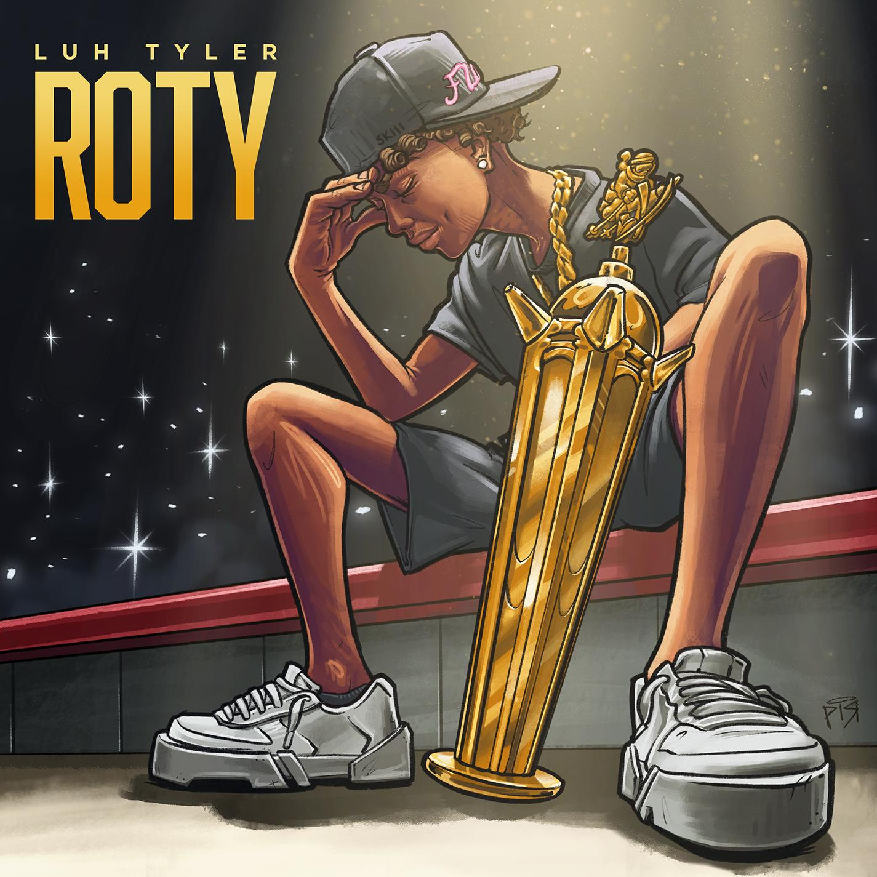
DOWNLOAD HI-RES ARTWORK + PRESS IMAGES

“With an unmistakable Southern twang, raspy laid-back flow and charisma for days, Tyler is among the most likable talents to emerge in recent rap memory.” – GQ

“The overall impression is that of a natural…crystallizes the Tallahassee rapper’s status as the most exciting young rapper in Florida.” – COMPLEX

“His boisterous bars and technical wizardry become more impressive as it sinks in that this kid is still so young.” – STEREOGUM

“Coolest 16-year-old in America.” – PITCHFORK
“An actual overnight sensation.” – XXL

“A precociously charismatic rapper at just 17 years old.” – FADER

“Talented Emerging Artist You Don’t Want To Miss!” – PEOPLE

"Luh Tyler has a lot to celebrate..." – BILLBOARD

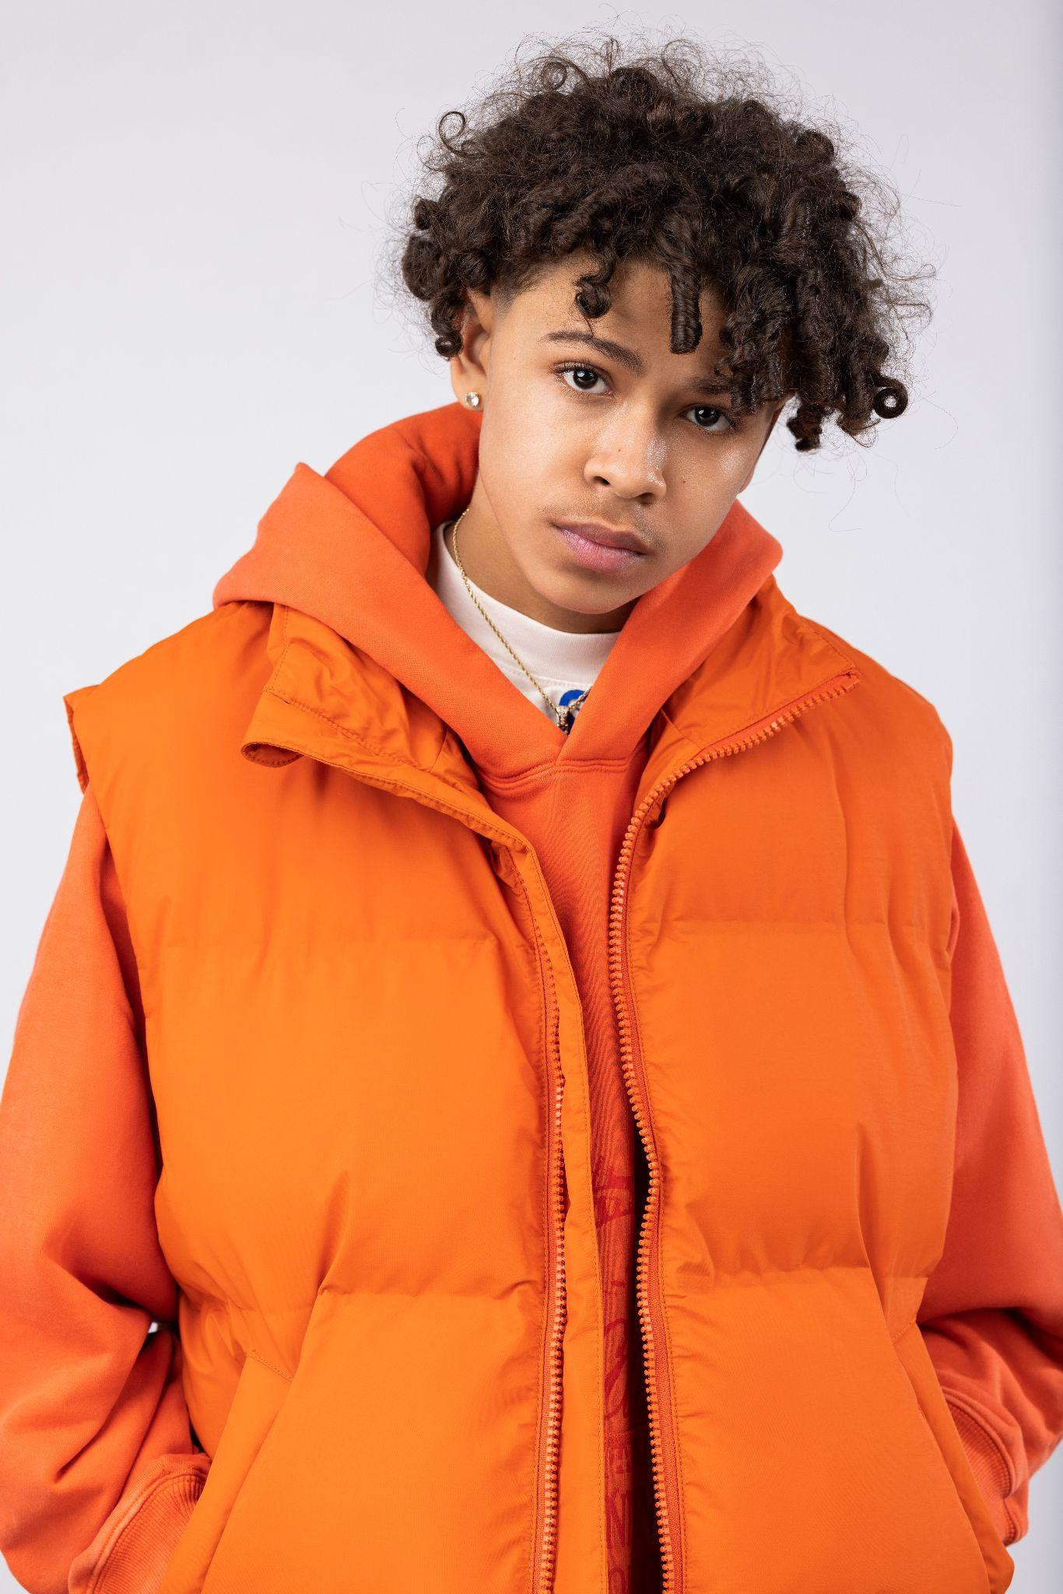
DOWNLOAD HI-RES ARTWORK + PRESS IMAGES (Photo Credit - Cam Kirk)

# # #

For all Luh Tyler press inquiries, please contact:
Jason Davis | Jason.Davis@atlanticrecords.com

ABOUT LUH TYLER
Wielding a wavy flow, irresistible melodies, and inventive dynamics, Luh Tyler animates bouncy anthems with undeniable unpredictability. He switches lanes seamlessly between his signature laidback cadence and airy high register, touting a style all his own. It’s why he’s quietly emerged as a vibrant voice out of his native Tallahassee, FL all before the age of 16. Growing up the youngest of three kids in “a good family,” he initially excelled on the basketball court as a point guard before picking up a mic in high school. Inspired by local favorites Wizz Havin, Trapland Pat, L.O.E. Shimmy, and more, he started to upload music of his own. Following “5 On It Freestyle,” he gained traction on Spotify and YouTube with “Jayda Wayda.” Meanwhile, YouTube views on “Law & Order” soared. DJ Booth touted him as one of “10 Rappers You Should Know Right Now,” and Stereogum christened him, “Best new rapper.” During late 2022, Tyler released “Back Flippin,” the in demand song he teased weeks prior on Tik Tok, which immediately bolstered with support from the likes of Jordan Ross, Chris Brown and Kehlani while Pitchfork declared “…Luh Tyler’s music makes you long for the days when chilling was your only responsibility…his punchlines are boosted by his icy delivery.”

