LAUREN DAIGLE TEAMS WITH KULTURECITY
TO ESTABLISH 17 “SENSORY ROOMS”
IN DAIGLE’S “KALEIDOSCOPE TOUR” VENUES

TOUR LAUNCHES SEPTEMBER 6th
FOLLOWED BY THE SEPTEMBER 8th
COMPLETE 23-TRACK ALBUM LAUREN DAIGLE RELEASE

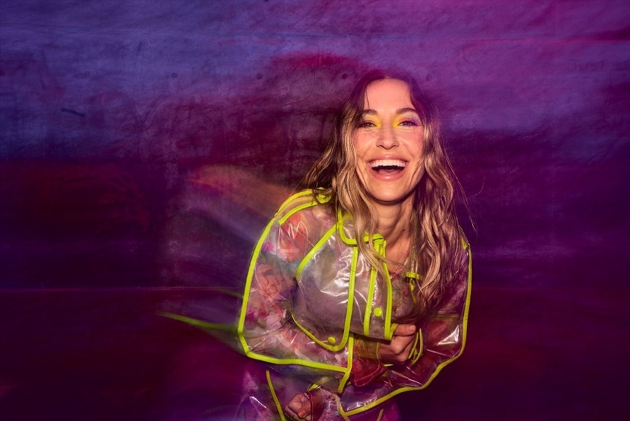
Download Hi-Res HERE | Photo Credit: Jeremy Cowart

Today, 2x GRAMMY® Award winner and multi-platinum selling artist Lauren Daigle announced her continued partnership with KultureCity to create and renovate seventeen “sensory rooms” at venue stops on her The Kaleidoscope Tour, including fifteen new rooms. Specially designed by medical professionals, the renovated or refurbished spaces provide dedicated environments for individuals in need of a quieter and more secure environment from which to enjoy concert (and sporting) events. The rooms are scheduled to be completed by the time Daigle’s The Kaleidoscope Tour kicks off September 6th. Each sensory room will be outfitted with bean bags from Yogibo, visual light panels by Nanoleaf, activity panels, Sparkle Interactive Light by NunoErin, bubble walls, and a custom tactile artwork created by an autistic artist. In addition, sensory bags will be available at all tour stops for those who might need them. More information about the rooms can be found HERE.

“The amazing thing about playing live is that feeling I get when I’m looking out from the stage seeing people connect to the music – and to each other,” shares Daigle. “These sensory rooms we’re creating with KultureCity, are all about giving everyone that experience. For me, that’s what touring is all about.”

Daigle’s partnership with KultureCity began in 2021, when together they created the The Lauren Daigle Sensory Room at Nashville’s Bridgestone Arena. The room was sponsored by Daigle’s own The Price Fund, as are all of the rooms being created for this effort. Since 2019, KultureCity has created over 1,900 sensory-inclusive venues in seven countries and has been recognized nationwide for using its resources to revolutionize and effect change in the community for those with sensory needs, not just those with autism. Learn more about KultureCity HERE.

“Music is something that we associate with and to know that Lauren and her team are going the extra mile to ensure that everyone, no matter their ability, is included at a concert is truly amazing,” says Uma Srivastava, Executive Director, KultureCity. “We’re honored to partner with Lauren to provide a truly inclusive experience for all fans and guests!”

The Kaleidoscope Tour, which kicks off on September 6th in Memphis includes stops in LA, Newark, Boston, Atlanta, Seattle, Baton Rouge. Before its conclusion in the U.S. the tour will have seen 30 stops before heading overseas. Brandon Lake, Crowder, Josh Garrels, and Victory Boyd will appear on select dates. Tickets for The Kaleidoscope Tour are now on sale at https://www.laurendaigle.com/tour/.

In addition, on September 8th, Daigle will release the remainder of her self-titled album via Atlantic Records, in partnership with Centricity Music. Led by GRAMMY®-winning producer Mike Elizondo (Twenty One Pilots, Mary J. Blige, Fiona Apple, Carrie Underwood), Lauren Daigle features co-writes with award-winning songwriters, including Natalie Hemby, Amy Wadge, Shane McAnally, Jason Ingram, Lori McKenna, and Jon Greene. The album marks a new creative chapter for the Louisiana-born artist.

Since the release of her GRAMMY® Award-winning, platinum-certified 2018 album Look Up Child – which includes the breakthrough, newly-6x platinum-certified hit single “You Say” – Daigle has been a mainstay on the Billboard charts. When Look Up Child debuted at No. 3 on the Top 200 Albums chart, Daigle became the first female artist in history to simultaneously hit the Top 10 on both Billboard’s Pop and Christian Album charts. She went on to break another record when the LP reached 100 weeks at No. 1 on the Top Christian Albums chart, which is the greatest number of weeks that any artist has spent at the top of any individual album chart. Similarly, “You Say” is the longest-running No. 1 to appear on any weekly Billboard chart. Born in Lake Charles, Louisiana, Daigle is a 2x Grammy®, seven-time Billboard Music Award, four-time American Music Award, and ten-time GMA Dove Music Award winner.

***

The Kaleidoscope Tour Dates
*KultureCity Sensory Room

SEPTEMBER
6 – Memphis, TN – FedExForum*
7 – Bossier City, LA – Brookshire Grocery Arena*
8 – Baton Rouge, LA – Raising Cane’s River Center*
14 – Grand Rapids, MI – Van Andel Arena
15 – Indianapolis, IN – Gainbridge Fieldhouse*
16 – Hoffman Estates, IL – NOW Arena
28 – Wichita, KS – INTRUST Bank Arena*
29 – Des Moines, IA – Wells Fargo Arena*
30 – Minneapolis, MN – Target Center*

OCTOBER
4 – Charleston, WV – Charleston Coliseum*
5 – Louisville, KY – KFC Yum! Center*
6 – Atlanta, GA – State Farm Arena
19 – Boston, MA – Agganis Arena
20 – Newark, NJ – Prudential Center
21 – Baltimore, MD – CFG Bank Arena
26 – Kansas City, MO – T-Mobile Center*
27 – St. Louis, MO – Enterprise Center*
28 – Columbus, OH – Schottenstein Center

NOVEMBER
10 – Los Angeles, CA – Crypto.com Arena*
11 – Phoenix, AZ – Desert Diamond Arena
14 – Sacramento, CA – Golden 1 Center*
16 – Portland, OR – Moda Center*
17 – Spokane, WA – Spokane Arena
18 – Seattle, WA – Climate Pledge Arena
30 – Tulsa, OK – BOK Center

DECEMBER
1 – Ft Worth, TX – Dickies Arena*
2 – San Antonio, TX – AT&T Center*
7 – Greensboro, NC – Greensboro Coliseum*
8 – Knoxville, TN – Thompson-Boling Arena
9 – Greenville, SC – Bon Secours Wellness Arena

CONNECT WITH LAUREN DAIGLE
Website | Facebook | Instagram | Twitter | TikTok | YouTube

For More Information, Please Contact:
Sheila Richman | Atlantic Records | Sheila.Richman@atlanticrecords.com
Katy Carmichael | Atlantic Records | Katy.Carmichael@atlanticrecords.com

Paul Freundlich | PFA Media | paulf@pfamedia.net
Alicia Krass | PFA Media | akrass@pfamedia.net
