2x GRAMMY® AWARD-WINNING MULTI-PLATINUM ARTIST
LAUREN DAIGLE
SHARES OFFICIAL MUSIC VIDEO
FOR “THESE ARE THE DAYS”

WATCH THE MUSIC VIDEO HERE

THE COMPLETE 23-TRACK ALBUM
LAUREN DAIGLE
ARRIVES SEPTEMBER 8, 2023
VIA ATLANTIC RECORDS/CENTRICITY MUSIC

THE KALEIDOSCOPE TOUR
KICKS OFF SEPTEMBER 6 IN MEMPHIS, TN

PRE-SAVE LAUREN DAIGLE ALBUM HERE

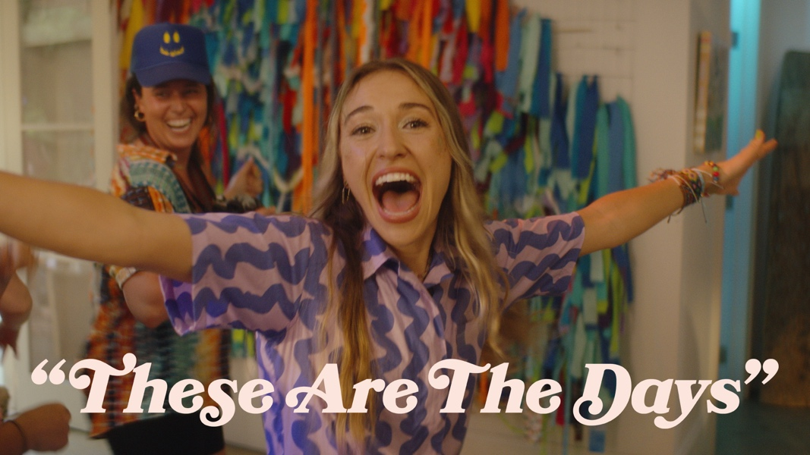
Download Hi-Res Thumbnail HERE

“…one of the best singers in contemporary pop.” – VARIETY

“…filled with songs that highlight her brand of personal pop and soulful roots.” – BILLBOARD

Today, two-time GRAMMY® Award-winning singer-songwriter Lauren Daigle shares the vibrant, one-shot official music video for standout song “These Are The Days.” Directed by John Gray, the colorful visual was filmed in Daigle’s beloved, native Louisiana, and features snow cones, confetti, and an unexpected pool party – watch the music video HERE.

“These Are The Days” is lifted off Daigle’s forthcoming 23-track, self-titled album, Lauren Daigle, which is due out Friday, September 8, 2023 via Atlantic Records/Centricity Music.

Led by GRAMMY®-winning producer Mike Elizondo (Twenty One Pilots, Mary J. Blige, Fiona Apple, Carrie Underwood), Lauren Daigle boasts co-writes with award-winning songwriters, including Natalie Hemby, Amy Wadge, Shane McAnally, Jason Ingram, Lori McKenna, and Jon Green, and features from Jon Batiste, Natalie Hemby, and Gary Clark Jr. The album showcases Daigle’s stunning and powerful voice, rich storytelling, and incredible musicality.

Daigle recently previewed the 23-track project with an intimate, livestreamed performance at Nashville’s legendary Bluebird Café, where she was joined by several of the above creative partners, including Elizondo, Hemby, Ingram, and Green. The event also included a conversation hosted by BMI’s Shannon Sanders.

In May, Daigle shared the album’s first 10 songs (listen HERE), receiving immediate acclaim from the likes of Billboard, The Tennessean, and Variety, the latter of whom declared her “one of the best singers in contemporary pop.”

At the end of July, she performed one of these tracks – a stunning rendition of “Saint Ferdinand” with Jon Batiste – during the fellow Louisiana native’s ‘Jon Batiste & Friends’ set at Newport Folk Festival.

Meanwhile, Daigle’s current single, the Billboard #1 “Thank God I Do,” recently topped all 6 Christian song charts at once, a feat that has not been achieved by any artist since her 2018 smash hit, “You Say,” did the same.

“Thank God I Do” is currently Top 15 at Hot AC Radio and at AC Radio. Daigle has performed the song live on The TODAY Show, Live with Kelly and Mark, and on the season finale of American Idol, duetting with season 21’s runner-up Megan Danielle (watch HERE).

Says Daigle, of her forthcoming self-titled release:

“In May, I released the first 10 songs from my self-titled album. It had been a while since I had put out new music, so I wanted to share these songs as soon as they were ready to go. This is just the beginning of the journey to the complete story of the 23-song album, which I am excited to announce is coming out September 8. These 23 tracks represent all that I am – they embody my soul and my spirit. I can’t wait for you all to hear them.”

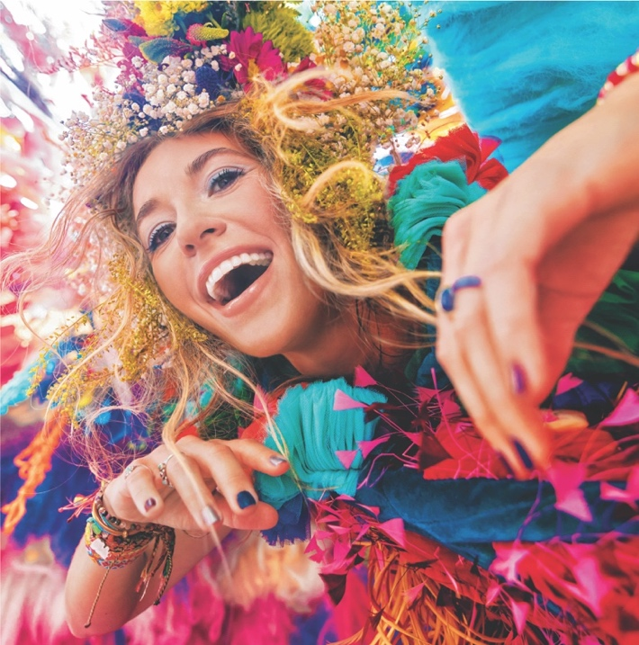
Download Hi-Res Album Artwork HERE

LAUREN DAIGLE: Tracklist

- Thank God I Do
- Saint Ferdinand (feat. Jon Batiste and Natalie Hemby)
- New
- Waiting
- To Know Me
- Kaleidoscope Jesus
- Valuable
- Don’t Believe Them
- Ego
- These Are The Days
- Salvation Mountain (feat. Gary Clark Jr.)
- Back To Me
- 21 Days
- Love Me Still
- Interlude #1
- Turbulent Skies
- Sometimes
- Interlude #2
- Inherited
- He’s Never Gunna
- Be Okay
- Interlude #3
- You’re All I’ll Take With Me

This fall, Daigle will embark upon her highly-anticipated fall US arena tour – The Kaleidoscope Tour – traversing the country from New Jersey’s Prudential Center to LA’s Crypto.com Arena, with stops in Boston, Atlanta, Seattle, Baton Rouge, and many more cities in between. Brandon Lake, Crowder, Josh Garrels, and Victory Boyd will join Daigle as support on select dates.

The Kaleidoscope Tour kicks off on September 6 in Memphis, TN. Tickets are on sale at www.laurendaigle.com, where the full list of upcoming dates is listed.

***

With over a billion streams and years of sold-out US and international tours to her name, Lauren Daigle continues to cement her status as a modern vocal powerhouse with a global, ever-growing fanbase.

Since the release of her GRAMMY® Award-winning, platinum-certified 2018 album Look Up Child – which includes the breakthrough, newly-6x platinum-certified hit single “You Say” – Daigle has been a mainstay on the Billboard charts. When Look Up Child debuted at No. 3 on the Top 200 Albums chart, Daigle became the first female artist in history to simultaneously hit the Top 10 on both Billboard’s Pop and Christian Album charts. She went on to break another record when the LP reached 100 weeks at No. 1 on the Top Christian Albums chart, which is the greatest number of weeks that any artist has spent at the top of any individual album chart. Similarly, “You Say” is the longest-running No. 1 to appear on any weekly Billboard chart. Born in Lake Charles, Louisiana, Daigle is a two-time Grammy®, seven-time Billboard Music Award, four-time American Music Award, and ten-time GMA Dove Music Award winner.

Off stage, Daigle remains committed to investing her time to promote music education, work with at-risk youth, and provide care for children, the elderly, and those in need through The Price Fund, an organization she founded in 2018. To date, she has distributed over $2.5 million to 42 nonprofits around the world.

***

CONNECT WITH LAUREN DAIGLE
Website | Facebook | Instagram | Twitter | TikTok | YouTube

For More Information, Please Contact:
Sheila Richman | Atlantic Records | Sheila.Richman@atlanticrecords.com
Katy Carmichael | Atlantic Records | Katy.Carmichael@atlanticrecords.com

Paul Freundlich | PFA Media | paulf@pfamedia.net
Alicia Krass | PFA Media | akrass@pfamedia.net
