FOR IMMEDIATE RELEASE
JUNE 16, 2022

NCOGNITA IS BACK WITH “LA (FT. KALAN.FRFR)”

SOUTH CENTRAL LYRICIST KICKS OFF NEXT CHAPTER WITH POWERHOUSE NEW SINGLE

“LA (FT. KALAN.FRFR)” AVAILABLE NOW VIA RAEDIO/ATLANTIC RECORDS – LISTEN

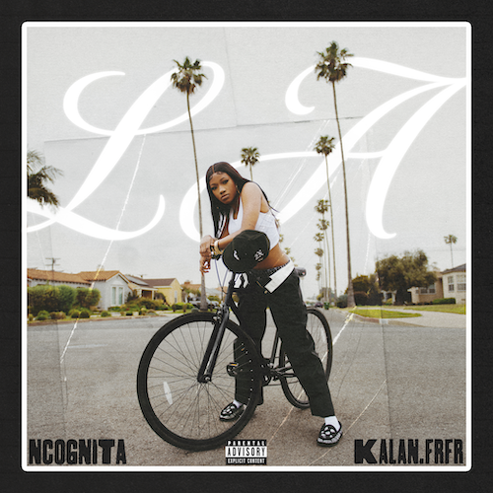
DOWNLOAD HI-RES ARTWORK HERE

Los Angeles, CA-based rapper-poet NCognita is back with her eagerly awaited new single, “LA (Ft. Kalan.FrFr),” available via Raedio/Atlantic Records at all DSPs and streaming services HERE. “LA” heralds the start of a major next chapter for NCognita, with additional new music to follow through the summer.

“This record was made to show love for my city and to romanticize the LA dream. Westside love is the best type love,” says NCognita.

“LA” marks the much-anticipated follow-up to NCognita’s acclaimed 2022 major label debut EP, The Playbook, available now via Raedio/Atlantic Records HERE. Hailed for its raw energy and razor-sharp pen game, the EP includes the captivating single, “2x Freestyle (Ft. Tundra),” joined by a Jonathan Benavente-directed visual streaming HERE. In addition, NCognita celebrated The Playbook by showcasing her killer mic skills with explosive freestyles on Bars On I-95 and Fire In The Booth.

Standing firm in the belief that words have incredible power, NCognita is a 21-year-old rapper and poet from Los Angeles. As an artist on Issa Rae’s joint venture with the renowned Atlantic Records umbrella, the South-Central native brings her unabashed confidence and impassioned lyrical dexterity to the consciously curated Raedio roster. With poetry as her first love, NCognita’s vibrant musical upbringing encouraged her to come into her own as a rapper. First embarking on the path of a recording artist during her senior year at the Los Angeles County High School for the Arts, NCognita decided to continue her musical education at Loyola University in New Orleans. NCognita is grinding in every sense of the word, balancing it all, while staying super busy with new music due in the weeks and months to come.

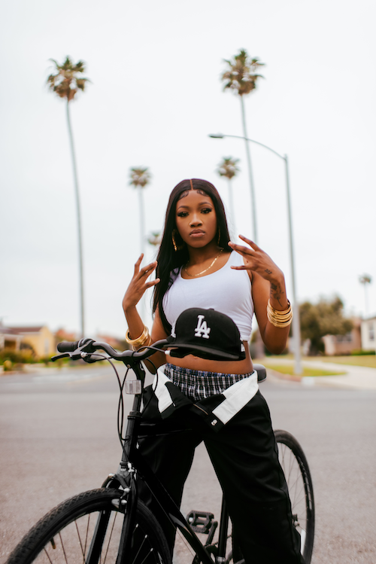
DOWNLOAD HI-RES IMAGE HERE | PHOTO CREDIT: EMILIO SANCHEZ

CONNECT WITH NCOGNITA
WEBSITE | TWITTER | INSTAGRAM | FACEBOOK | YOUTUBE

PRESS CONTACTS
Fairley McCaskill | Fairley.McCaskill@atlanticrecords.com

