FOR IMMEDIATE RELEASE
AUGUST 21, 2023

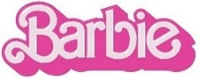

RYAN GOSLING TAKES FANS BEHIND THE SCENES OF “I’M JUST KEN” WITH EXCLUSIVE NEW VIDEO

WATCH THE “‘I’M JUST KEN’ EXCLUSIVE”
FEATURING UNRELEASED FOOTAGE OF THE BARBIE CAST, GRETA GERWIG, MARK RONSON,
“I’M JUST KEN” CO-WRITER/CO-PRODUCER ANDREW WYATT AND MORE

BARBIE THE ALBUM SURPASSES 1B+ GLOBAL STREAMS

BARBIE CONTINUES TO DAZZLE AT GLOBAL BOX OFFICE WITH OVER $1B WORLDWIDE

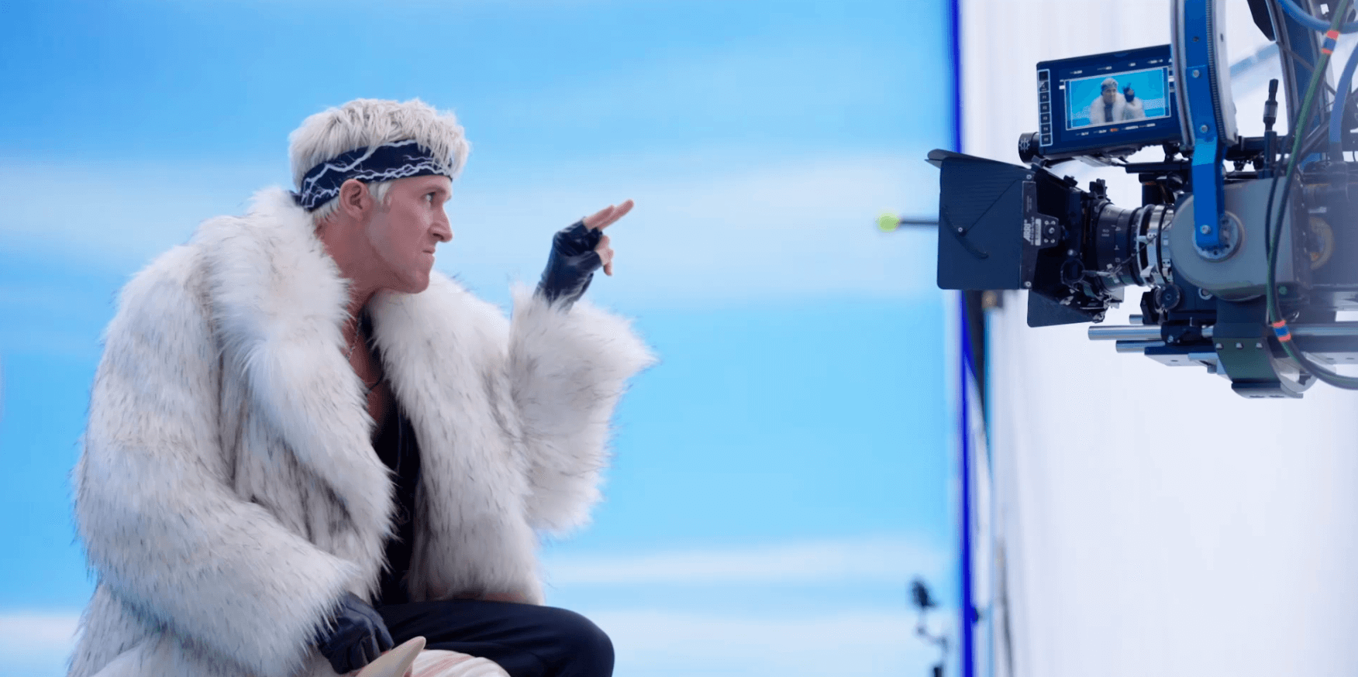

Ryan Gosling is taking fans behind-the-scenes for an exclusive look at his show-stopping performance of “I’m Just Ken” in Greta Gerwig’s critically acclaimed blockbuster film, Barbie, starring Margot Robbie and Ryan Gosling as Barbie and Ken and distributed by Warner Bros. Pictures. Featuring previously unreleased footage from the making of both the song and scene in the film, watch the official “‘I’m Just Ken’ Exclusive” video streaming now HERE.

Racking up over 75M worldwide streams, reaching the top 5 on Billboard’s “Hot Rock & Alternative Songs” and becoming Gosling’s official Billboard “Hot 100” chart debut, “I’m Just Ken” has quickly proven a cultural phenomenon as one of the indisputable highlights from the groundbreaking and star-studded BARBIE THE ALBUM, which has officially amassed over 1B global streams. For more information, download BARBIE THE ALBUM press materials HERE.

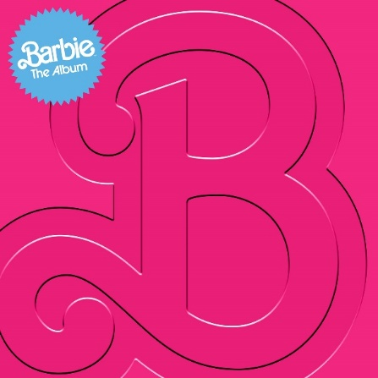
DOWNLOAD HI-RES IMAGES HERE

WHAT CRITICS ARE SAYING ABOUT BARBIE THE ALBUM
“The Album of Summer 2023” – COSMOPOLITAN’S “BEST MOVIE SOUNDTRACKS OF ALL TIME”
“‘Barbie the Album’ Is Like a Perfect Night on the Dreamhouse Dancefloor. You Won’t Want It to End” – ROLLING STONE
“the soundtrack of the summer, a cultural moment of pop music's biggest icons” – THE TODAY SHOW
“an upbeat, immersive soundtrack full of pop gems from a global who’s who of top pop hitmakers” – BILLBOARD
“the kind of stellar original soundtrack we haven’t heard in years” – USA TODAY
“an electric sprawl of a soundtrack that can be enjoyed from start to finish” – ASSOCIATED PRESS
“The soundtrack is more than just an accessory...it is a crucial element in bringing Gerwig’s creative vision to life” – PEOPLE
“more memorable pop moments than most major motion picture soundtracks” – FADER
“a veritable toybox of the biggest pop stars today” – GRAMMY.COM
“a shimmering pop mixtape as joyful as the movie” – CONSEQUENCE
“The Barbie soundtrack is a pop lover's dream” – ESQUIRE
“a stellar musical experience” – FORBES

CONNECT WITH BARBIE THE ALBUM:
BARBIETHEALBUM.COM | INSTAGRAM | TIKTOK | TWITTER | FACEBOOK | PRESS SITE

BARBIE THE ALBUM PRESS CONTACT:
ANDREW GEORGE | ANDREW.GEORGE@ATLANTICRECORDS.COM

