FOR IMMEDIATE RELEASE
AUGUST 30, 2023

LILY WILLIAMS RETURNS WITH “THINGS THAT FALL”

RISING SINGER-SONGWRITER SHARES DEEEPLY ROMANTIC NEW SINGLE

LISTEN TO “THINGS THAT FALL” | WATCH OFFICIAL MUSIC VIDEO

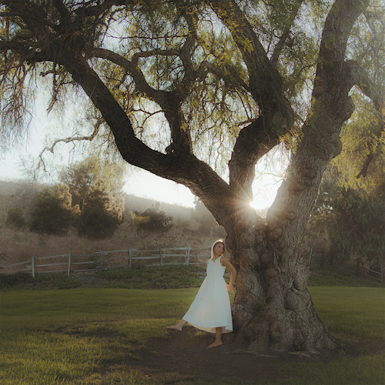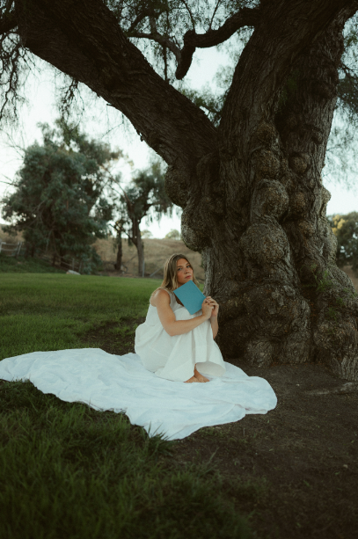
DOWNLOAD ASSETS HERE
PRESS PHOTO CREDIT: ANDREW BARAJAS

Rising singer-songwriter Lily Williams has shared her romantic new single, “Things That Fall,“ available now via Overall Recordings/Atlantic Records. Co-written with Dan Gleyzer, the track is released alongside a dreamy official music video – Watch HERE.

“‘Things That Fall’ is about falling so hard for someone that you can’t imagine anyone or anything has ever fallen quite as hard,” says Lily Williams. “Everything about this song is meant to feel whimsical and dreamy. I wrote it with Dan Gleyzer and once the song started to take shape we knew we had to make the production just as dreamy as the lyrics. I hope this song reminds you of late summer, new beginnings, novels, sunsets, and falling in love.”

“Things That Fall” follows the British-born, Southern California-based artist’s recently released label debut, How The Story Ends. Highlights include the heartbreakingly beautiful “What If I Still Miss You?“ and the aching “Kinda Like The Heartbreak,” the latter of which was teased via popular IG Reels and TikTok videos now boasting over 1M views.

How The Story Ends – which sees Lily taking inspiration from influences spanning classic Disney scores, Chet Baker, and The Beach Boys to Sara Bareilles, Laufey, and John Mayer – also includes such singles as “When All The Love Is Gone,” “Let Me Be The One,” and the deeply moving title track, “How The Story Ends,” the latter accompanied by an official companion video – Watch HERE.

Narrating life as it passes by, Lily Williams is a singer-songwriter, composer, and multi-instrumentalist. At the age of 10 in a little town outside of London, she began playing classical piano and clarinet inspired by her mother. At the same time, her father introduced her to Billy Joel, Carole King and more, sparking her love of songwriting. A passion for storytelling combined with her orchestral and jazz influences soon merged in her own dreamy writing. Having honed her talents overseas at Berklee College of Music in Boston, the multi-talented musician found herself stuck back in London during the pandemic where she began writing How The Story Ends.

After posting some of her unreleased demos online in 2021, the prolific concert pianist swiftly attracted an audience of loyal listeners attracted to her lullabylike vocals and aesthetically pleasing short film mood boards. Sparking attention on TikTok, “I Hope You Think Of Me” became the first single. On its heels, “July (Later On)” and 2023 “July (Live)” inspired a combined 450K+ unique Reels on Instagram and went on to amass over 6M streams. Tallying over 10M streams independently, her authentic voice has endeared a growing fanbase.

How The Story Ends tells one cohesive story through ten songs written over the course of two years. Throughout the project, Lily’s vivid lyricism and transportive melodies illustrate her most intimate memories of young love, heartbreak, a fear of the unknown, grief, loss, and a journey to find peace.

CONNECT WITH LILY WILLIAMS
WEBSITE | FACEBOOK |INSTAGRAM |TIKTOK | TWITTER | YOUTUBE

PRESS CONTACT
Andrew George // Andrew.George@atlanticrecords.com

