FOR IMMEDIATE RELEASE
AUGUST 25, 2023

corook shares their “emergency contact”
and announces serious person (part 2) EP

funky new single heralds second installment in serious person project arriving friday, september 22

north american headline serious person tour begins september 5
with stops at nyc’s bowery ballroom on sept. 14 and the roxy in LA on oct. 7

listen to “emergency contact”
listen to serious person (part 1)

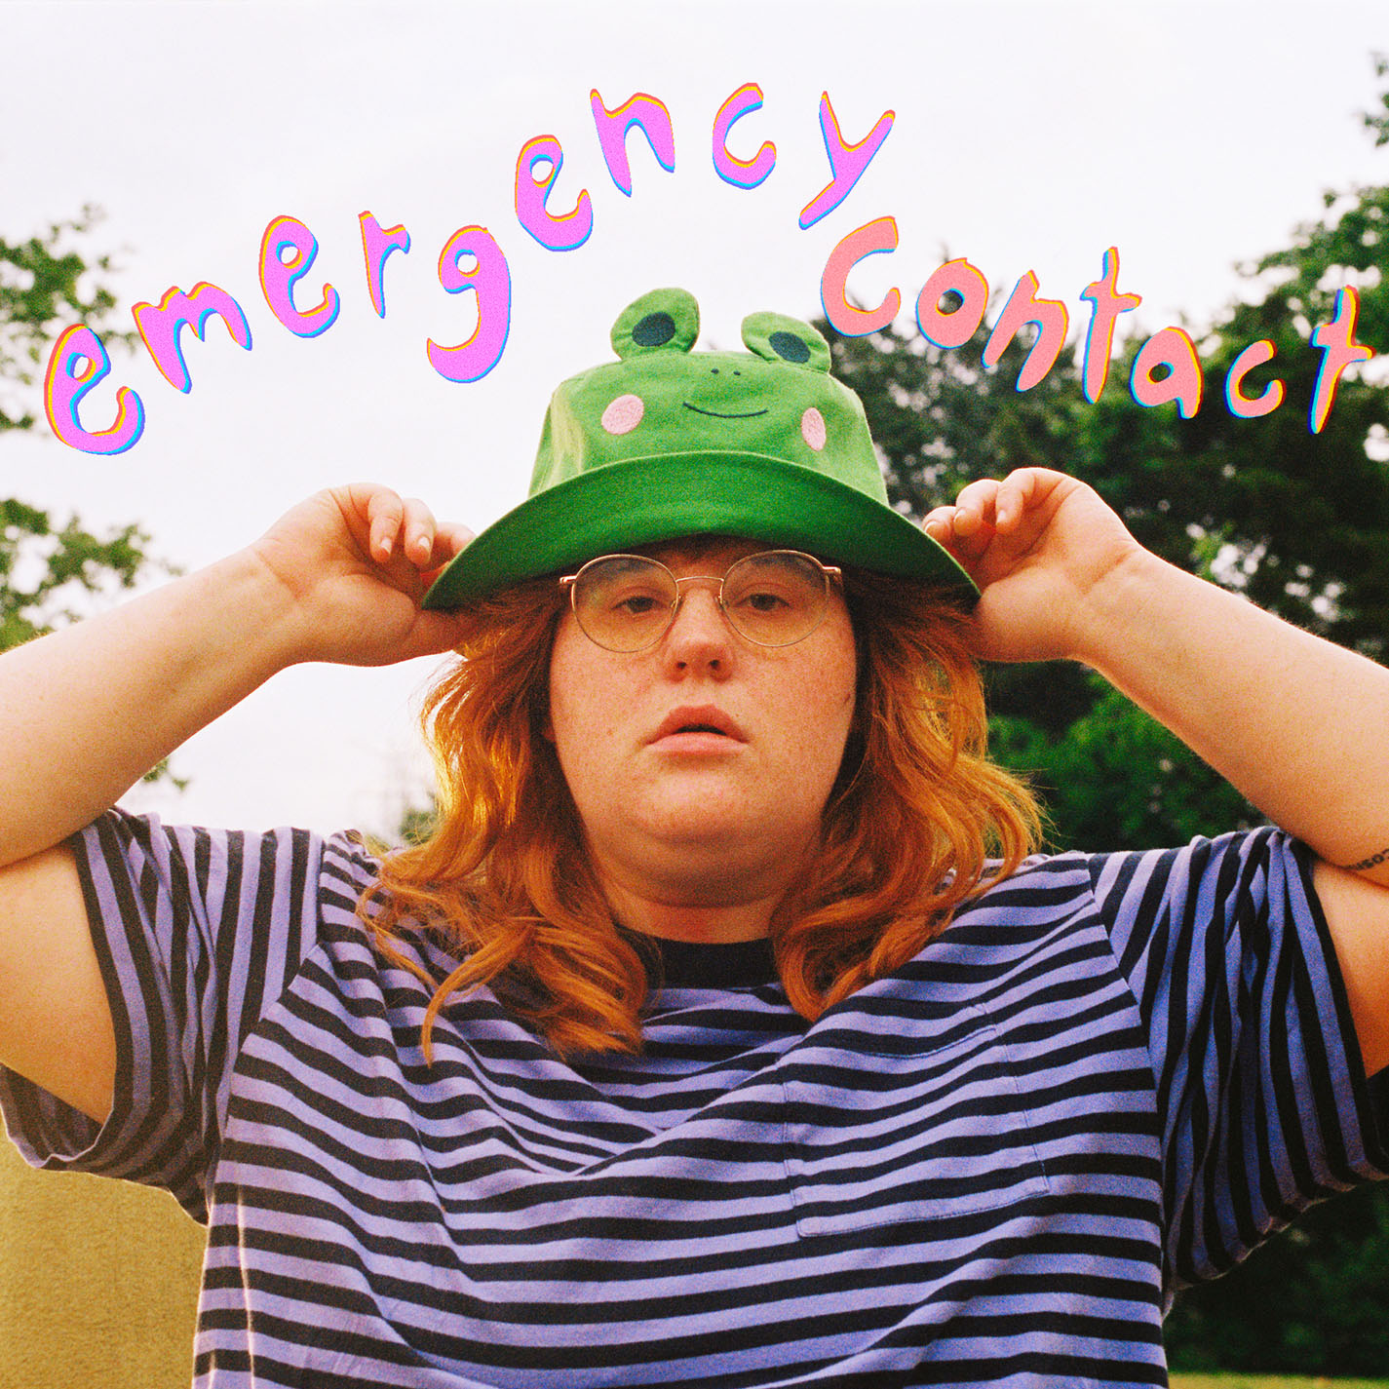
download hi-res artwork

Nashville-based singer-songwriter and multi-instrumentalist corook is kicking off their busy fall season with the release of their new single, “emergency contact” – listen HERE. “emergency contact” heralds the arrival of corook’s forthcoming EP, serious person (part 2), the eagerly anticipated second installment of their serious person project, arriving on Friday, September 22.

“‘emergency contact’ is the introduction to a new funky character-driven corner of corook,” says corook. “The song itself plays like a conversation between me and my whimsical friends cheering me on to go for the girl of my dreams. it’s about the time in my adulthood that i started prioritizing myself and my happiness. i finally trusted myself to pick a partner that was good to me and for me and thus began my journey to find my emergency contact. it is the first single off of my EP, ‘serious person (part 2),’ which will lean more into the bouncy and energetic side of corook while still covering serious topics.”

corook will celebrate the serious person project and much more with the serious person tour, their first-ever North American headline run getting underway September 5 with a sold-out show at Atlanta, GA’s Vinyl and then traveling through mid-October. Highlights include shows at New York City’s Bowery Ballroom (September 14), Nashville, TN’s The Blue Room at Third Man Records (September 23), and Los Angeles, CA’s The Roxy in LA (October 7), as well as festival performances at Raleigh, NC’s Hopscotch Music Festival (September 8), Kerrville, TX’s Welcome Home Festival (October 14), and Austin, TX’s Austin City Limits Music Festival (October 15). For complete details and remaining ticket availability, please visit www.corook.com/tour.

From there, corook will cross the Atlantic for a major EU/UK tour, kicking off with a special guest run supporting Bombay Bicycle Club making stops in Spain, Italy, Germany, Switzerland, France, Poland, Belgium, and the Netherlands. corook will then head to the UK and Ireland for their own eagerly anticipated headline tour, including sold-out shows at Birmingham, England’s O2 Institute3 Birmingham (December 2) and Bristol, England’s Exchange (December 5).

serious person (part 2) marks the second chapter in corook’s two-part serious person project. The first installment, serious person (part 1), arrived this spring, highlighted by the acclaimed title track, “serious person,” as well as the viral smash, “if i were a fish (ft. olivia barton).” Co-written with their girlfriend Olivia Barton as a response to internet hate whilst feeling emotional, insecure, and out of place, “if i were a fish” came together in ten minutes before it was posted to TikTok where it received an incredible response, earning 18.7M views, 2.9M likes and 385.7K shares and counting. Following the outpouring of love and support on social media, corook and Olivia worked quickly to record a full version of the song and the official video – watch HERE. The track is their biggest streaming debut to date with over 18.3M+ global audio streams and counting. It first premiered on BBC Radio 1’s Future Pop and since then, corook has been profiled by NPR, Rolling Stone, New York Times, Boston Globe, and more. The serious person (part 1) EP went on to garner critical acclaim from Billboard, Alternative Press, UPROXX and more. Celebrating the release of serious person (part 1), corook wrapped their first SOLD-OUT mini headline tour earlier this summer, including shows at NY’s Baby’s All Right and LA’s The Echo, plus a special performance at Nashville Pride and their first-ever UK headline show at London’s Colours Hoxton.

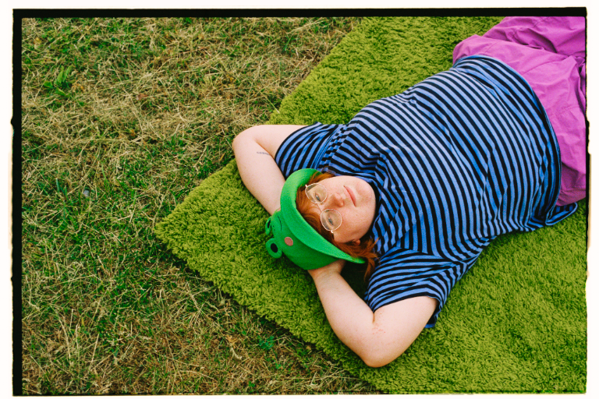
download hi-res press photos
photo credit: libby danforth

about corook
Named as one of PEOPLE’s “Emerging Artists” to watch and The Advocate’s “7 Queer Artists For Your Fall Playlist,” corook [pronounced co-rook] aka Corinne Savage (yes that’s their real last name) is a singer, songwriter, producer, multi-instrumentalist born and raised just outside of downtown Pittsburgh Pennsylvania, where they grew up listening to Drake, Gwen Stefani and Mac Miller. They went to a performing arts high school where they came out as QUEERAF their senior year and eventually graduated from the esteemed Berklee College of Music with two degrees.

Now living in Nashville, corook has become known for their ability to tackle deeply personal themes in their music and visuals through a humorous lens. In the spring of 2022, they released their debut EP, achoo!, featuring such surprising and insightful tracks as “idk god,” “degree,” “bad friend,” and “sims” in addition to the fan favorite “snakes.” As their community of fans began to grow, further releases followed, among them the viral adult lullaby, “it’s ok!,” the unrestrained “BDSM,” super-hot “hell yeah,” the heartfelt “your mom,” and ode to self-worth, “smoothie.” After spending much of 2022 on the road, including their first-ever live runs, supporting K.Flay and Jukebox the Ghost, as well as their debut festival performance at Bonnaroo (featured in Rolling Stone), the rising musician went on to join Maddie Zahm as special guest on her sold-out “You Might Not Like Her” tour.

corook’s serious person tour

SEPTEMBER
5 – Atlanta, GA – Vinyl (SOLD OUT)
8 – Raleigh, NC – Hopscotch Music Festival *
- – Washington DC – Songbyrd (SOLD OUT)
10 – Northampton, MA – Academy of Music
11 – Philadelphia, PA – The Foundry
14 – New York, NY – Bowery Ballroom
15 – Cambridge, MA – Sonia (SOLD OUT)
16 – Montreal, QC – Ausgang Plaza
17 – Toronto, ON – Longboat Hall
19 – Pittsburgh PA – Thunderbird
21 – Chicago, IL – Schubas Tavern (SOLD OUT)
23 – Nashville, TN – The Blue Room at Third Man (SOLD OUT)
26 – Denver, CO – Ophelia's Electric Soapbox
27 – Salt Lake City, UT – Soundwell
28 – Boise ID – Shrine Basement
30 – Olympia, WA – ALMA

OCTOBER
1 – Seattle, WA – Barboza (SOLD OUT)
2 – Portland, OR – Polaris (SOLD OUT)
5 – San Francisco, CA – Café du Norde (SOLD OUT)
7 – Los Angeles, CA – The Roxy
9 – San Diego, CA – The Casbah
11 – Phoenix, AZ – Rebel Lounge
12 – Tucson, AZ – Club Congress
14 – Kerville, TX – Welcome Home Festival *
15 – Austin, TX – Austin City Limits Music Festival *

NOVEMBER
13 – Madrid, Spain – La Riviera †
14 – Barcelona, Spain – Sala Apolo †
16 – Milan, Italy – Alcatraz †
17 – Munich, Germany – Tonhalle †
18 – Lausanne, Switzerland – Les Docks †
19 – Hamburg, Germany – Docks †
21 – Paris, France – La Trabendo †
22 – Berlin, Germany – Columbiahalle †
23 – Warsaw, Poland – Progresja †
25 – Borgerhout, Belgium – De Roma †
26 – Cologne, Germany – Live Music Hall †
27 – Amsterdam, Netherlands – Melkweg †
28 – Amsterdam, Netherlands – Melkweg †

DECEMBER
1 – Manchester, UK – Manchester Academy 3
2 – Birmingham, UK – O2 Institute3 Birmingham (SOLD OUT)
3 – Glasgow, UK – The Garage
5 – Bristol, UK – Exchange (SOLD OUT)
6 – London, UK – XOYO
7 – Brighton, UK – Chalk
9 – Dublin, Ireland – The Workman’s Club

* Festival Performance
† w/ Bombay Bicycle Club

connect with corook:
corook.com | instagram | tiktok | press assets

press contact:
andrew.george@atlanticrecords.com

