FOR IMMEDIATE RELEASE
AUGUST 11, 2023

THE NEW 1017’S LATEST SIGNEE SETT RELEASES HIS DEBUT MIXTAPE
LIFE OF A SLIMECROOK

ACCOMPANIED BY AN OFFICIAL VISUAL FOR “COTTONWOOD TO SOUTH VEGAS”
FEATURING NLE CHOPPA

THE 2-DISC PROJECT FEATURES GUCCI MANE, FINESSE2TYMES, KEY GLOCK, NOCAP, AND MORE

FEATURES PREVIOUSLY RELEASED MEMPHIS ANTHEMS “PISS SETT OFF” & “SNAP”

DOWNLOAD/STREAM LIFE OF A SLIMECROOK
WATCH/SHARE “COTTONWOOD TO SOUTH VEGAS”

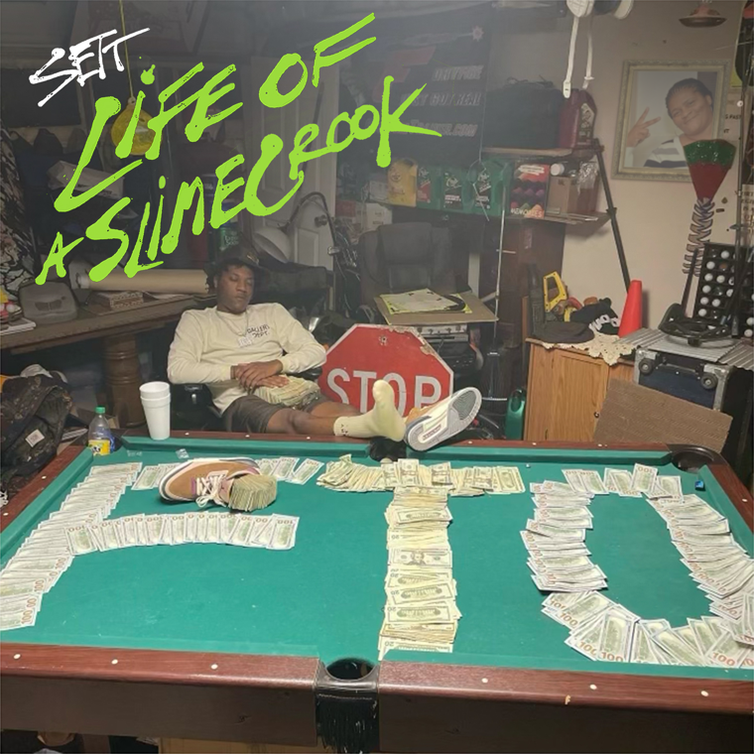
DOWNLOAD HI-RES ARTWORK

Today, Memphis rising star, Sett, has released his debut mixtape, Life Of A SlimeCrook, via The New 1017/Atlantic Records. The two discs project features 19 brand-new tracks with appearances from Key Glock, NLE Choppa, Rob49, NoCap, Co3, and Action Pack on disc one. Disc two will feature 10 previously released singles with appearances from Gucci Mane, Finesse2tymes, and label mates Mac Critter and KATO2X along with production from Tay Keith. Life Of A SlimeCrook is accompanied by an official visual for “Cottonwood to South Vegas” ft. NLE Choppa.

Life Of A SlimeCrook symbolizes how Sett is a 'smooth criminal' in his music. Signed to The New 1017 label at the end of 2022, it was only a few months later when Sett's talents were recognized by his peers and industry tastemakers. “2 For 1” was the final standalone single prior to the release of his debut mixtape and comes on the heels of his breakout Memphis anthems, “Piss Sett Off” (7.8M streams to date, #1 on Spotify Local Pulse Memphis chart, #52 on Spotify Top Songs Memphis, #1 Shazam in Memphis) and “Snap” (highest weekly streaming number to date, #1 on Spotify Memphis Local Pulse Chart). With his string of releases piling up, Sett will continue to flood the market with hit after hit.

When you think of Memphis, TN from the outside, landmarks like Sun Studio, Graceland, or Beale Street may immediately come to mind. At the bottom of the city though, you will find South Vegas. This stretch of town flaunts its own “lingo” and what locals refer to as “a little casino with fast cars and gambling.” Sett calls this neighborhood home. He absorbs the unrestrained energy around him and transfers it into searing and scorching rhymes. Piling up millions of views and streams, he welcomes everyone into this world on his forthcoming debut for The New 1017/Atlantic Records and more to come.

He gained traction with “Free Marvin”—a tribute to his incarcerated brother—before landing back behind bars. After hearing Sett on “GOT MOTION” featuring TayG in 2022, Gucci Mane signed him to The New 1017. “Gucci got me out,” he recalls. “He had confidence in me. He said, ‘We’re going to get this paper’. He showed me how to get myself right. He’s very wise. I watched him, and I learned to make everything count.”

During 2022, the buzzing rapper ignited his next era with “Break Out Dat Cake” with Gucci Mane. Right out of the gate, it gathered over 700k streams and 500K YouTube views. On its heels, he tore through a Zaytoven beat on “First Day in the A.” He consistently developed an incendiary flow punctuated by hard-hitting hooks.“I’m different,” he says. “I have my own joint. I’m not forcing it. I’m not in competition with anyone. I do what I do. I stick in my lane. I can run anybody over.”

Now, he’s about to take off at full speed. “When you hear my songs, I hope you’re motivated,” he leaves off. “I stand firm on everything. If I want this shit, I’m going to get it. You can just make it happen. I’m proof you can.”

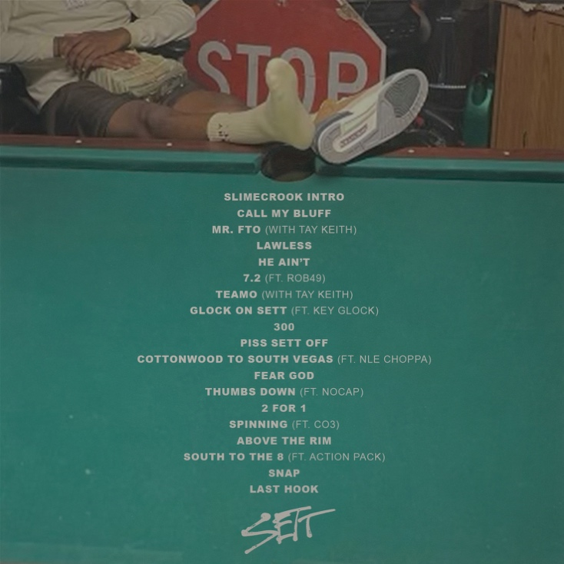

CONNECT WITH SETT
TWITTER | INSTAGRAM | FACEBOOK | YOUTUBE | TIKTOK

