FOR IMMEDIATE RELEASE
AUGUST 18, 2023

RISING ALT-COUNTRY TROUBADOUR TANNER USREY
SHARES DEEPLY PERSONAL NEW SINGLE “WHO I AM”

NEW SINGLE FOLLOWS MONUMENTAL GRAND OLE OPRY DEBUT PERFORMANCE

EPIC LIVE SCHEDULE CONTINUES WITH NATIONWIDE HEADLINE SHOWS,
FESTIVAL PERFORMANCES, AND OPENING SLOTS FOR SHANE SMITH & THE SAINTS AND PAUL CAUTHEN

LISTEN TO “WHO I AM”

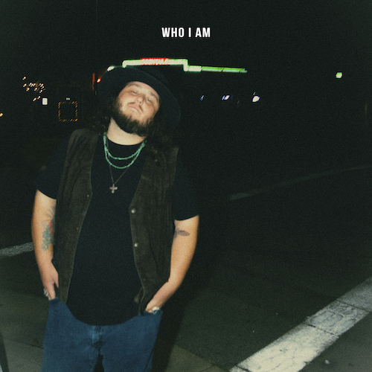
DOWNLOAD HI-RES ARTWORK

“If there is one artist set up for a major explosion over the next year or so, it has to be Tanner Usrey.” – WHISKEY RIFF

Rising country troubadour Tanner Usrey returns with his most personal single thus far, “Who I Am,” available now via Atlantic Records HERE. The heartfelt new track is produced by Beau Bedford (Lillie Mae, Delta Spirit, Orville Peck).

“Who I am is an anthem to anyone who has felt trapped in a cycle of self-destruction,” shares Tanner. “Living on the run, never being able to slow down, and being seen as someone else by people around you. I know a lot of people can relate to that message and this song is for them.”

“Who I Am” marks the latest in a series of new releases from the Texas-based Usrey, including “Last Goodbye” and this spring’s label debut, “Give It Some Time,” both available now at all DSPs and streaming services. Co-written by Usrey and producer Beau Bedford, the latter track is accompanied by an official music video streaming HERE. “Give It Some Time” arrived amidst a flurry of high-profile media attention, including a major signing announcement in Billboard and praise from such high-profile outlets as PEOPLE, Entertainment Tonight, Variety, and others.

An electrifying and energetic live presence who played over 180 shows in 2022 alone, Usrey will continue his non-stop touring with an upcoming live schedule that will see him on the road through to December. The itinerary – which includes headline shows, festival appearances, dates alongside such like-minded artists as Koe Wetzel, Paul Cauthen, and Charles Wesley Godwin – is highlighted by shows at such historic venues as Morrison, CO’s Red Rocks Amphitheatre (supporting Dierks Bentley) and Nashville, TN’s Ryman Auditorium (supporting Shane Smith & The Saints). For complete details and ticket availability, please visit www.tannerusreymusic.com/tour-dates.

ABOUT TANNER USREY
Tanner Usrey has earned national applause for channeling a classic spirit from a personal perspective, blending straight-shooting storytelling with country grit, rock ‘n’ roll energy, and Americana eloquence. Inspired by a range of influences – spanning George Strait, Tom Petty, Lynyrd Skynyrd, and The Rolling Stones to his favorite band, Whiskey Myers – Usrey grew up in the small town of Prosper, TX, where he worked as a skip tracer while honing his signature style by writing countless songs and performing gigs anywhere that had a stage. In 2019, he quit his job and unveiled the Medicine Man EP, followed in 2021 by the SÕL Sessions EP, earning tens of millions of streams and featured placement on the highly rated Yellowstone Season 4 finale. Usrey kicked off 2023 with “Take Me Home,” drawing over 10M streams thus far. Now, as the latest member of the world-renowned Atlantic Records roster, Tanner Usrey is poised to bare it all with “Who I Am” and more new music to come.

“I hope you hear what you want to hear, enjoy it, resonate with it, and know it’s real,” Usrey says. “It’s been a wild ride. I’ve busted my ass. I started off doing all of this on my own, so it’s crazy to see how this and the team around me have grown. People are going after real music right now, and that’s great. I’m looking forward to seeing where it goes next.”

TANNER USREY
ON TOUR 2023

AUGUST
18 – Salt Lake City, UT – Soundwell
19 – Helena, MT – Dess Fest 2023 *
20 – Jackson, WY – The Virginian Saloon
21 – Billings, MT – Pub Station Ballroom
24 – Omaha, NE – The Waiting Room
25 – Fargo, ND – The Hall
26 – Henriette, MN – Northwoods Jam *
27 – Milwaukee, WI – The Back Room @ Colectivo Coffee
28 – Des Moines, IA – Wolly’s
29 – Davenport, IA – Raccoon Motel

SEPTEMBER
2 – Fort Worth, TX – Bulls, Bands, and Barrels *
3 – Lake View, IA – Stone Pier Summer Concert Series *
6 – Morrison, CO – Red Rocks Amphitheater †
13-16 – Pryor, OK – Born & Raised 2023 *
15 – Amarillo, TX – Starlight Ranch
16 – Royse City, TX – Southern Junction Live
28 – Cape Girardeau, MO – Show Me Center ^
29 – Rogers, AR – Walmart AMP ^
30 – Oklahoma City, OK – Paycom Center ^

OCTOBER
1 – Ashland, KY – Foxfire Music Festival *
5 – Corpus Christi, TX – American Bank Center ^
6 – San Antonio, TX – AT&T Center ^
7 – Lubbock, TX – United Supermarkets Arena ^
8 – Austin, TX – Austin City Limits Music Festival *
19 – Baton Rouge, LA – Texas Club
21 – Fort Worth, TX – Gordy's HWY30 Texas Edition *
24 – Norfolk, VA – The Norva #
25 – Philadelphia, PA – World Café Live #
27 – Washington, DC – Howard Theatre #
28 – Harrisburg, PA – XL Live #
29 – Cambridge, MA – The Sinclair #
31 – South Burlington, VT – Higher Ground #

NOVEMBER
1 – New York, NY – Racket #
3 – Columbus, OH – The Bluestone #
4 – Detroit, MI – Majestic Theatre #
5 – Chicago, IL – Metro #
7 – Indianapolis, IN – The Vogue #
8 – Columbia, SC – The Senate
9 – Athens, GA – Georgia Theatre
10 – Asheville, NC – The Orange Peel **
11 – Greenville, NC – The State Theatre
18 – Fort Smith, AR – The Majestic
30 – Nashville, TN – Ryman Auditorium †† [SOLD OUT]

DECEMBER
10 – Stateline, NV – Harrah’s #
12 – Bend, OR – Midtown Ballroom #
14 – Seattle, WA – Showbox #
15 – Spokane, WA – Knitting Factory #
16 – Portland, OR – Crystal Ballroom #

* Festival Performance
† w/ Dierks Bentley
^ w/ Koe Wetzel
# w/ Paul Cauthen
** w/ Charles Wesley Godwin
†† w/ Shane Smith & The Saints

# # #
CONNECT WITH TANNER USREY
OFFICIAL | FACEBOOK | INSTAGRAM | TWITTER | YOUTUBE
N”

