FOR IMMEDIATE RELEASE
SEPTEMBER 13, 2023

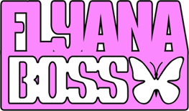

FLYANA BOSS OFFICIALLY LIFT CURTAIN ON HIGHLY ANTICIPATED
“YOU WISH” MUSIC VIDEO

DOORDASH RESPONDS TO FANS FOR HOT NEW MUSIC VIDEO COLLAB

WATCH THE “YOU WISH” VIDEO HERE

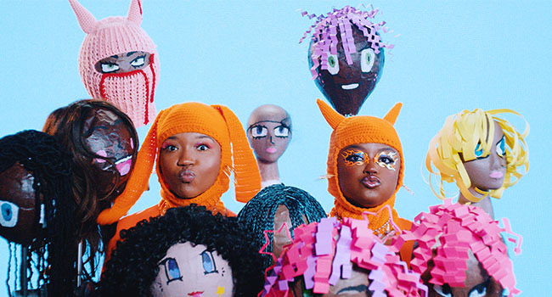
DOWNLOAD HI-RES THUMBNAIL HERE

DUO CELEBRATING BREAKOUT SUCCESS AS SPECIAL GUESTS
ON JANELLE MONÁE’S THE AGE OF PLEASURE TOUR

LISTEN TO RECENTLY-RELEASED “YOU WISH (WITH MISSY ELLIOTT & KALIII) – REMIX” HERE

“Flyana Boss’ opening bars to their hit ‘You Wish’ has become the bat signal for Black alt-girls across the internet.” – VULTURE

“The rap duo are pushing the boundaries of contemporary hip hop with their raunchy and witty storytelling, and their breakout track ‘You Wish’ has become one of this year’s definitive summer anthems, having Black girls everywhere declare they’re ‘made of sugar, spice, kanekalon, and cinnamon.’ – DAZED

Today, “Cute-girl-rap” duo Flyana Boss has lifted the curtain on the official music video directed by Brad Wong for their chart-topping viral smash, “You Wish,” at YouTube HERE.

In June, Flyana Boss posted a “You Wish” TikTok, while riding DoorDash branded bikes. The response from fans for a Flyana Boss x DoorDash collab was immense—with that post being viewed more than 10M times. The public asked, and DoorDash delivered (pun intended) by officially collaborating with Flyana Boss on the fun and colorful video that the masses have been waiting for.

The Black girl magic continues to brew as the ladies recently joined forces with the icon herself Missy Elliott and rising it-girl Kaliii for a new star-studded spin on the worldwide viral hit. The "You Wish (with Missy Elliott & Kaliii) - Remix", includes brand new fire verses from Flyana Boss and their guest stars. Stream HERE.

Flyana Boss – a.k.a. multi-instrumentalist/MCs Bobbi LaNea and Folayan – are currently celebrating the explosive success of “You Wish” as special guests on Janelle Monáe’s The Age of Pleasure Tour, making stops across North America through mid-October. Highlights include a visits to such historic venues as Morrison, CO’s Red Rocks Amphitheatre (September 7), Toronto, ON’s Massey Hall (September 21, 22), New York City’s Radio City Music Hall (September 26), and Atlanta, GA’s Fox Theatre (October 6).

Hailing from Detroit, MI and Dallas, TX respectively, Bobbi and Folayan met at a music college in Los Angeles where they immediately hit it off and began collaborating. The fierce duo adopted the name Flyana Boss (rhymes with Diana Ross), repping the Vagina Dynasty while simultaneously embodying the spirit of flyness and bossness. Together, Bobbi and Folayan form a formidable union that pushes the boundaries of contemporary hip-hop, seamlessly blending their individual strengths to create a sound that is distinctively Flyana Boss. Bobbi brings a knack for storytelling and infuses her music with authenticity and vulnerability as Folayan effortlessly switches between different styles and genres, adding depth and dimension to Flyana Boss’ one-of-a-kind music.

Flyana Boss burst onto the scene with their breakout single, “You Wish,” which debuted at # 1 on Spotify’s “Viral 100” amidst worldwide attention from hip-hop legends Missy Elliott and Timbaland as well as such high-profile media outlets as Variety, Complex, NYLON, Vulture, UPROXX, Ones To Watch, and Rolling Stone, among many others. Produced by rising hitmaker Marky Style, the track – featured on the two-track single “You Wish + Trashboi” – quickly proved a sensation, earning over 16M global streams to date while rocketing the duo into the spotlight (and kickstarting a spirited viral discussion regarding the word “Kanekalon”). “You Wish – DJ Smallz 732 – Jersey Club Remix,” another spin on the hit track, is available everywhere now via vnclm_ x Atlantic Records HERE.

Increasingly known for their unforgettable live performances – including a spectacular set at New Orleans’s Essence Festival of Culture highlighted by a twerkable onstage moment with Megan Thee Stallion – Flyana Boss are focused on creating music that reflects their experiences and resonates with their listeners, embracing their uniqueness and uplifting others through their art.
With talent, ambition, and more impossible-to-resist tracks to come, Flyana Boss is poised to leave an indelible mark on the hearts and minds of music lovers worldwide.

FLYANA BOSS
ON TOUR 2023

DOWNLOAD ADMAT HERE

ALL DATES w/ JANELLE MONÁE’S THE AGE OF PLEASURE TOUR

SEPTEMBER
7 – Morrison, CO – Red Rocks Amphitheatre
9 – Kansas City, MO – The Midland Theatre
10 – Indianapolis, IN - Egyptian Room at Old National Centre
11 – Minneapolis, MN – Armory
13 – St. Louis, MO – Stifel Theatre
14 – Chicago, IL – Byline Bank Aragon Ballroom
15 – Columbus, OH – Mershon Auditorium
17 – Boston, MA – MGM Music Hall at Fenway
18 – Philadelphia, PA – The Met
20 – Montreal, QC – Mtelus
21 – Toronto, ON – Massey Hall
22 – Toronto, ON – Massey Hall
24 – Washington, DC – The Anthem
25 – Washington, DC – The Anthem
26 – New York City, NY – Radio City Music Hall
28 – Brooklyn, NY – Kings Theatre

OCTOBER
2 – Charlotte, NC – Skyla Credit Union Amphitheatre
3 – Nashville, TN – Ryman Auditorium
4 – Birmingham, AL – Avondale Brewing Company
6 – Atlanta, GA – Fox Theatre Atlanta
7 – New Orleans, LA – Orpheum Theatre

# # #

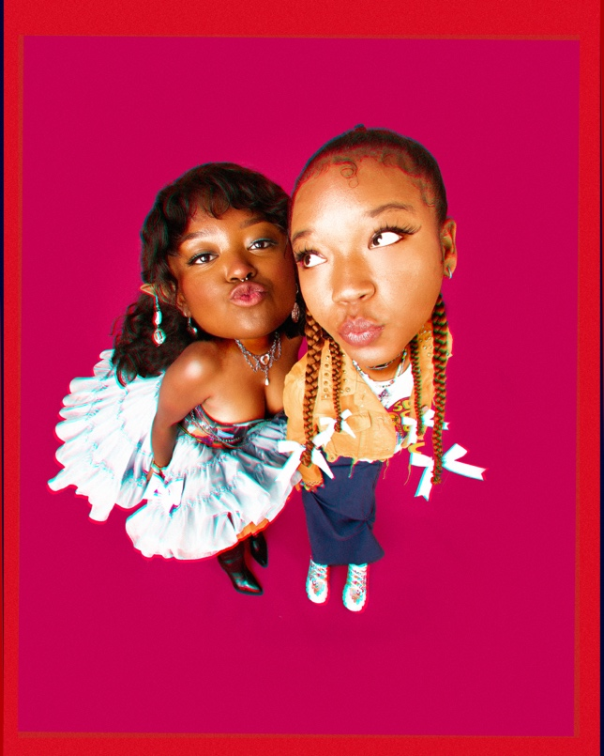
DOWNLOAD PRESS PHOTO HERE // PHOTO CREDIT: SJ SPRENG

CONNECT WITH FLYANA BOSS
FLYANABOSS.COM | INSTAGRAM | TIKTOK | TWITTER | YOUTUBE

PRESS CONTACT
FAIRLEY MCCASKILL | FAIRLEY.MCCASKILL@ATLANTICRECORDS.COM

