BRISTON MARONEY SHARES NEW TRACK “SUNSHINE”

BUY/STREAM HERE | WATCH ACOUSTIC PERFORMANCE HERE

NEW ALBUM ULTRAPURE – PRODUCED BY DANIEL TASHIAN
DUE OUT SEPTEMBER 22 VIA CANVASBACK MUSIC/ATLANTIC RECORDS
PRE-ORDER HERE

LEAD SINGLE “BODY” ASCENDS INTO TOP 15 AT TRIPLE A RADIO
WATCH OFFICIAL VIDEO – CO-DIRECTED BY MARONEY – HERE

US RECORD STORE TOUR SET FOR FALL 2023
FULL ROUTING HERE

SECOND ANNUAL ‘PARADISE FESTIVAL’ – CURATED BY MARONEY – SET FOR OCT 12-14 AT BROOKLYN BOWL NASHVILLE WITH SAMIA, HOVVDY + MORE

“Pretty flawless. Briston Maroney has pulled it off.”
Zane Lowe re: “Body” on New Music Daily [listen here]

“Briston Maroney tells stories that feel personal without posturing. ‘Sunburn Fades,’ which arrives ahead of a new album slated for September, is an example of the minimalist, home-spun sound the artist is continuing to craft…”
CONSEQUENCE

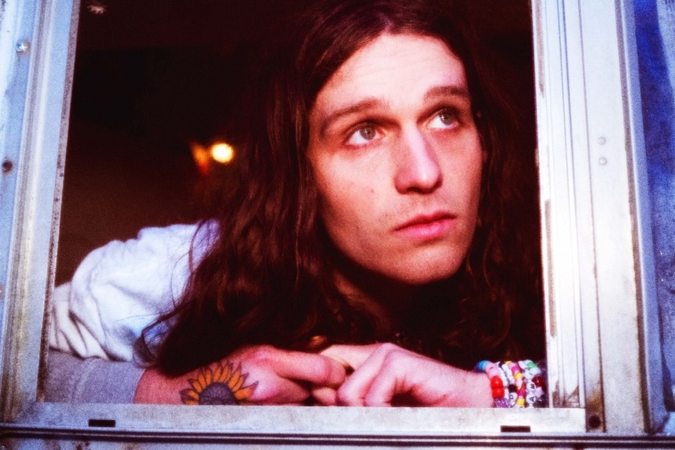
press photo credit: Muriel Margaret | download hi-res HERE
download additional images, boiler + Maroney’s album note HERE

September 1, 2023 – Acclaimed Nashville-based artist Briston Maroney has shared new track “Sunshine” (buy/stream here), the latest offering from his forthcoming album, Ultrapure, due out Friday, September 22 via Canvasback Music/Atlantic Records (pre-order here). The song arrives alongside a stunning live, acoustic performance video (watch here).

“Sunshine” follows July’s two-sided single release, “Detonator” / “The Idea” (buy/stream here), “Sunburn Fades,” which was immediately hailed by Consequence as “an example of the minimalist, home-spun sound the artist is continuing to craft” upon release, and lead single “Body,” which debuted in May via Apple Music’s New Music Daily alongside an interview with Briston and Zane Lowe, and is currently Top 15 at AAA Radio (and very quickly rising).

This past Monday, Maroney announced his official US Record Store Tour, set for September/October 2023. In partnership with Record Store Day, Maroney will be stopping at 12 different indie record stores this fall to perform acoustic songs from Ultrapure, and sign his indie exclusive vinyl.

Maroney’s first stop will be at Grimey’s, his hometown record store in Nashville, TN, on album release day [September 22] before he traverses the country from NYC’s Rough Trade to San Francisco’s Amoeba SF, with many more stops in between [full routing enclosed below]. The tour will also be supported by local radio stations in each market.

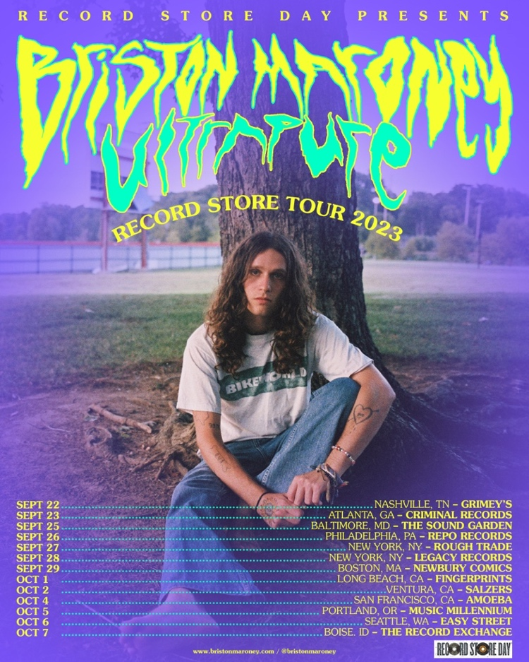
download hi-res admat HERE

Produced by 2x GRAMMY®-winner Daniel Tashian (Kacey Musgraves) and engineered by Konrad Snyder (Noah Kahan, Rainbow Kitten Surprise), Ultrapure was crafted in Maroney’s adopted hometown of Nashville, TN and showcases the artist playing every single instrument.

Of the album’s genesis, Maroney shares: My favorite moments in the human experience are ones that you don’t even realize have started,but feel so deeply when you realize they’ve ended. I refer to these as ‘Ultrapure’ moments. This album was my humble, unqualified, and earnest as hell attempt at sitting in those feelings until they had no choice but to burst out of my head. These songs are about a type of pain I hate and love, but mostly have a deep appreciation for.

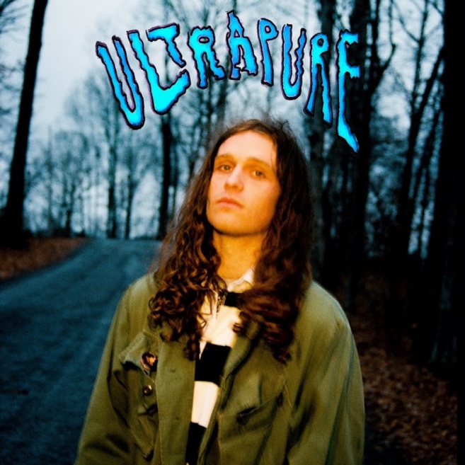
download hi-res album artwork HERE

This fall, Maroney will host his second annual ‘Paradise Festival,’ set to return to Brooklyn Bowl Nashville from October 12-14. Last year’s sold-out inaugural edition was curated in its entirety by the artist himself, who closed out each night with high-energy and celebratory headline sets. Featuring a handpicked lineup of peers – including Samia, Hovvdy, and Skullcrusher joining this fall’s iteration – and with a portion of proceeds supporting Nashville-based nonprofits, the annual event further cements Maroney’s status as an artist who “has helped define a new generation of local music” (Nashville Scene).

Later this year, Maroney will embark on a headline UK/EU tour in support of Ultrapure. The dates kick off in Brighton, UK on October 31 and culminate in Cologne, Germany on November 16, with stops in London, Paris, Amsterdam, and many more cities in between [all upcoming tour dates enclosed below].

Maroney’s debut LP Sunflower was released in 2021, following a trio of EPs: Miracle, Indiana, and Carnival – the latter of which spurned the RIAA Platinum-certified single, “Freakin’ Out On The Interstate.” These releases amassed critical acclaim from the likes of NPR, Vulture, NME, amongst many others, and led to sold-out headline tour dates across the US, Canada, UK and Europe; performances at marquee festivals around the world (from Bonnaroo to Outside Lands to Pitchfork Paris); opening slots for Jack White and Rainbow Kitten Surprise; and a feature collaboration with Manchester Orchestra on 2022’s Sunflower: Deluxe.

###

BRISTON MARONEY | UPCOMING TOUR DATES
* Record Store Tour performance
# festival performance

SEPTEMBER
8 – Denver, CO @ Endless Sunshine #
22 – Nashville, TN @ Grimey’s *
23 – Atlanta, GA @ Criminal Records *
25 – Baltimore, MD @ The Sound Garden *
26 – Philadelphia, PA @ Repo Records *
27 – New York, NY @ Rough Trade *
28 – Brooklyn, NY @ Legacy Dumbo *
29 – Boston, MA @ Newbury Comics *

OCTOBER
1 – Long Beach, CA @ Fingerprints *
2 – Ventura, CA @ Salzers *
4 – San Francisco, CA @ Amoeba SF *
5 – Portland, OR @ Music Millennium *
6 – Seattle, WA @ Easy Street *
7 – Boise, ID @ The Record Exchange *
12 – Nashville, TN @ Brooklyn Bowl Nashville – Paradise Festival #
13 – Nashville, TN @ Brooklyn Bowl Nashville – Paradise Festival #
14 – Nashville, TN @ Brooklyn Bowl Nashville – Paradise Festival #
31 – Brighton, UK @ Chalk

NOVEMBER
1 – London, UK @ Scala
3 – Manchester, UK @ Gorilla
4 – Glasgow, UK @ Stereo
5 – Leeds, UK @ Brudnell Social Club
7 – Nottingham, UK @ Rescue Rooms
8 – Bristol, UK @ Thekla
10 – Paris, FR @ Le Trabendo
11 – Nijmegen, NL @ Doornroosje
12 – Amsterdam, NL @ Melkweg OZ
14 – Hamburg, DE @ Knust
15 – Berlin, DE @ Gretchen

###

CONNECT WITH BRISTON MARONEY:
OFFICIAL I INSTAGRAM I YOUTUBE I FACEBOOK I TWITTER I TIKTOK

FOR ALL PRESS INQUIRIES, PLEASE CONTACT:
Libby Kober (National) | Libby.Kober@AtlanticRecords.com
Gabby Reese (Tour) | Gabrielle.Reese@AtlanticRecords.com

