BRISTON MARONEY RELEASES ULTRAPURE

BUY/STREAM HERE + OFFICIAL VIDEO FOR “CHAOS PARTY” HERE

FULL NORTH AMERICAN HEADLINE TOUR UNVEILED FOR 2024

MARONEY SET TO MAKE TV DEBUT ON CBS SATURDAY MORNING ON 9/30

SECOND ANNUAL ‘PARADISE FESTIVAL’ – CURATED BY MARONEY – SET FOR OCT 12-14 AT BROOKLYN BOWL NASHVILLE WITH SAMIA, HOVVDY + MORE

“Pretty flawless. Briston Maroney has pulled it off.”
ZANE LOWE

“Briston Maroney tells stories that feel personal without posturing. ‘Sunburn Fades,’ which arrives ahead of a new album slated for September, is an example of the minimalist, home-spun sound the artist is continuing to craft…”
CONSEQUENCE

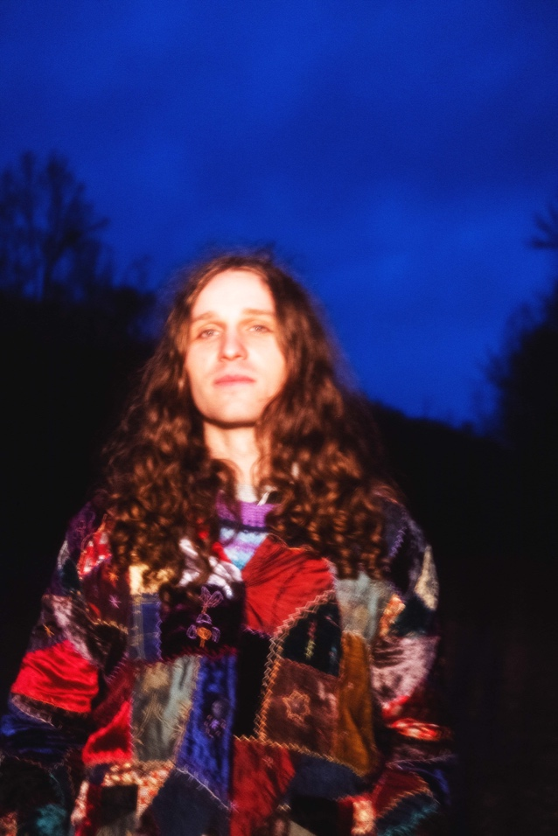
press photo credit: Muriel Margaret | download hi-res HERE
download additional images, boiler + Maroney’s album note HERE

September 22, 2023 – Acclaimed Nashville-based artist Briston Maroney has released his highly-anticipated new album, Ultrapure, via Canvasback Music/Atlantic Records (buy/stream here). The record arrives alongside an official music video for “Chaos Party” – watch here – directed by Maroney as well as frequent visual collaborator Drew Bauml.

Produced by 2x GRAMMY®-winner Daniel Tashian (Kacey Musgraves) and engineered by Konrad Snyder (Noah Kahan, Rainbow Kitten Surprise), the 13-track LP was crafted in Maroney’s adopted hometown of Nashville, TN and showcases the artist playing every instrument.

Maroney will make his TV debut on CBS Saturday Morning, performing new singles “Chaos Party” and “Body,” plus his RIAA Platinum-certified hit “Freakin’ Out On The Interstate” on 9/30.

Of Ultrapure’s genesis, Maroney shares: My favorite moments in the human experience are ones that you don’t even realize have started,but feel so deeply when you realize they’ve ended. I refer to these as ‘Ultrapure’ moments. This album was my humble, unqualified, and earnest as hell attempt at sitting in those feelings until they had no choice but to burst out of my head. These songs are about a type of pain I hate and love, but mostly have a deep appreciation for.

Earlier this week, Maroney announced a North American headline tour in support of Ultrapure. Set for January-March 2024, the run includes two nights at Webster Hall in NYC, two nights at The Fonda in LA, along with stops in Seattle, Chicago, Austin, Toronto, and many more cities in between [buy tickets here; full routing enclosed below].

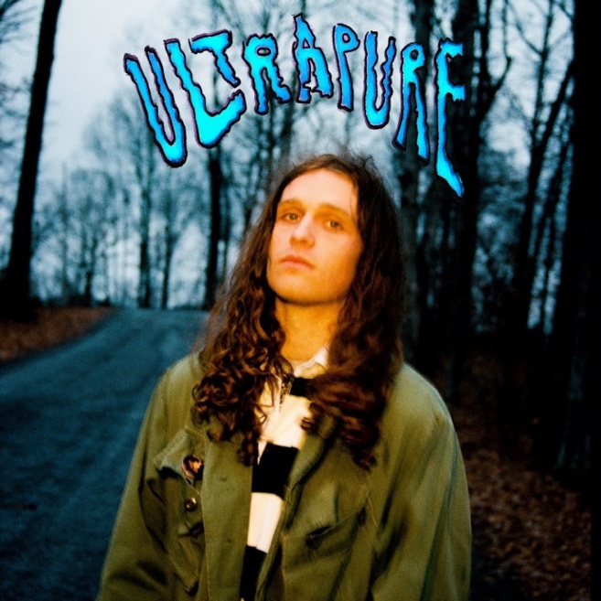
download hi-res album artwork HERE

Today, Maroney will embark upon his official US Record Store Tour – kicking off at Grimey’s, his hometown record store in Nashville, TN – before continuing to NYC’s Rough Trade, San Francisco’s Amoeba SF, and many other stores in between [full routing enclosed below]. The tour will also be supported by local radio stations in each market.

Next month, Maroney will host his second annual ‘Paradise Festival,’ set to return to Brooklyn Bowl Nashville from October 12-14. Last year’s sold-out inaugural edition was curated in its entirety by the artist himself, who closed out each night with high-energy and celebratory headline sets. Featuring a handpicked lineup of peers – including Samia, Hovvdy, and Skullcrusher joining this fall’s iteration – and with a portion of proceeds supporting Nashville-based nonprofits, the annual event further cements Maroney’s status as an artist who “has helped define a new generation of local music” (Nashville Scene).

And later this year, Maroney will embark on a headline UK/EU tour in support of Ultrapure. The dates kick off in Brighton, UK on October 31 and culminate in Cologne, Germany on November 16 [all upcoming tour dates enclosed below].

###

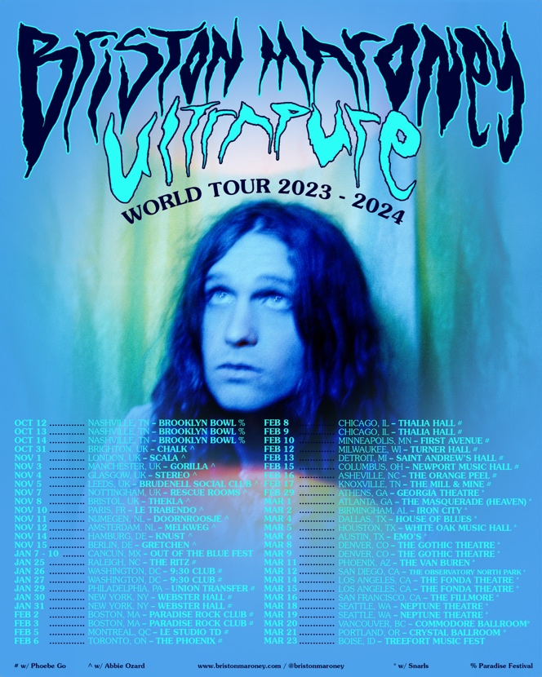
download hi-res admat HERE

BRISTON MARONEY | UPCOMING TOUR DATES
@ Record Store Tour performance
% festival performance
# w/ Phoebe Go
* w/ Snarls

SEPTEMBER
22 – Nashville, TN @ Grimey’s @
22 – Nashville, TN @ The East Room
23 – Atlanta, GA @ Criminal Records @
25 – Baltimore, MD @ The Sound Garden @
26 – Philadelphia, PA @ Repo Records @
27 – New York, NY @ Rough Trade @
28 – Brooklyn, NY @ Legacy Dumbo @
29 – Boston, MA @ Newbury Comics @

OCTOBER
1 – Long Beach, CA @ Fingerprints @
2 – Ventura, CA @ Salzers @
4 – San Francisco, CA @ Amoeba SF @
5 – Portland, OR @ Music Millennium @
6 – Seattle, WA @ Easy Street @
7 – Boise, ID @ The Record Exchange @
12 – Nashville, TN @ Brooklyn Bowl Nashville – Paradise Festival %
13 – Nashville, TN @ Brooklyn Bowl Nashville – Paradise Festival %
14 – Nashville, TN @ Brooklyn Bowl Nashville – Paradise Festival %
31 – Brighton, UK @ Chalk

NOVEMBER
1 – London, UK @ Scala
3 – Manchester, UK @ Gorilla
4 – Glasgow, UK @ Stereo
5 – Leeds, UK @ Brudnell Social Club
7 – Nottingham, UK @ Rescue Rooms
8 – Bristol, UK @ Thekla
10 – Paris, FR @ Le Trabendo
11 – Nijmegen, NL @ Doornroosje
12 – Amsterdam, NL @ Melkweg OZ
14 – Hamburg, DE @ Knust
15 – Berlin, DE @ Gretchen

JANUARY 2024
7-10 – Riviera Cancún, Mexico @ Out of the Blue Festival %
25 – Raleigh, NC @ The Ritz #
26 – Washington DC @ 930 Club #
27 – Washington DC @ 930 Club #
29 – Philadelphia, PA @ Union Transfer #
30 – New York, NY @ Webster Hall #
31 – New York, NY @ Webster Hall #

FEBRUARY 2024
2 – Boston, MA @ Paradise Rock Club #
3 – Boston, MA @ Paradise Rock Club #
5 – Montreal, QC @ Le Studio TD #
6 – Toronto, ON @ The Phoenix #
8 – Chicago, IL @ Thalia Hall #
9 – Chicago, IL @ Thalia Hall #
10 – Minneapolis, MN @ First Avenue #
12 – Milwaukee, WI @ Turner Hall #
13 – Detroit, MI @ Saint Andrew’s Hall #
15 – Columbus, OH @ Newport Music Hall #
16 – Asheville, NC @ The Orange Peel #
17 – Knoxville, TN @ The Mill & Mine #
29 – Athens, GA @ Georgia Theatre *

MARCH 2024
1 – Atlanta, GA @ The Masquerade (Heaven) *
2 – Birmingham, AL @ Iron City *
4 – Dallas, TX @ House of Blues *
5 – Houston, TX @ White Oak Music Hall *
6 – Austin, TX @ Emo’s *
8 – Denver, CO @ The Gothic Theatre *
9 – Denver, CO @ The Gothic Theatre *
11 – Phoenix, AZ @ The Van Buren *
12 – San Diego, CA @ The Observatory North Park *
14 – Los Angeles, CA @ The Fonda *
15 – Los Angeles, CA @ The Fonda *
16 – San Francisco, CA @ The Fillmore *
18 – Seattle, WA @ Neptune Theatre *
19 – Seattle, WA @ Neptune Theatre *
20 – Vancouver, BC @ Commodore *
21 – Portland, OR @ Crystal Ballroom *
23 – Boise, ID @ Treefort Music Fest %

###

CONNECT WITH BRISTON MARONEY:
OFFICIAL I INSTAGRAM I YOUTUBE I FACEBOOK I TWITTER I TIKTOK

FOR ALL PRESS INQUIRIES, PLEASE CONTACT:
Libby Kober (National) | Libby.Kober@AtlanticRecords.com
Gabby Reese (Tour) | Gabrielle.Reese@AtlanticRecords.com

