FOR IMMEDIATE RELEASE
AUGUST 24, 2023
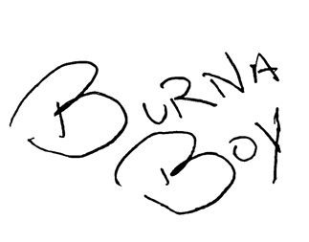
BURNA BOY RELEASES HIGHLY ANTICIPATED 7TH STUDIO ALBUM I TOLD THEM…

15-TRACK ALBUM INCLUDES APPEARANCES FROM GZA, RZA, 21 SAVAGE, DAVE, SEYI VIBEZ,
J. COLE AND BYRON MESSIA

EXCLUSIVE LIMITED EDITION I TOLD THEM… MAGAZINE AVAILABLE NOW

RECENTLY SEEN AS SURPRISE GUEST PERFORMER ON OPENING NIGHT OF
DAVE CHAPPELLE’S ‘IT’S A CELEBRATION B!%?#&$! TOUR’

READ RECENT COVER STORY WITH THE LA TIMES HERE

DOWNLOAD/STREAM I TOLD THEM… | PURCHASE I TOLD THEM… MAGAZINE
PURCHASE THE LATEST I TOLD THEM… MERCH AND BUNDLES

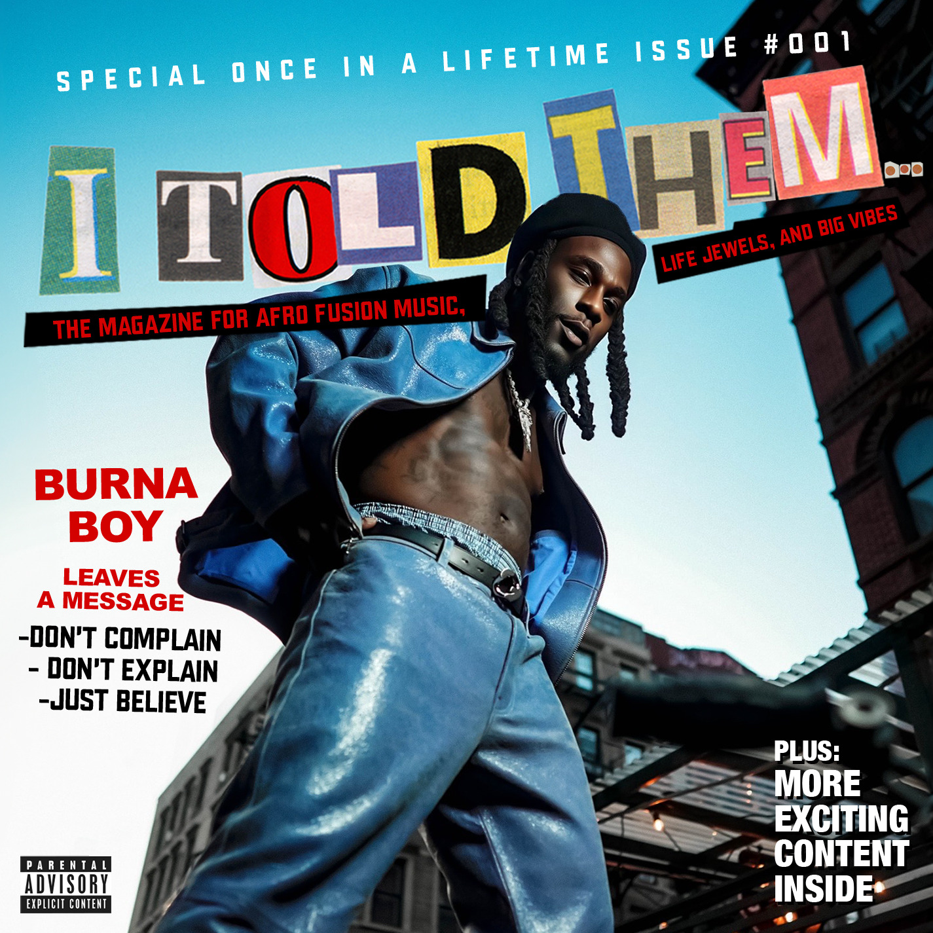
DOWNLOAD HI-RES ARTWORK
(ALBUM PHOTO SHOT BY APM + COVER DESIGN BY FLASHGRFX)
GRAMMY® Award-winning global superstar Burna Boy releases his seventh studio album, I Told Them… via Spaceship/Bad Habit/Atlantic Records. The 15-track album includes appearances from GZA, RZA, 21 Savage, Dave, Seyi Vibez, J. Cole and Byron Messia. I Told Them… is available now via all streaming services.

With his latest body of work, Burna Boy invites you to immerse yourself in the stories, rhythms, and melodies that define I Told Them… an album that encapsulates the essence of his musical journey. With an intricate blend of musical influences, from elements of 90s Hip-hop to Afrofusion, the project creates a vibrant fusion of sounds while Burna’s signature storytelling takes center stage, inviting listeners into a world where themes of triumph, grinding and resilience converge.

I Told Them… marks a pivotal chapter in Burna's artistic journey. The album is a reflection of his growth, both as an artist and as an individual. The album's title serves as a powerful statement of Burna's self-assurance and the validation of his ascension to the top. It encapsulates his journey from an aspiring artist to a global icon, using his music as a catalyst to the world stage. Burna's influence extends far beyond the borders of Nigeria. His music resonates with listeners across continents, and I Told Them… is poised to further cement his status as a global music sensation. The album is set to provide fans with an immersive and captivating listening experience, showcasing Burna Boy's dedication to his craft.

I Told Them… is accompanied by a special edition magazine. The exclusive piece is meant to serve as a collector’s item/special keepsake for fans. From front to back the magazine features never-before-seen content including a conversation between Burna Boy and RZA (of the Wu-Tang Clan), articles written by his grandfather (former manager of the legendary Fela Kuti), photos from throughout the making of the album, and more. The limited run magazine will be available exclusively at select pop-up events and Burna Boy’s official website.

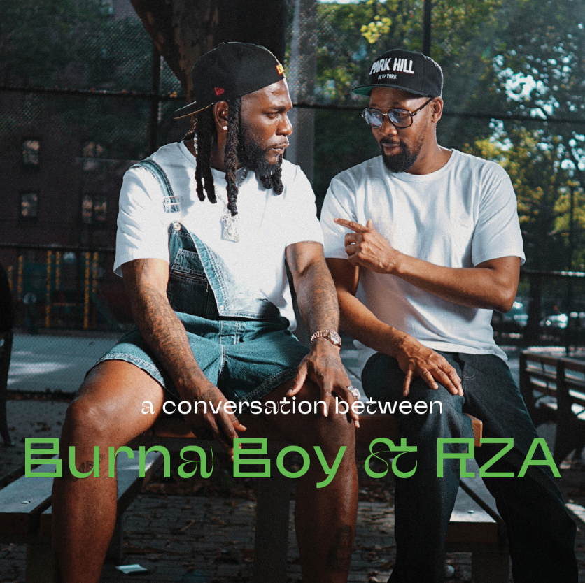
Download/stream I TOLD THEM…: https://burna.lnk.to/itoldthem
Purchase special edition I TOLD THEM… Magazine: https://burnaboy.lnk.to/ITTMag
Purchase the latest I TOLD THEM… merch and bundles: https://burna.lnk.to/BurnaBoyStore

Burna kicked off release week with the release of his exclusive cover story with the LA Times followed by an official album release party in New York City on August 21st and a series of global listening parties taking place in several cities including New York, Houston, Atlanta, Sydney, Toronto, Lagos and many more. He was also seen performing on opening night of Dave Chappelle’s ‘It’s a Celebration B!%?#&$! Tour’ at Madison Square Garden on the night of August 22nd helping to close the show with standout records “Ye” and “Last Last”. Dave was later seen backstage learning the signature dance to the highly anticipated record, “City Boys” (see original post here).

Earlier this week Burna also unveiled the latest single from the album “Cheat On Me” featuring friend and previous collaborator, Dave. The album also includes previously released singles Talibans II with Byron Messia, “Big 7”, which was accompanied by an official visual shot by the legendary Benny Boom in New York City with notable cameos from Rza (Wu-Tang Clan), Busta Rhymes, Junior Mafia and actor Shameik Moore (Spiderman), and “Sittin’ On Top Of The World” featuring multi-platinum artist, 21 Savage.

Last month, Burna Boy made history once again with his sold-out show at New York City’s Citi Field stadium. Becoming the first African artist in history to sell out a stadium in the U.S., the Nigerian showman commanded a crowd of more than 40,000 fans, including celebs like Busta Rhymes, SZA, NBA star Mo Bamba, NFL star Larry Ogunjobi, and British rapper Dave, who also joined Burna on stage for a special performance of their hit song “Location.” Highlights included a performance of his newest single, “Sittin’ On Top Of The World," a sneak peek of his unreleased track “Big 7,” and an explosive finale where the crowd belted every word to the star’s massive hit “Last, Last” while fireworks lit up the sky. This history-making performance shortly followed his landmark London stadium performance where he became the first African to headline a stadium in the U.K. Viewers were able to enjoy this monumental show via an exclusive Apple Music Live stream.
# # #

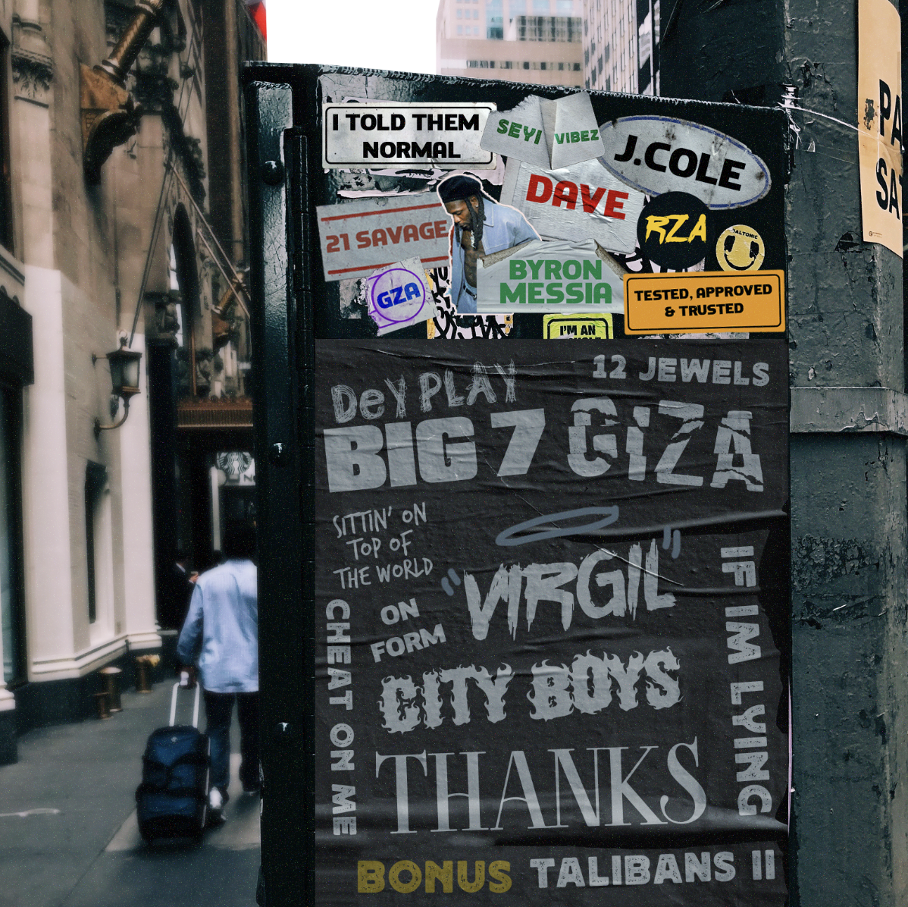
DOWNLOAD HI-RES GRAPHIC

I TOLD THEM…
BURNA BOY
- I Told Them (feat. GZA)
- Normal
- On Form
- Sittin’ On Top Of The World (feat. 21 Savage)
- Tested, Approved & Trusted
- Cheat On Me (feat. Dave)
- Virgil
- Big 7
- Dey Play
- City Boys
- Giza (feat. Seyi Vibez)
- 12 Jewels (feat. RZA)
- If I’m Lying
- Thanks (feat. J. Cole)
- Talibans II (with Byron Messia)

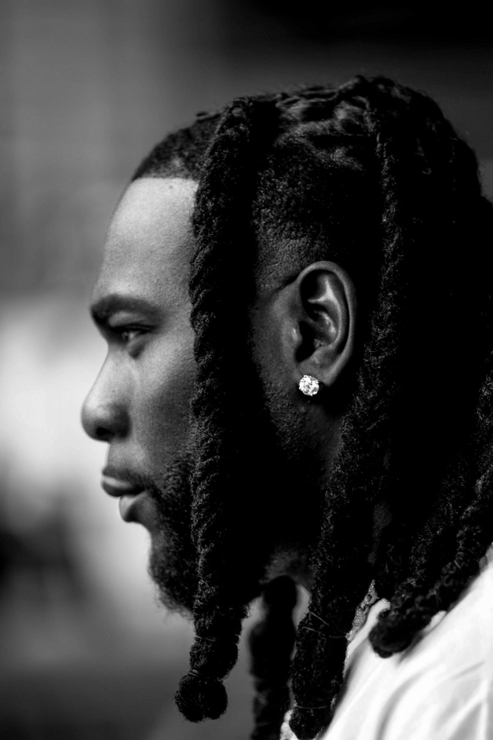
DOWNLOAD HI-RES PRESS PHOTO
CONNECT WITH BURNA BOY
TWITTER | FACEBOOK | INSTAGRAM | YOUTUBE |TIKTOK
PRESS CONTACTS
Corey Brewer | Corey.Brewer@atlanticrecords.com
Selam Belay | Selam.Belay@atlanticrecords.com

