CHARLOTTE CARDIN RELEASES SOPHOMORE ALBUM 99 NIGHTS

LEAD SINGLE “NEXT TO YOU” OUT NOW

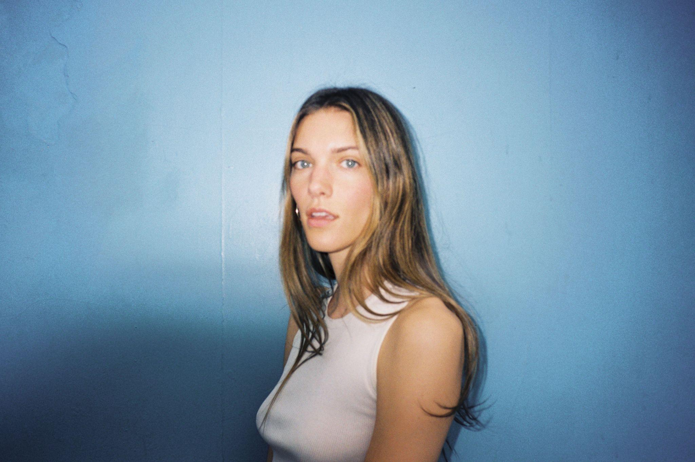
DOWNLOAD PRESS PHOTO HERE

Multi JUNO-winning Canadian singer/songwriter Charlotte Cardin has released her stellar sophomore album 99 Nights via Cult Nation/Atlantic Records. The album was made in Montreal with a slew of collaborators; DFA (Dua Lipa), Rob Grimaldi (BTS), Mr.Hudson (Kanye West), Jorgen Odegard (Justin Bieber), Jenn Decilveo (Miley Cyrus), Ryan Linvill (Conan Gray), Felix Joseph (Jorja Smith). The vinyl LP is available to pre-order now.

PRE-ORDER VINYL HERE

The latest single, “Next to You”, is a hypnotic piano ballad that fully displays Cardin’s rich and ethereal vocals, serves as a love letter and farewell to her hometown of Montreal.

Of the song she says, “‘Next to You” is a love letter to my hometown of Montreal. So many people, places and emotions anchored me there and this song is about letting go when the winds of change call. It was written with my dear and talented friend Patrick Watson, over a period of six transformative months where I knew I had to leave a place I love in order to grow.”

WATCH "NEXT TO YOU" VISUALIZER HERE
STREAM 99 NIGHTS HERE

“Next to You” rounds out a string of impressive tracks from the new album - “Jim Carrey,” “99 Nights,” “Confetti” and “Looping” - all of which garnered widespread critical acclaim. As Charlotte’s star continues to rise, the talented singer/songwriter will be taking her new material on the road for an international headline tour kicking off August 30th with stops in New York City at Irving Plaza, Boston at Brighton Music Hall, Los Angeles at the El Rey Theatre and London at KOKO. Many US dates are already sold out. Tickets are available to purchase now - find HERE.

WATCH “NEXT TO YOU” COLORS PERFORMANCE HERE

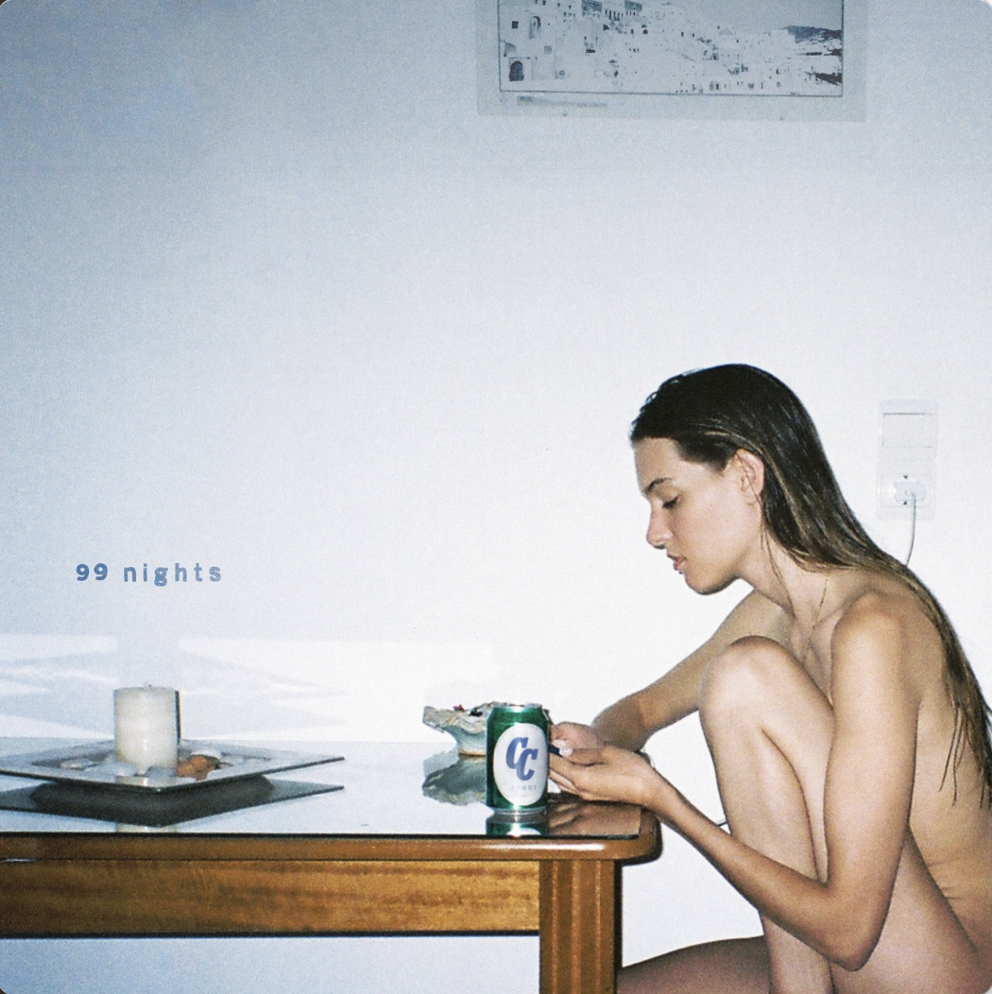

Charlotte carefully assembled what would become 99 Nights while on the road in 2021. After initial sessions in Montréal, she wrote and recorded in London, Los Angeles, and Toronto. The album allowed Charlotte to tap into her instincts as an artist and lean into what she was going through at the present moment.

“I’m more comfortable with my true instincts than I’ve ever been. This process helped me with a lot of things. I’m happier than I’ve been in a long time too, so it’s really positive,” she says of the final product.

Cardin released her debut full-length album Phoenix in 2021 to immense acclaim (and Platinum-sales certification in Canada) including a sweep of 2022 Juno Awards that included wins for Artist, Album, Pop Album and Single of the Year and a 2022 Polaris Music Prize nomination.

Praised by HYPEBAE for its “rippling melodies” and “stunningly raw vocals,” the album held the #1 spot in Canada for two weeks and boosted Cardin to over 400m global career audio streams. The album was celebrated with an elaborate and immersive ticketed livestream performance dubbed “The Phoenix Experience,” in addition to an expanded deluxe edition.

Charlotte Cardin – “99 Nights Tour”
8/30 – Trois-Rivières, QC @ Amphithéâtre Cogeco
8/31 – Trois-Rivières, QC @ Amphithéâtre Cogeco
9/7 – Quebec City, QC @ l'Agora - Port du Québec (Sold Out)
9/8 – Quebec City, QC @ l'Agora - Port du Québec (Sold Out)
9/13 – London, UK @ KOKO
9/14 – Manchester, UK @ Band on the Wall
9/15 – Bristol, UK @ Thekla
9/21 – Brussels, BE @ La Madeleine (Sold Out)
9/22 – Amsterdam, NL @ Tolhuistuin (Sold Out)
9/23 – Cologne, DE @ Club Volta
9/26 – Munich, DE @ Ampere
9/27 – Berlin, DE @ Columbia Theater
9/28 – Hamburg, DE @ Kent Club
9/30 – Istanbul, TR @ Zorlu PSM
10/24 – Washington, DC @ Union Stage
10/25 – Boston, MA @ Brighton Music Hall (Sold Out)
10/27 – New York, NY @ Irving Plaza (Sold Out)
10/28 – Philadelphia, PA @ The Foundry at the Fillmore
10/30 – Chicago, IL @ Lincoln Hall
11/4 – Phoenix, AZ @ Crescent Ballroom
11/5 – San Diego, CA @ House of Blues - Voodoo Room (Sold Out)
11/7 – Los Angeles, CA @ El Rey Theatre
11/9 – San Francisco, CA @ The Independent
11/11 – Portland, OR @ Mission Theater
11/12 – Seattle, WA @ Neumos
11/16 – Vancouver, BC @ Commodore Ballroom
11/17 – Vancouver, BC @ Commodore Ballroom (Sold Out)
11/18 – Victoria, BC @ Capital Ballroom (Sold Out)
11/22 – Edmonton, AB @ Midway Music Hall
11/23 – Calgary, AB @ The Palace Theatre
11/24 – Saskatoon, SK @ Coors Event Centre
11/25 – Winnipeg, MB @ Park Theatre (Sold Out)
12/7 - Moncton, NB @ Casino New Brunswick
12/8 - Halifax, NS @ Light House Arts Centre (Sold Out)
12/9 - Halifax, NS @Light House Arts Centre
1/23 – Strasbourg, FR @ La Laiterie
1/24 – Paris, FR @ L’Olympia (Sold Out)
1/26 – Bordeaux, FR @ Krakatoa
1/27 – Toulouse, FR @ Le Métronum
1/30 – Lille, FR @ Théâtre Sébastopol
1/31 – Caen, FR @ Big Band Café
2/2 – Rennes, FR @ L’antipode
2/3 – La Roche Sur Yon, FR @ Quaim
2/8 – Laval, QC @ Place Bell
2/9 – Laval, QC @ Place Bell (Sold Out)
2/10 – Laval, QC @ Place Bell (Sold Out)
2/14 - Kitchener, ON @ Centre In The Square
2/15 - Toronto, ON @ Massey Hall
2/16 - Hamilton, ON @ FirstOntario Concert Hall
2/17 - London, ON @ London Music Hall

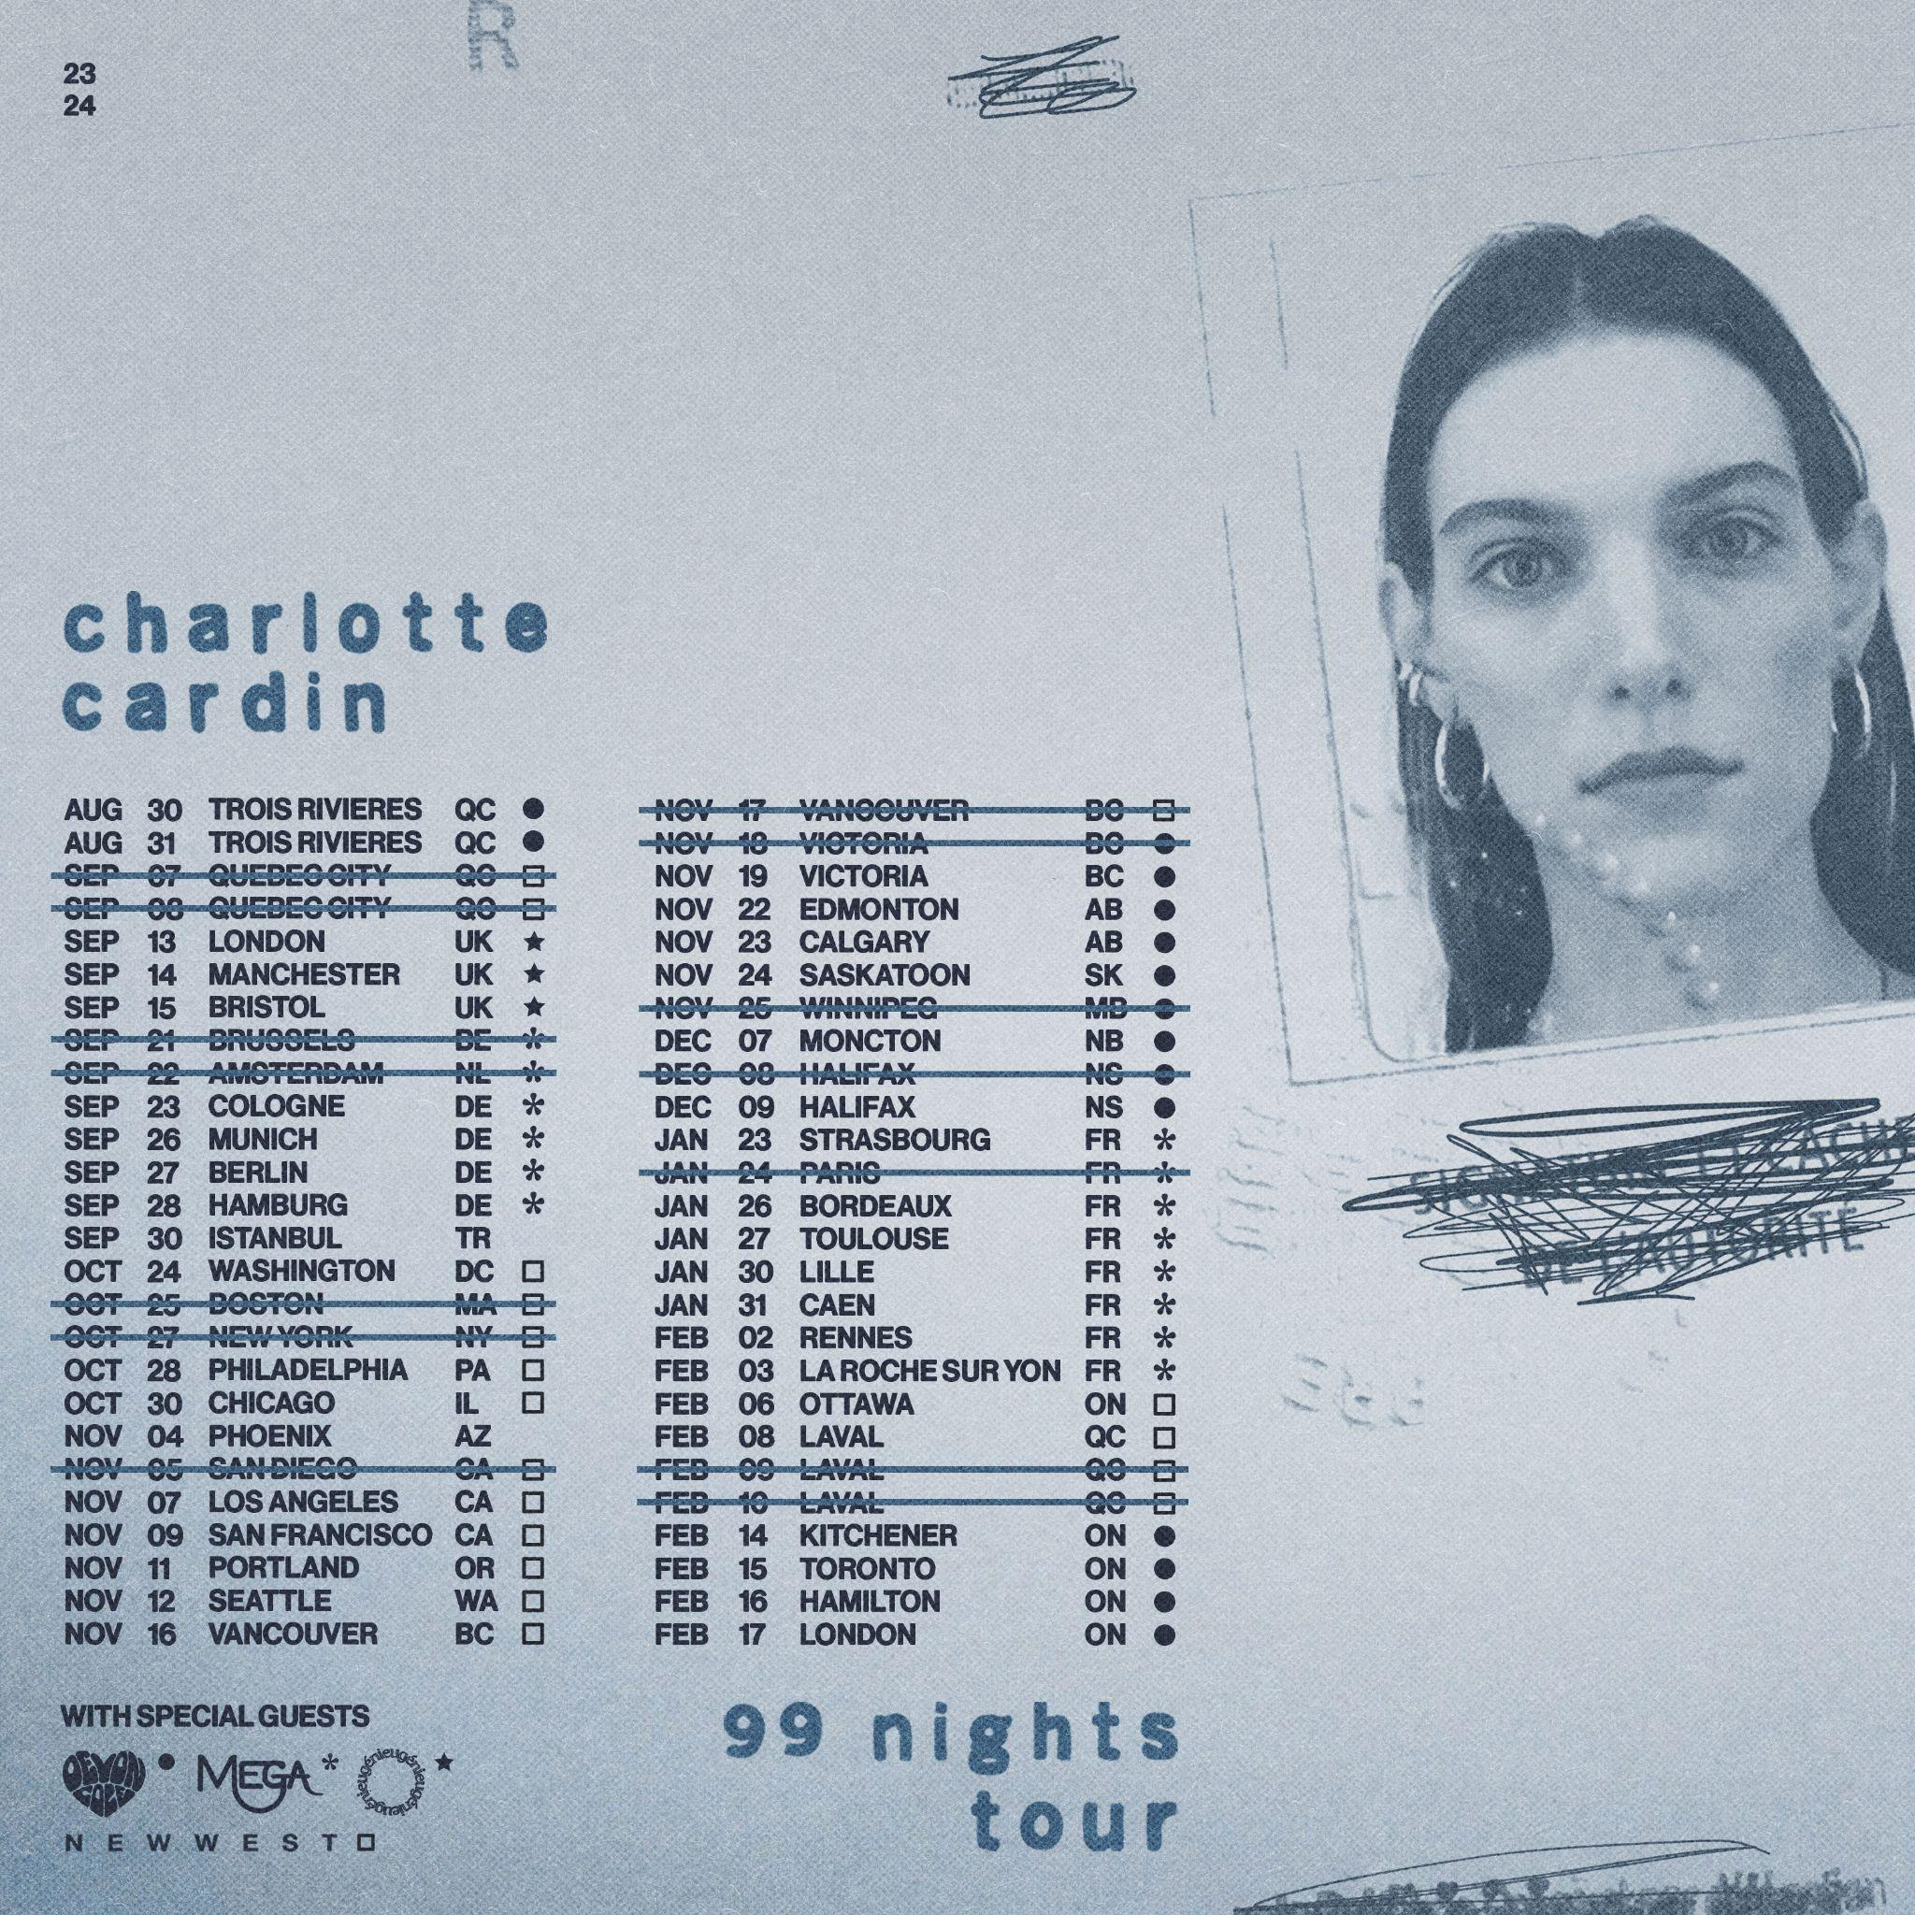

KEEP UP WITH CHARLOTTE CARDIN:
CHARLOTTECARDIN.COM | TIKTOK | INSTAGRAM | TWITTER | YOUTUBE | FACEBOOK | PRESS ASSETS

FOR MORE INFORMATION ON CHARLOTTE CARDIN:
Chloë Walsh: chloe@theoriel.co
Amy Fennie: amy@theoriel.co
Christina Kotsamanidis: christina.kotsamanidis@atlanticrecords.com
Ted Sullivan: ted.sullivan@atlanticrecords.com

